**COPYRIGHT TRANSFER AGREEMENT FORM**

This letter is signed by me personally:

Name : 1)Maria Ulfa

2)Imam Sucahyo

Institution* : State University of Surabaya

Email* : [mariau11200@gmail.com](mailto:mariau11200@gmail.com) / phone 085850926376

Place & date of birth* : Bangkalan, 11 November 2000

Address* : Ketintang Street, Gayungan District, City of Surabaya, Jawa Timur 60231, Indonesia

Title of Article : Development of HOTS-Based E-modules Using Sigil Application on Circular Motion Materials

Article acceptance : date.......... month ..................... year ......................

I declare that the submitted article is an original text, which was written by my self, and it is not the result of adaptation nor translated from other articles, and it has not yet been publshed in any media. I will be responsible for any potential damage to certain parties who feel personally harmed or legal claim of lawsuit due to the publication of this article.

I also submit the rights of ownership of submitted draft and article to the Editor Jurnal Pendidikan Fisika, and the Editor has right to reproduce and publishing either partial or entire contents of draft and article.

Thus, this statement has been drawn up to be used properly.

Surabaya, 18 May 2022

Author,

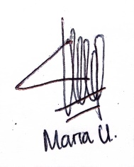

Maria Ulfa

*\* Write the name of Corresponding author*