**DECLARATION OF ORIGINALITY**

**JURNAL PENDIDIKAN FISIKA**

We the undersigned declare that this manuscript is original, has not been published before and is not currently being considered for publication or submitted elsewhere.

We wish to confirm that there are no known conflicts of interest associated with this publication and there has been no significant financial support for this work that could have influenced its outcome.

We confirm that the manuscript has been read and approved by all named authors and that there are no other persons who satisfied the criteria for authorship but are not listed. We further confirm that the order of authors listed in the manuscript has been approved by all of us.

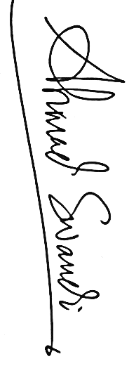We confirm that we have given due consideration to the protection of intellectual property associated with this work and that there are no impediments to publication, including the timing of publication, with respect to intellectual property. In so doing we confirm that we have followed the regulations of our institutions concerning intellectual property.

Author,

Ahmad Swandi

**LETTER OF STATEMENT**

**No: 13/JPF/IV/1442/2021**

I hereby declare that the article:

title : The Relationship of Learning Motivation through Guided Discovery Model Assisted Video and Interactive Simulation toward Student Learning Outcomes

authors : 1. Ifa Safira

2. Abdul Wahid

3. Sri Rahmadhanningsih

4. Nurhayati

5. Ahmad Suryadi

6. Ahmad Swandi

is **APPROVED** to be published in JPF for April 2021 Issue.

Hereby this statement is made truthfully and to be used accordingly.



Makassar, 21 April 2021

First Author,

Ahmad Swandi

**COPYRIGHT TRANSFER AGREEMENT FORM**

This letter is signed by me personally:

Name : 1) Ifa Safira

2) Abdul Wahid

3) Sri Rahmadhanningsih

4) Nurhayati

5) Ahmad Suryadi

6) Ahmad Swandi

Institution* : Universitas Bosowa

Email* : ahmad.swandi@universitasbosowa.ac.id/ phone +628970959551

Place & date of birth* : Kassa 17 January 1993

Address* : Perumahan Dosen Unhas Blok AC Baru No. 17, Tamalandrea, Makassar

Title of Article : The Relationship of Learning Motivation through Guided Discovery Model Assisted Video and Interactive Simulation toward Student Learning Outcomes

Article acceptance : 20 April 2021

I declare that the submitted article is an original text, which was written by my self, and it is not the result of adaptation nor translated from other articles, and it has not yet been publshed in any media. I will be responsible for any potential damage to certain parties who feel personally harmed or legal claim of lawsuit due to the publication of this article.

I also submit the rights of ownership of submitted draft and article to the Editor Jurnal Pendidikan Fisika, and the Editor has right to reproduce and publishing either partial or entire contents of draft and article.

Thus, this statement has been drawn up to be used properly.

Makassar, 21 April 2021

Author,

Ahmad Swandi