**COPYRIGHT TRANSFER AGREEMENT FORM**

This letter is signed by me personally:

Name : 1) Alifia Ilwi Agusty

2) Mita Anggaryani

Institution* : Universitas Negeri Surabaya

Email* : [alifia0708@gmail.com](mailto:alifia0708@gmail.com) / 08311842878

Place & date of birth* : Surabaya, 7 Agustus 1999

Address* : Jl. Juwingan No. 53-U RT. 05 RW. 10 Kel. Kertajaya Kec. Gubeng

Kota Surabaya

Title of Article : Teaching Global Warming with Millealab Virtual Reality

Article acceptance : 22 April 2021

I declare that the submitted article is an original text, which was written by my self, and it is not the result of adaptation nor translated from other articles, and it has not yet been publshed in any media. I will be responsible for any potential damage to certain parties who feel personally harmed or legal claim of lawsuit due to the publication of this article.

I also submit the rights of ownership of submitted draft and article to the Editor Jurnal Pendidikan Fisika, and the Editor has right to reproduce and publishing either partial or entire contents of draft and article.

Thus, this statement has been drawn up to be used properly.

Surabaya, 22 April 2021

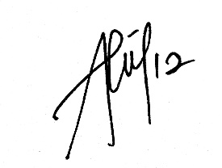Author,

(Alifia Ilwi Agusty)

*\* Write the name of Corresponding author*