COPYRIGHT TRANSFER AGREEMENT FORM

This letter is signed by me personally:
Name : 1) Friska Octavia Rosa
2) Arif Rahman Aththiby
Institution* : Universitas Muhammadiyah Metro
Email* : friskaoctaviarosa@gmail.com/ phone 0856 5897 0444
Place & date of birth* : Metro, 14 Oktober 1990
Address* : Jl. Gatot Subroto No.7 Yosodadi, Metro Timur, Lampung
Title of Article : Exploring Collaborative Problem-Solving Competency of Junior
High School Students
Article acceptance : 30 – 10- 2021

I declare that the submitted article is an original text, which was written by my self, and it is not the result of adaptation nor translated from other articles, and it has not yet been publshed in any media. I will be responsible for any potential damage to certain parties who feel personally harmed or legal claim of lawsuit due to the publication of this article.
I also submit the rights of ownership of submitted draft and article to the Editor Jurnal Pendidikan Fisika, and the Editor has right to reproduce and publishing either partial or entire contents of draft and article.
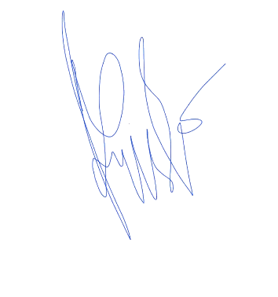
Thus, this statement has been drawn up to be used properly.
Metro, 31 Oktober 2021
Author,

(Friska Octavia Rosa)

* Write the name of Corresponding author

