COPYRIGHT TRANSFER AGREEMENT FORM

This letter is signed by me personally:
Name : 1) Ifa Safira
2) Abdul Wahid
3) Sri Rahmadhanningsih
4) Nurhayati
5) Ahmad Suryadi
6) Ahmad Swandi
Institution* : Universitas Bosowa
Email* : ahmad.swandi@universitasbosowa.ac.id/ phone +628970959551
Place & date of birth* : Kassa 17 January 1993
Address* : Perumahan Dosen Unhas Blok AC Baru No. 17, Tamalandrea, Makassar
Title of Article : The Relationship of Learning Motivation through Guided Discovery Model Assisted Video and Interactive Simulation toward Student Learning Outcomes
Article acceptance : 20 April 2021

I declare that the submitted article is an original text, which was written by my self, and it is not the result of adaptation nor translated from other articles, and it has not yet been publshed in any media. I will be responsible for any potential damage to certain parties who feel personally harmed or legal claim of lawsuit due to the publication of this article.
I also submit the rights of ownership of submitted draft and article to the Editor Jurnal Pendidikan Fisika, and the Editor has right to reproduce and publishing either partial or entire contents of draft and article.
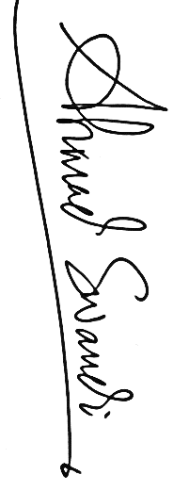
Thus, this statement has been drawn up to be used properly.
Makassar, 21 April 2021
Author,

Ahmad Swandi

