DECLARATION OF ORIGINALITY
JURNAL PENDIDIKAN FISIKA

We the undersigned declare that this manuscript is original, has not been published before and is not currently being considered for publication or submitted elsewhere.
We wish to confirm that there are no known conflicts of interest associated with this publication and there has been no significant financial support for this work that could have influenced its outcome.
We confirm that the manuscript has been read and approved by all named authors and that there are no other persons who satisfied the criteria for authorship but are not listed. We further confirm that the order of authors listed in the manuscript has been approved by all of us.
We confirm that we have given due consideration to the protection of intellectual property associated with this work and that there are no impediments to publication, including the timing of publication, with respect to intellectual property. In so doing we confirm that we have followed the regulations of our institutions concerning intellectual property.

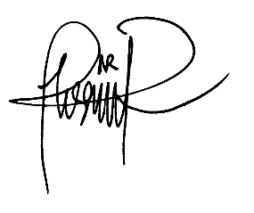
The first author,

[Nisrina Nur Ramadhani]

LETTER OF STATEMENT
No: 11/JPF/I/1442/2021

I hereby declare that the article:
title : Five-Tier Diagnostic Test Instrument for Uniform Circular Motion Concepts: Development, Validity, Reliability and Limited Trials

authors : 1. Nisrina Nur Ramadhani
2. Frida Ulfah Ermawati

is APPROVED to be published in JPF for Januari 2021 Issue.
Hereby this statement is made truthfully and to be used accordingly.

Makassar, [23-01-2021]
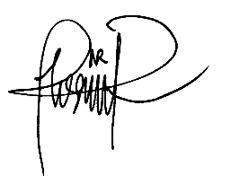
First Author,

[Nisrina N. Ramadhani]

