Integration of Pancasila Students Profile with Civic Disposition to Build Students with Character

**Sukron Mazid 1), Kokom Komalasari 2), Aim Abdulkarim 3), Rahmat 4), Muhammad Ardhi Razaq Abqa 5), Atsani Wulansari 6)**

1 2 3 4) *Citizenship Education Study Program, Faculty of Social Sciences Education*, Universitas Pendidikan Indonesia, Jl. Dr. Setiabudi No.229, Isola, Kec. Sukasari, Kota Bandung, Jawa Barat, Indonesia

*5 6) Law, Faculty Of Social And Political Sciences,* Universitas Tidar, Jl. Kapten Suparman No.39, Potrobangsan, Kec. Magelang Utara, Kota Magelang, Jawa Tengah, Indonesia

*Corresponding Author: Kokom Komalasari, Email:* [kokom@upi.edu](mailto:kokom@upi.edu) sukronmazid@untidar.ac.id

|  |
| --- |
| **History:** Received 07/09/2022 | Revised 08/10/2021 | Accepted 25/10/2021 | Published 30/10/2022 |
| **Abstract**. Education in Indonesia is vital in building the students' character based on Pancasila values. This article discusses the integration of the Pancasila Student Profile with civic disposition to build citizens with character. Civic disposition refers to the attitude and behavior of responsible, independent, disciplined, polite, and tolerant citizens. By combining these two concepts, education is expected to produce young people who not only understand Pancasila but also apply it in daily life as members of a democratic society. Through qualitative research methods, this study analyzed an educational approach that prioritizes the internalization of Pancasila values and civic disposition in students. The results show that this integration can increase students' awareness, responsibility, and active participation as citizens and strengthen their character in facing social and national challenges, thus forming ethical and high-integrity citizens. |
| ***Keywords:*** *Pancasila Student Profile; Civic Disposition; Character Education* |

**INTRODUCTION**

The Law on the National Education System Number 20 of 2003, in article 3, discusses education's basis, function, and purpose. It states that national education serves to develop abilities and shape the character and civilization of a dignified nation in order to educate the life of the nation, aiming to develop the potential of students to become human beings who believe and fear God Almighty, have noble character, healthy, knowledgeable, capable, creative, independent, and become democratic and responsible citizens. Education helps people perfect themselves as human beings [1]. Philosophically, education is humanizing people as a whole. Ki Hajar Dewantara, an Indonesian National Education figure, explained that education plays a role in developing children's morals, thinking, and physicality to achieve a harmonious life with their environment and society [2].

Character education is implicitly stated in Law No. 20 of 2003 Article 3. Character can be defined as the individuals' mindset and behavior in living life and interacting in the family, school, community, and country [3]. Character is the central aspect of a quality person [4]. Character is a pattern of behavior that is unique to each individual and reflects a person's moral condition [5]. Character education is one of the main focuses in the education curriculum in Indonesia [6]. Character education has become a significant focus of Indonesia's education system to form an academically intelligent but also moral and ethical generation. Character education is a deliberate effort to help individuals understand, pay attention to, and apply core ethical values (Lickona, 1996). It aims to prepare a person to make ethical judgments and act following those judgments (Howard et al., 2004).

Perfect human beings result from human development that has noble character and morals [7]. Human development starts from education and teaching, especially character. The main focus of education is centered on the values of Pancasila because they guide the universal life values. Pancasila, as the basis of the Indonesian state, acts as a guide in the social life of the community. This ideology has become the Indonesian nation's ideal view and life guideline [8].

The 21st-century education focuses on achieving the nation's ideals by forming a society of quality human resources, namely independent individuals, so that Indonesia can become a prosperous and happy country and enjoy glory and equality with other countries [9]. The 21st-century education should keep the nation's generation from being complacent and dissolved in ignorance. Furthermore, education should reduce students' bad traits such as being technology illiterate, brawls, spreading hoaxes, fighting each other, slandering, and putting each other down. Therefore, the learning process in schools must develop a noble attitude, character, and pancasilaist. The conceptual flow and phases must also be modified to keep up with the times. The Ministry of Education and Culture promoted the Merdeka curriculum to answer the era's challenges. This is to form a young generation with global insight and character. The Merdeka Curriculum is a curriculum designed to develop character through the concept of the Pancasila Student Profile. This character is formed based on Indonesia's national education goals [10], [11].

The Ministry of Education and Culture formulated six dimensions of the Pancasila Student Profile, i.e., faith and piety to God Almighty, noble character, global diversity, cooperation, independence, and the ability to think critically and creatively [12]. The Pancasila Student Profile covers the abilities, character, and competencies that Indonesian students must have in the 21st century. The cultivation of character education in the Merdeka Curriculum can be done by implementing the Pancasila Student Profile Strengthening Project (P5). P5 is a cross-disciplinary project that focuses on the needs of the community or the surrounding environment in the education unit, intending to realize Pancasila students [13]. Students are expected to show a positive attitude towards friends and facilitators to achieve goals at school. Good communication between group members is also needed so that activities can occur smoothly. They must understand information from various sources and effectively convey messages to others to achieve common goals [14].

Kalidjernih explained that education, in general, and civic education, in particular, faced the impacts of these changes, especially those related to an increasingly global life. This has shaped and reinforced the culture of teaching and learning [15]. Citizenship Education emphasizes character building, encompassing knowledge, skills, and values of citizenship that all play a role in forming good citizens [16]. Civic Disposition refers to attitudes, characters, and values that motivate individual or social behavior [17], which develops through learning and experience at home, school, and community [18]. The primary purpose of civic disposition is to cultivate the character of citizens privately, such as moral responsibility and self-discipline, as well as publicly, such as social care, compliance with the Law, critical thinking, and negotiation skills [16].

Civic disposition is awareness of the rights and welfare of others, being fair to all people without exception, caring for the environment, respecting and appreciating each other, and having social responsibility [19]. As part of character education, civic disposition includes attitudes and values such as responsibility, tolerance, and active social participation. The nation's character can also be formed by transforming local cultural values as a tool to build the nation's character [20]. Civic disposition is formed through the learning and experience a person gains from the environment [21]. Civic disposition aims to prepare students to become global citizens [22]. Civic disposition is closely related to the character of students in living their lives as citizens [23].

Asiati & Hasanah (2022); Kahfi (2022); Rusnaini et al. (2021); and Ulandari & Rapita (2023) have conducted research related to the Pancasila student profile for character development. Their focus was on the project of strengthening the Pancasila Student profile at the Mover School, the implications for student character, the implications for students' resilience, and the strengthening of students' character. Therefore, this study focuses on integrating the profile of Pancasila students and civic disposition to form the character of Pancasialist students. This article is new because it combines the concept of the principal character and the Pancasialist character. Pancasila Student Profile is a manifestation of Pancasila values that are expected to be applied by students in everyday life. On the other hand, civic disposition is an essential aspect of civic education, as students are expected to have attitudes that support democracy, social responsibility, and active participation in national life.

School is the primary basis of education, especially in educating the nation's children. It is following the ideals of the nation, educating the life of the nation. The profile of Pancasila students and civic disposition is a dynamic bond that can strengthen the nation's character. It concentrates on aligning the Pancasila value philosophy, strengthened by internalizing the citizenship character. The Merdeka curriculum related to P5 has been implemented in junior high schools in Indonesia in response to 21st-century challenges. Critical thinking, creativity, and global insight, along with the spirit of Pancasilaist, are embodied in the contents and goals of P5. Integrating Pancasila Student Profile and civic disposition is expected to strengthen students' character building so that they understand, internalize, and practice Pancasila values in civic life. This article analyzes this integration and its impact on the student's character building as a citizen with character. Thus, the research question is, "How can the integration of the Pancasila Learner Profile with civic disposition shape the character of students who are smart, capable, skilled, and have Pancasila character?"

**RESEARCH METHODS**

This study used a descriptive approach with qualitative methods since this study described words [25]. Creswell said the method used to describe, explore, and understand the meaning considered by individuals or groups comes from social or humanitarian problems [26]. The participant was chosen by purposive sampling. The research subjects were DL (48) (school principal), ET (45) & NR (47) (teachers) and students. The research location was at SMP N 2 Pakis Magelang, Central Java. Students in grade VII were chosen as the research subject because the class implements the Merdeka curriculum and the Pancasila Student Profile. In addition, the students of grade VII were chosen as their age is at a crucial stage of character-building development. The research was conducted from January 2024 to August 2024. The informants revealed the symptoms and described the integration process of the Pancasila Student Profile and civic disposition in the teaching and learning process. The data in the field were collected through observation, interviews, and documentation. Furthermore, the data were analyzed in the form of a description. The data collection technique used in this study was an interview. Observation is carried out through field observations related to activities done in school and surroundings. The documentation was in the form of photos/videos, and other documents were obtained from the Teacher and Administration Documentation of SMP N 2 Pakis Magelang. The data were collected from January to May 2024. The data sources used in this study were triangulation techniques and methods. Miles and Huberman's model, such as data reduction, data presentation, and drawing conclusions, was used to analyze the data (Miles & Huberman, 1992).

**DISCUSSION**

The profile of Pancasila Students, under the Vision and Mission of the Ministry of Education and Culture (now the Ministry of Education, Culture, Research, and Technology) listed in Regulation of the Minister of Education and Culture Number 22 of 2020 concerning the Strategic Plan of the Ministry of Education and Culture in 2020-2024. It describes Indonesian students as lifelong learners with global competencies who behave under Pancasila values. This profile includes six main characteristics: faith and piety in God Almighty, noble character, global diversity, cooperation, independence, and the ability to think critically and creatively (Rusnaini et al., (2021); Sufyadi, et al. (2021). Pancasila Student Profile is a concept introduced in the Merdeka Curriculum to internalize Pancasila values in students.

Pancasila Student Profile, commonly called P3, is a form of effort to cultivate Pancasila values in students. Minister of Education and Culture Nadiem Anwar Makarim stated that strengthening students' character education can be achieved through various policies that focus on the achievement of Pancasila Students, ranging from primary education to higher education [28]. Strengthening character education related to P3 is part of the Ministry's strategy to build an intelligent and civilized nation. Therefore, this study observed the integration of P3 with a civic disposition at SMP N 2 Pakis Magelang to build the student's character. The interview result with DL (48) is described as follows.

The Merdeka curriculum significantly impacts students' development, especially with the application of P3, which can change thinking and acting. The appreciation of the experience and practice of Pancasila values is emphasized. Therefore, P3 indirectly has an impact related to strengthening students' character.

Based on the interview above, implementing the Merdeka curriculum related to P3 is considered appropriate, especially in fostering the character of Pancasilaists amid globalization. The students become the capital of the nation's development, following the slogan of welcoming the golden Indonesia 2045. Hence, it is necessary to prepare the next generation to be capable, skilled, characterized, and have a global mind. Pancasila Student Profiles must be applied in everyday characters and brought to students' lives through school culture, intracurricular, co-curricular, and extracurricular learning [29]. As a civic education teacher, Mrs. E.T. (45) mentioned the following:

For several semesters, SMP N 2 Pakis has consistently implemented P3 and also P5, which have many activities. Students' Intracurricular activities are related to the material being taught, while extracurricular activities are part of their interests and talents. Then, this co-curricular is part of the project that is tailored to the themes. There are many P5 activities in this school, ranging from entrepreneurship, diversity and other themes.

Based on the results of the interview above, it is clear that the school has carried out P3 well. Moreover, P5 has also been carried out with the guidance of the Ministry of Education and Culture. Some of the P5 activities carried out by SMP N 2 Pakis are elaborated in the following table.

Table 1: The Activity Map of Pancasila Student Profile Strengthening Project

|  |  |
| --- | --- |
| Theme | Description |
| Wake Up Body and Soul | This project aims to create an inclusive and bullying-free school environment. It is an activity that shows that all students are friendly. The activities are greetings and smiles. |
| The Voice of Democracy | This project aims to create a democratic and civilized school, i.e., the election of the student council president. (Vote directly, publicly, freely, secretly, honestly and fairly) |
| Entrepreneurship | The project aims to mobilize students for entrepreneurship and independence. An example of this activity is making local Magelang products such as Onde-Onde and Getuk. |
| Local Wisdom | This project aims to create schools that uphold local wisdom, such as traditional games (Dakon, Playing kite, Playing walking stilts). |
| Sustainable Lifestyle | This project aims to create a creative, hard-working, and responsible school by creating a vertical garden (creating plant pots). |
| Bhineka Tunggal Ika (Unity in Diversity) | This project aims to create a multicultural school such as arts activities (Soreng dance, Topeng Ireng dance). |

Source: Data processing by researchers

In developing the Pancasila student profile strengthening project, the Ministry of Education and Culture launched seven themes. It developed them based on priority issues in the 2020-2035 National Education Roadmap, Sustainable Development Goals, and other relevant documents. Five common themes are Sustainable Lifestyle, Local Wisdom, Bhinneka Tunggal Ika (Unity in Diversity), Engineering and Technology to Build a Nation, and Entrepreneurship. The following are activities related to the project to strengthen the profile of Pancasila students at SMP N 2 Pakis.

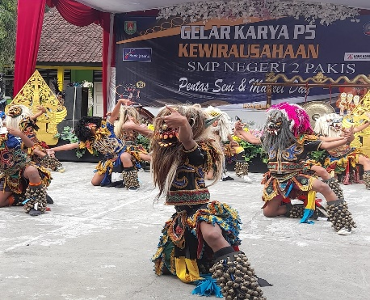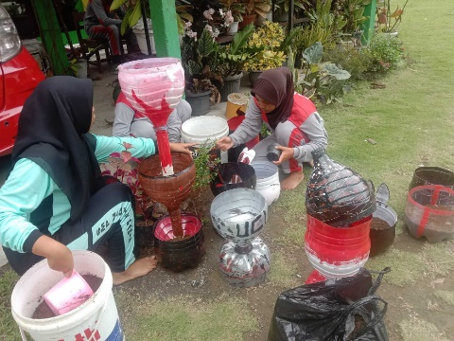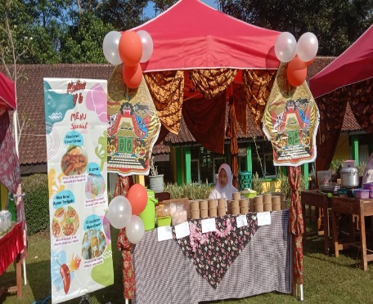

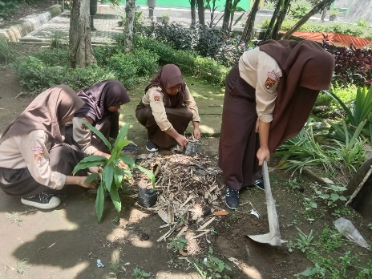

Figure 1: P5 Activity

Source: Documentation from Researchers

The Pancasila Student Profile Strengthening Project is designed to provide students with a fun and flexible learning experience with a non-rigid structure. This activity emphasizes interactivity and direct involvement with the surrounding environment to strengthen the competencies needed in the Pancasila Student Profile [30]. Therefore, the activities carried out at SMP N 2 Pakis related to P5 have been running well. The P5 values are expressed in various project activities. The following are the values of the Pancasila Student Profile.

Figure 2: Pancasila Student Profile Values

Source: Ministry of Education and Culture 2022

The values of the Pancasila Student Profile reflect the character and competencies expected of students in Indonesia. These values are integrated into school learning and activities to form character and competencies that align with Pancasila. The strategy of transferring P5 values is embedded in various activities in the form of activity projects. The construct developed is to form intelligent student characters and pancasilaist. The hope and goal is for superior human resources to align with the character of Pancasila values. Personal character, such as moral responsibility, self-discipline, and respect for the dignity and human dignity of each individual, is mandatory [31], [32]. Meanwhile, public character is related to the students' concerns as citizens[33]. Civic disposition training is usually conducted through learning models such as citizen projects [34].

Civic disposition refers to attitudes and behaviors that reflect democratic and civic values. This disposition includes tolerance, moral responsibility, discipline, independence, and politeness in school and community. Some schools have successfully implemented programs integrating these concepts, such as social projects, group discussions on national issues, and extracurricular and co-curricular activities focusing on developing civic disposition. As a result, students become more aware of their role as citizens with character and contribute positively to society. The following is the figure of the civic disposition 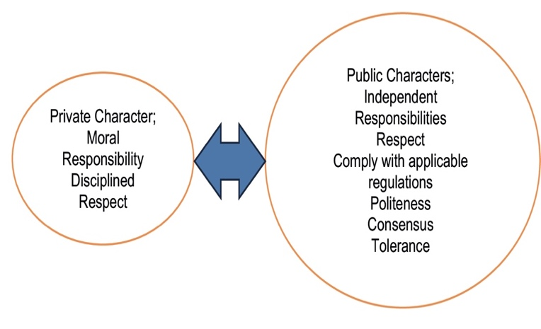indicator based on Branson's theory.

Figure 3: Civic Disposition Indicator

Source: The Value of Civic Disposition [16].

These values are then adapted according to local needs and culture, including moral responsibility, participation, politeness, care, and patience. Meanwhile, the activities of the project to strengthen the student profile of Pancasila (P5) and civic disposition are relevant to Parsons' theory of functionalism—first, interdependence among other parts, components, and processes that include visible regularities. The second is interdependence with other components and their surrounding environments [35]. Therefore, the integration characteristics spread in P5 and civic disposition have dependence and attachment in forming Pancasilaist character. The following describes the integration and distribution of the two values between P5 and civic disposition.

Table 2: Matrix of P5 and Civic Disposition Value Integration

|  |  |  |
| --- | --- | --- |
| The Activities at SMP N 2 Pakis | Pancasila Student Profile Values | Civic Disposition Values |
| Friendly activities (greetings and smiles). | Faith and piety in God Almighty and noble character,  Global Diversity  Independent  Critical Thinking  Creative | Moral Responsibility  Politeness  Tolerance  Independent  Disciplined |
| The election of the Student Council President (Vote directly, publicly, freely, secretly, honestly, and fairly) | Independent  Critical Thinking  Creative | Moral Responsibility  Independent  Disciplined |
| Making local Magelang products such as Onde-Onde and Getuk. | Independent  Critical Thinking  Creative | Independent  Disciplined |
| Traditional games (Dakon, playing kite, Playing walking stilts). | Independent  Critical Thinking  Creative  Global Diversity | Independent  Disciplined  Tolerance |
| Vertical garden (make plant pots) | Independent  Critical Thinking  Creative  Global Diversity | Moral Responsibility  Independent  Disciplined |
| arts activities (Soreng dance, Topeng Ireng dance). | Independent  Critical Thinking  Creative  Global Diversity | Tolerance  Independent  Disciplined |

Source: processed by researchers

Based on the spread of values sourced from various activities that contain P5 and civic disposition values at SMPN N 2 Pakis, it can be seen that there is integration in each activity, and the values are the basis for character building. The value integration contains pancasilaist character values. The souls of these values are based on Pancasila as the nation's view of life. If this combination of values is implemented and becomes a student's practice, then what is valued is the formation of a capable, skilled, global-minded, and democratic character. Combining the values of the Pancasila Learner Profile (P5), i.e., faith and piety in God Almighty, noble character, global diversity, cooperation, independence, and the ability to think critically and creatively, with the value of Civic Disposition, i.e., moral responsibility, politeness, independence, discipline, and tolerance in the life of students at SMP N 2 Pakis Magelang is carried out through various daily activities and behaviors.

Students are taught to pray, maintain courtesy, and take responsibility for their actions. Students learn to appreciate cultural differences, be polite, and collaborate on cross-cultural projects. Independence is fostered by regulating study time, doing assignments on time, and discipline in following school rules. Students are also trained to think critically and consider moral decision-making. Creativity is encouraged through art projects, extracurricular activities, and co-curricular activities while remaining open to criticism and teamwork. The school conducts mentoring programs, devotional work, anti-bullying campaigns, anti-violent sexuality campaigns, and debates between classes to practice these values.

By integrating these values into various aspects of school life, students will develop academic competence and a balanced and robust character under Pancasila values. It will build a generation of the nation, especially students with noble character. Integrating the Pancasila Student Profile with civic disposition can be done through a holistic educational approach, which combines the teaching of Pancasila values with the practice of citizenship in everyday life. This includes project-based learning, involvement in social activities, and strengthening the role of schools as agents of social change. The results showed that integrating the Pancasila Student Profile and civic disposition could be done effectively through a participatory and contextual educational approach. Students involved in activities that combine the learning of Pancasila values with the practice of citizenship show improvement in tolerance, social responsibility, and active participation in community activities.

**CONCLUSION**

Integrating the Pancasila Student Profile and civic disposition has excellent potential in shaping students into citizens with character. Through a comprehensive and participatory educational approach, Pancasila values can be internalized more deeply, while civic disposition strengthens the application of these values in community life. Character education that combines these two aspects will produce young people who not only know Pancasila, but also commit to apply it in daily life. Thus, students will grow into individuals who contribute actively to building and upholding the values of divinity, humanity, unity, democracy, and justice. Combining the values of the Pancasila Learner Profile (P5), i.e., faith and piety in God Almighty, noble character, global diversity, cooperation, independence, and the ability to think critically and creatively, with the values of civic disposition, namely moral responsibility, politeness, independence, discipline, and tolerance. The purpose of integrating these values is to shape students into individuals who have strong faith and morals and can contribute positively to society. This integration aims to create a generation with a strong character that can think critically, independently, and creatively and has a high moral and social commitment to realizing the values of Pancasila in everyday life.

**ACKNOWLEDGMENTS (Optional)**

Write down the Institutions/institutions that assist in research, especially funding support for your research. Also include individuals who have assisted you in your studies such as Advisors, financial supporters or possibly other supports (if any).

**REFERENCES**

[1] E. Christiana, “Pendidikan yang Memanusiakan Manusia,” *Humaniora*, vol. 4, no. 1, p. 398, Apr. 2013, doi: 10.21512/humaniora.v4i1.3450.

[2] B. Dalyono and E. D. Lestariningsih, “Implementasi Penguatan Pendidikan Karakter Di Sekolah,” *bangunrekaprima*, vol. 3, no. 2, p. 33, Oct. 2017, doi: 10.32497/bangunrekaprima.v3i2.865.

[3] E. R. Marampa, “PERAN ORANGTUA DAN GURU PENDIDIKAN AGAMA KRISTEN DALAM MEMBENTUK KARAKTER KEROHANIAN PESERTA DIDIK,” *SJTPK*, vol. 2, no. 2, pp. 239–258, Jun. 2021, doi: 10.53687/sjtpk.v2i2.46.

[4] B. Manullang, “GRAND DESAIN PENDIDIKAN KARAKTER GENERASI EMAS 2045,” *J. Pendidik. Karakter*, vol. 4, no. 1, Mar. 2013, doi: 10.21831/jpk.v0i1.1283.

[5] A. Sudrajat, “MENGAPA PENDIDIKAN KARAKTER?,” *J. Pendidik. Karakter*, vol. 1, no. 1, Oct. 2011, doi: 10.21831/jpk.v1i1.1316.

[6] A. Anugrah and R. Rahmat, “Pendidikan Karakter dalam Perspektif Kurikulum Pendidikan Pancasila dan Kewarganegaraan (PPKn),” *jppi*, vol. 4, no. 1, pp. 22–34, Jun. 2024, doi: 10.53299/jppi.v4i1.403.

[7] S. Mazid, D. Sundawa, and D. Prasetyo, “Penguatan karakter kebangsaan civitas akademika melalui filosofi nama perguruan tinggi,” *J. Pendidik. Karakter*, vol. 14, no. 1, pp. 1–10, Apr. 2023, doi: 10.21831/jpka.v14i1.53947.

[8] S. Hakim and S. Mazid, “Penanaman Nilai-Nilai Pancasila dalam Jamaah Kopdariyah,” *CIVICUS*, vol. 9, no. 1, p. 91, Mar. 2021, doi: 10.31764/civicus.v9i1.5990.

[9] W. Anggraini and H. Hudaidah, “Reformasi Pendidikan Menghadapi Tantangan Abad 21,” *joe*, vol. 3, no. 3, pp. 208–215, Apr. 2021, doi: 10.31004/joe.v3i3.363.

[10] A. Kahfi, “IMPLEMENTASI PROFIL PELAJAR PANCASILA DAN IMPLIKASINYA TERHADAP KARAKTER SISWA DI SEKOLAH,” *dirasah: j. pemikir. pendidik. dan dasar islam*, vol. 5, no. 2, pp. 138–151, Sep. 2022, doi: 10.51476/dirasah.v5i2.402.

[11] S. Ulandari and D. D. Rapita, “Implementasi Proyek Penguatan Profil Pelajar Pancasila sebagai Upaya Menguatkan Karakter Peserta Didik,” *JMK*, vol. 8, no. 2, pp. 116–132, Apr. 2023, doi: 10.21067/jmk.v8i2.8309.

[12] R. Rusnaini, R. Raharjo, A. Suryaningsih, and W. Noventari, “Intensifikasi Profil Pelajar Pancasila dan Implikasinya Terhadap Ketahanan Pribadi Siswa,” *JKN*, vol. 27, no. 2, p. 230, Oct. 2021, doi: 10.22146/jkn.67613.

[13] Kementerian Pendidikan, Kebudayaan, Riset, dan Teknologi, *Panduan pengembangan Projek Penguatan Profil Pelajar Pancasila*. Badan Standar, Kurikulum, dan Asesmen Pendidikan KemendibudRistek., 2022.

[14] Kemendikbudristek, *Dimensi, Elemen, Dan Subelemen Profil Pelajar Pancasila Pada Kurikulum Merdeka. In Keputusan Kepala Badan Standar, Kurikulum, Dan Asesmen Pendidikan Kementerian Pendidikan, Kebudayaan, Riset, Dan Teknologi Nomor 009/H/Kr/2022*. 2022.

[15] F. K. Kalidjernih, *Puspa ragam konsep dan isu kewarganegaraan*, Cet. 1. Bandung: Widya Aksara Press, 2009.

[16] M. S. Branson, *Belajar civic education dari Amerika*. Yogyakarta: Lembaga Kajian Islam dan Sosial (LKIS) dan The Asia Foundation, 1999.

[17] S. Pasandaran, A. L. Lonto, T. Pangalila, and R. A. Barahama, “The Efforts of Civic Education Teachers in Strengthening Students’ Civic Disposition,” in *Proceedings of the Annual Civic Education Conference (ACEC 2018)*, Bandung, Indonesia: Atlantis Press, 2018. doi: 10.2991/acec-18.2018.14.

[18] B. Mulyono, “Reorientasi civic disposition dalam kurikulum Pendidikan Kewarganegaraan sebagai upaya membentuk warga negara yang ideal,” *civ.*, vol. 14, no. 2, pp. 218–225, Oct. 2017, doi: 10.21831/civics.v14i2.17007.

[19] L. Latipa, S. Sulistyarini, and T. S. Atmaja, “PEMBENTUKAN CIVIC DISPOSITION PADA PESERTA DIDIK DI MADRASAH ALIYAH NEGERI KOTA SINGKAWANG,” *JPPK*, vol. 11, no. 7, p. 507, Jul. 2022, doi: 10.26418/jppk.v11i7.55984.

[20] R. Yunus, “TRANSFORMASI NILAI-NILAI BUDAYA LOKAL SEBAGAI UPAYA PEMBANGUNAN KARAKTER BANGSA,” *JPP*, vol. 13, no. 1, Aug. 2016, doi: 10.17509/jpp.v13i1.3508.

[21] W. A. Galston, “Civic Education and Political Participation,” *APSC*, vol. 37, no. 2, pp. 263–266, Apr. 2004, doi: 10.1017/S1049096504004202.

[22] E. Karliani, S. Kartadinata, U. S. Winataputra, and K. Komalasari, “Indonesian civic engagement among college students,” *Journal of Human Behavior in the Social Environment*, vol. 29, no. 5, pp. 582–592, Jul. 2019, doi: 10.1080/10911359.2019.1571980.

[23] G. A. D. Liem and B. L. Chua, “An expectancy-value perspective of civic education motivation, learning and desirable outcomes,” *Educational Psychology*, vol. 33, no. 3, pp. 283–313, May 2013, doi: 10.1080/01443410.2013.776934.

[24] S. Asiati and U. Hasanah, “IMPLEMENTASI PROJEK PENGUATAN PROFIL PELAJAR PANCASILA DI SEKOLAH PENGGERAK,” *jlmp*, vol. 19, no. 2, pp. 61–72, Dec. 2022, doi: 10.54124/jlmp.v19i2.78.

[25] L. J. Meleong, *Metologi penelitian kualitatif*. Bandung: PT Remaja Rosdakarya, 1989.

[26] J. W. Creswell, *Qualitative inquiry and research design: choosing among five traditions*. Thousand Oaks, Calif: Sage Publications, 1998.

[27] M. B. Miles, and M. Huberman, *Analisis Data Kualitatif*. Jakarta: Universitas Indonesia, 1992.

[28] S. Ismail, S. Suhana, and Q. Yuliati Zakiah, “ANALISIS KEBIJAKAN PENGUATAN PENDIDIKAN KARAKTER DALAM MEWUJUDKAN PELAJAR PANCASILA DI SEKOLAH,” *JMPIS*, vol. 2, no. 1, pp. 76–84, Feb. 2021, doi: 10.38035/jmpis.v2i1.388.

[29] E. Susilawati, S. Sarifudin, and S. Muslim, “INTERNALISASI NILAI PANCASILA DALAM PEMBELAJARAN MELALUI PENERAPAN PROFIL PELAJAR PANCASILA BERBANTUAN PLATFORM MERDEKA MENGAJAR,” *Teknodik*, pp. 155–167, Dec. 2021, doi: 10.32550/teknodik.v25i2.897.

[30] M. Mery, M. Martono, S. Halidjah, and A. Hartoyo, “Sinergi Peserta Didik dalam Proyek Penguatan Profil Pelajar Pancasila,” *basicedu*, vol. 6, no. 5, pp. 7840–7849, Jun. 2022, doi: 10.31004/basicedu.v6i5.3617.

[31] B. Engelen, A. Thomas, A. Archer, and N. Van De Ven, “Exemplars and nudges: Combining two strategies for moral education,” *Journal of Moral Education*, vol. 47, no. 3, pp. 346–365, Jul. 2018, doi: 10.1080/03057240.2017.1396966.

[32] S. Woofter, “Book Review: Building Equity: Policies and Practices to Empower All Learners,” *American Journal of Qualitative Research*, vol. 3, no. 1, Jun. 2019, doi: 10.29333/ajqr/5815.

[33] S. A. Klien, “Public Character and the Simulacrum: The Construction of the Soldier Patriot and Citizen Agency in *Black Hawk Down*,” *Critical Studies in Media Communication*, vol. 22, no. 5, pp. 427–449, Dec. 2005, doi: 10.1080/07393180500342993.

[34] Sarkadi and D. N. Fadhillah, “The Engagement of Learning Management on Civic Education for Civic Disposition Building in Senior High School,” *Journal of Social Studies Education Research*, vol. 11, no. 3, pp. p134-155, 2020.

[35] S. N. Eisenstadt, “Culture and Social Structure Revisited,” *International Sociology*, vol. 1, no. 3, pp. 297–320, Sep. 1986, doi: 10.1177/026858098600100307.