CROSS-SECTOR COLLABORATION IN INTERVENTION TO PREVENT AND REDUCE STUNTING IN PENAJAM PASER UTARA DISTRICT

Heryono Susilo Utomo¹, Thalita Rifda Khaerani¹, Yustisia Anzalna³

Faculty of Social and Political Sciences, Universitas Mulawarman^{1,2,3}
E-mail Correspondence: thalitarifdakhaerani@fisip.unmul.ac.id

ABSTRACT

Stunting is a chronic nutritional problem that will affect the quality of human resources both from a cognitive and physical perspective so that cross-sectoral collaboration is needed to tackle the problem of stunting. North Penajam Paser Regency is a stunting locus area which is included in the locus of the list of stunting prevention intervention policies in 100 districts/cities with relatively high stunting rates, namely being ranked 2nd highest in East Kalimantan Province which reached 27.3%. This study aims to know the forms of cross-sectoral collaboration in interventions to prevent and reduce stunting in North Penajam Paser Regency. The type of research used is descriptive qualitative with data collection techniques through observation, interviews, documentation and literature studies as well as analytical techniques using interactive models. Based on the results of the research, so far the program has been running although it has not made any major changes in its handling. This is influenced by various obstacles and obstacles that make its implementation less effective in efforts to prevent and reduce stunting in North Penajam Paser Regency.

Keyword: Stunting, Handling, Intervention, Health Services

INTRODUCTION
In facing current public challenges,cross-sectoral collaboration is key in responding to problems that occur in society. Various global issues that occur, collaboration is considered necessary to form a strategy to overcome complex and difficult problems in both the education, health, economic and other sectors. Cross-sector collaboration is collaboration that involves the government, the private sector, and society as a whole (Bryson dkk., 2006)
Nutritional health of humans as a population is an important element in reflecting the quality of human resources in a region. Currently, stunting is one of the indicators that will affect the quality of human resources caused by delays in growth in cognitive and physical aspects so that the government as a stakeholder considers this issue to be addressed. (Mashar dkk., 2021)
The results of the analysis (Awaludin, 2019) on the problem of stunting in Indonesia are due to multi-dimensional factors, namely: (a) bad parenting where this is caused by a lack of knowledge about health and nutrition, (b) limited health services including health services (c) lack of access to nutritious food and (d) lack of access to clean water and sanitation.
Stunting is a nutritional problem that occurs in toddlers which is characterized by body size that does not match their age. In addition, stunting is also classified as vulnerable to disease and also has a below normal level of intelligence and productivity that is not like humans in general. (Kemenkes RI, 2018).
Nationally, the prevalence of stunting in Indonesia is still quite high, reaching 27.5 percent so that stunting in Indonesia is classified as chronic and requires treatment and prevention of stunting through a national development priority agenda.
Figure 1.
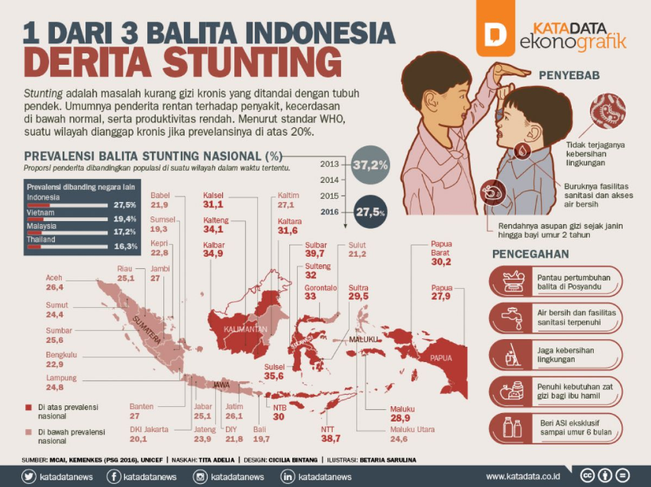
Of the 3 Indonesian Toddlers Suffer from Stunting
Source: Katadata, 2018)
Based on this figure, it can be seen that the problem of malnutrition or stunting has spread to several regions in Indonesia, where the average prevalence in each region is above 20%, so it is considered chronic. So that starting from this, we can predict and prepare for accelerated reduction to achieve the SDGs in 2030 by overcoming cases of stunting accompanied by ending hunger, achieving food security to improving nutrition. (UNICEF, 2022)
Then based on the opinion of the Director of Information and Communication for Human Development and Culture (IKPMK) which stated that 2030 Indonesia will experience a demographic bonus so that it will be dominated by the productive age group which amounts to 27.9% of the total population in Indonesia. For this reason, the acceleration of the handling of stunting is carried out so that the current generation of teenagers must be prepared to wait for this demographic bonus. (Kemensekneg, 2022)
In accelerating its handling, the government through TNP2K launched a guideline for the convergence of programs/activities to accelerate stunting prevention which involved various government institutions from the provincial government, district/city government and village government. This aims to provide coordinated and integrated interventions in a convergent manner.
Penajam Paser Utara Regency is included in the locus of the list of stunting prevention intervention policies in 100 regencies/cities with relatively high stunting rates (in terms of prevalence or number of stunting cases), which is ranked 2nd highest in East Kalimantan Province which reached 27.3% in 2021 (DPRD PPU, 2021). This is evidenced in the following figure.

Figure 2.
Level of Stunting Toddlers in Districts & Cities of East Kalimantan Province in 2022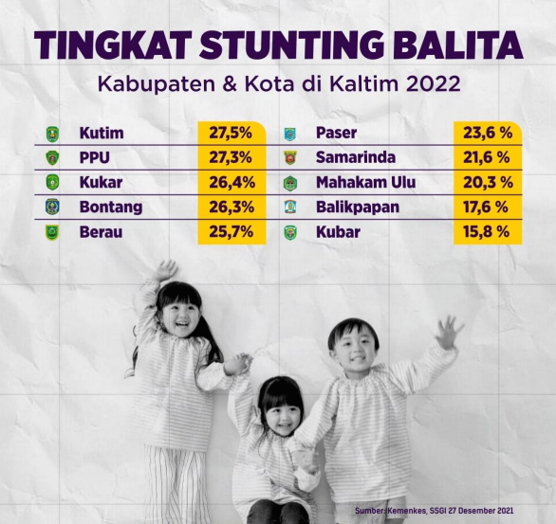
Source: Kemenkes, SSGI 27 Desember 2021
Based on the figure, it is known that the highest stunting rate in East Kalimantan Province is East Kalimantan with a total percentage of 27.5%, followed by Penajam Paser Utara with a percentage of 27.3%, Kukar with a percentage of 26.4%, Bontang with a percentage of 26.3%, Berau with a percentage of 25.7%, Paser with a percentage of 23.6%, Samarinda with a percentage of 21.6%, Mahakam Ulu with a percentage of 20.3%, Balikpapan with a percentage of 17.6% and Kubar with a percentage of 15.8%.
In this case, the government as a public servant in dealing with stunting problems greatly influences the size of stunting cases. Research result (Nurhaeni, dkk, (2021) said that the handling of stunting in the form of collaboration greatly affected children with stunting, especially during the Covid-19 pandemic.
In addition, efforts to prevent stunting are also maximized through community partnership programs through the PKM Team collaborating with Posyandu cadres to conduct counseling and training activities on hydroponic cultivation to the creation of child-friendly and safe play facilities which are also attended by the local community (Norcahyanti, dkk., 2019)
Based on the results of the previous research above, what is the difference in this study is that the author wants to analyze the forms of cooperation and coordination from various cross-sectors in achieving the target of reducing stunting rates in 2024 in accordance with Regent Regulation Number 34 of 2019 concerning Acceleration of Reduction and Prevention of Stunting that the participation of various sectors is needed by presenting cross-sectoral intervention programs to accelerate, reduce and prevent stunting in North Penajam Paser Regency.
For this reason, the authors are interested in conducting research to find out the forms of collaboration between stakeholders which are expected to provide an overview regarding collaboration in stunting management interventions in North Penajam Paser District with the title "Government Collaboration in Intervention to Prevent and Reduce Stunting in North Penajam Paser District".

LITERATURE REVIEW
Collaboration
Collaboration according to Roschelle and Teasley (Saleh, 2020) said that collaboration is more specific as a form of "reciprocal involvement of participants in a coordinated effort to solve problems together" which means that there is collaborative interaction seen from the existence of common goals, structural symmetry, and levels of negotiation, interaction, and interdependence.
Meanwhile, Camarihna-Matos and Afsarmanesh in (Saleh, 2020) stated that collaboration is a process of achieving a goal which is characterized by sharing information and designing programs between groups or individuals which will then be implemented and evaluated together.
In contrast to Wanna (Saleh, 2020) who initiated collaboration meant to work together or in collaboration with other people individually or as an organization by preparing several plans and efforts.
Based on the above understanding, it can be concluded that collaboration is a form of cooperation carried out between individuals and groups to achieve goals in accordance with what has been agreed upon.
Collaborative Governance
Ansell & Gash, (2008) defines Collaborative Governance as a governing arrangement in which one or more public institutions directly involve non-states.
Then Connick & Innes in Ansell & Gash, (2008) initiated Collaborative Governance including "representatives of all relevant interests".
Robertson dan Choi in (Astuti, dkk, (2020) stated that collaborative governance is a collective and egalitarian process in which it has an equal position in making a decision that aims to reflect aspirations in a design that will be agreed upon by stakeholders.
So it can be concluded that collaborative governance is a process of cooperation between government and non-government that is carried out for all government affairs.
Collaborative Governance Approach
In collaborative governance it can be understood that the collaboration carried out between sectors is seen from several elements described in the figure below:

Figure 3.
A Framework for Understanding Cross-Sector Collaboration
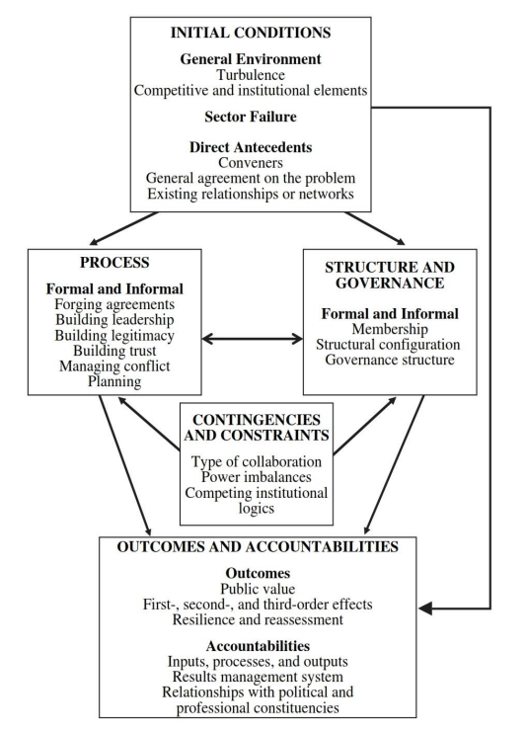
Source: (Bryson dkk., 2006)
Based on Figure 3. it can be understood that there are 5 elements in cross-sectoral collaboration which will be described below:
- Initial Condition
This condition includes environmental aspects where in forming collaborations one must see all possibilities of failure encountered. In addition, the elements of failure faced will be lighter because of cross-sectoral collaboration involving other organizations, the strength of the private sector will help and overcome failures which are considered as a form of contribution in creating public value. Then the bridging mechanism of forming collaborations needs to be considered by looking at intermediary organizations or official organizations that can facilitate collaboration formation.
- Process Components
This aspect includes initial agreements, building leadership, building legitimacy, building trust, managing conflict, and planning.
- Structure and Governance
The structure in an organization describes task specialization, procedural standards, division of labor to authority relations. This includes elements of structural context, structural configuration, and governance.
- Contingencies and Constraints
There are several factors that affect a process, structure, governance, namely the type of collaboration, the imbalance of power among members and the institutional logic that competes in collaboration (Astuti, 2020)

Stunting
World Health Organization, (2015) said stunting is a developmental disorder experienced by children due to malnutrition, repeated infections, and inadequate psychosocial stimulation. Children are defined as stunted if their height for age is more than two standard deviations below the median WHO Child Growth Standards. Meanwhile (Kemenkes RI, 2018) defines stunting as a chronic nutritional problem caused by nutritional intake that does not match nutritional needs over a long period of time. The problem of stunting occurs starting from the womb and will only be seen when the child is two years old.
Unicef in (Kemenkes, 2018) writes that stunting is defined as the percentage of children aged 0 to 59 months, with a height below minus (moderate and severe stunting) and minus three (chronic stunting), this is measured using standard child growth. issued by WHO..

Stunting Impact
The adverse effects of stunting are divided into two periods, namely:
- a. Short term, is the disruption of brain development, intelligence, physical growth disorders, and metabolic disorders in the body
- b. Long-term, is decreased cognitive ability and learning achievement, decreased immunity so that it is easy to get sick, and a high risk of developing diabetes, obesity, heart and blood vessel disease, cancer, stroke and disability in old age. (Kemendes, 2017)

In 2018, the government launched the National Action Plan for Combating Stunting in August 2017, which emphasizes convergence at the national, regional and village levels. Activities prioritized in sensitive and specific nutrition interventions are the first 1,000 days of life up to 6 years of age. In supporting this policy, there are several regulations based on:
- Presidential Regulation Number 42 of 2013 concerning the Acceleration of Nutrition Improvement
- Presidential Instruction Number 1 of 2017 concerning the Healthy Community Movement
- Presidential Regulation Number 83 of 2017 concerning Food and Nutrition Strategic Policy
Stunting Management
Treatment of stunting is carried out on the target of 1,000 First Days of Life up to 6 years through specific interventions and sensitive interventions which are described as follows:
- Spesific Nutrition Intervention
- Intervention aimed at pregnant women and children in the first 1,000 days of life
- These activities are generally carried out by the health sector
- Specific interventions are short term, the results can be recorded in a relatively short time
- Sensitive Nutrition Intervention
- Interventions are addressed through various development activities in the health sector wide
- The target is the general public, not specifically the First 1,000 Days of Life goal

RESEARCH METHODS
In this study, the type of research used is descriptive qualitative, namely the type of research that is described to describe or describe the situation or object of research (a person, institution, community and others). This type of research was used to find out about cross-sector collaboration in stunting prevention and reduction interventions in Penajam Paser Utara district.
The data collection techniques used include:
- Library and Document Research
- Field Work Research, namely collecting data by conducting observations, interviews and documentation
This study uses an interactive model of qualitative data analysis techniques. The data analysis technique used is interactive model data analysis, (Miles & Huberman, 2014) There are three flows that occur simultaneously, namely data condensation, Data Display, and Drawing and Veryfyin Conclusions.

DISCUSSION
The area of North Penajam Paser Regency is an area designated as a stunting locus. There are several villages that have become locus of stunting. This can be explained in the following table:
Table 1.
Geographical Conditions of Lokus Stunting Village in North Penajam Paser Regency in 2018
Village | Area Wide (km2)
Api-api | 179,56
Babulu Laut | 129,99
Gunung Makmur | 1.788,32
Sri Raharja | 11,605
Sumber Sari | 1.152
Labangka Barat | 2,69
Tengin Baru | 43,48
Sukaraja | 60
Karang Jinawi | 5,6
Binuang | 1.815,25
Total | 5.188
Source: processed data, 2022
Based on table 1, we can see that the villages included in the stunting locus are Api-api, Babulu Laut, Gunung Makmur, Sriraharja, Sumber Sari, Labangka Barat, Tengin Baru, Sukaraja, Karang Jinawi, and Binuang.
Stunting cases in North Penajam Paser Regency as a whole from year to year have not seen a significant reduction to reach the set prevalence target. From the table below it can be explained as follows:
Table 2.
Number of Stunting Cases from 2019 – 2022 from Withdrawal of the E-PPGBM Application
Year | Number of Stunting Cases
2019 | 525
2020 | 851
2021 | 811
2022 | 998
Source: Processed Data, 2022
One of the indicators that causes the high number of stunting in North Penajam Paser Regency is the nutritional status of pregnant women who are classified as Chronic Energy Deficiency (KEK) is higher than pregnant women who are not Chronic Energy Deficiency (KEK). This is proven in the graph below:

Chart 1.
Nutrition Status of Mothers during Pregnancy in 2018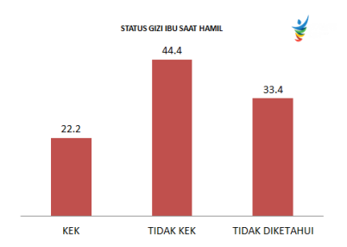
Source: North Penajam Paser Stunting Handling Report 2018
In accordance with the Regent's Regulation Number 34 of 2019 of 2019 concerning the Acceleration of Reduction and Prevention of Stunting, it is written that the District Level KP2S team is formed which involves several elements of stakeholders with the aim of carrying out the activities that have been determined.

Initial Condition
The Health Office of North Penajam Paser Regency acts as the coordinator in executing the program at the district level through the Guide to Convergence of Programs/Activities for the Acceleration of Stunting Prevention, which involves many agencies in carrying out the intervention, including Bappeda as the leading sector which plays a role in making budget systems and policies in the accelerated stunting prevention program. Then supervised by the Health Service, Public Works Service, Education Office, Food Security Service, Community and Village Empowerment Service, Other Regional Apparatus Organizations with the type of intervention that is in accordance with what has been determined.
By involving many agencies, this certainly creates complexity in program implementation resulting in cross-sectoral egos by adjusting the programs that have been guided by the agency's program so that the program becomes less optimal because the form of coordination is carried out separately. The Covid-19 pandemic has also hampered the program because socialization on the acceleration of stunting reduction, which was previously carried out in junior and senior high schools, can now only be carried out door to door to the target group, namely teenagers and pregnant women. So that in an effort to accelerate stunting prevention in North Penajam Paser Regency, it is very dependent on the North Penajam Paser Regency Health Office where as the district level coordinator can reach all agencies to carry out special evaluations regarding collaboration in the program so as to maximize the program.

Processed Components
The division of tasks and functions in carrying out interventions to accelerate the handling of stunting is clearly written in the guidelines and Regent Regulation Number 34 of 2019 of 2019 concerning the Acceleration of Decline and Prevention of Stunting where the roles assigned are in accordance with the duties and functions of each agency by involving several parties such as TP. -PKK, Village Facilitator Coordinator, Healthy District Forum, Business World/community organizations and the Ministry of Religion. One of the efforts that has been carried out is to collect data in each village and provide PMT food to pregnant women so that they can intervene as early as possible through monitoring and supervision. In this case, the implementation of the program originates from sources of state revenue and expenditure budget, provincial revenue and expenditure budget, regional revenue and expenditure budget, and village revenue and expenditure budget as well as other legal and non-binding sources in accordance with statutory provisions.

Structure and Governance
The standard procedure for reducing stunting only goes according to the convergence guidelines for programs/activities to accelerate stunting prevention, as stated in Regent Regulation Number 34 of 2019 concerning the Acceleration of Stunting Decline and Prevention, that cross-sectoral programs must run in an integrated manner through program development:
- Population family planning and family development
- Healthy living community movement
- Maternal and child health
- Improving community nutrition and preventing stunting in villages and sub-districts
- Population administration
- Religious coaching through the Ta'lim assemblies and Couples of Reproductive Age
- The strategic issue of stunting
- Publication of stunting
- Food self-sufficiency
- Development of business support systems for micro, small and medium enterprises
- Drinking water and sanitation
- Improving the quality of nutrition and food safety
Currently, the North Penajam Paser District Health Office is conducting monitoring and supervision through the E-PPGBM application which is one of the strategies for data collection that aims to make it easier to carry out stunting interventions as early as possible through the 1,000 HPK program and priority in giving PMT food to pregnant women. Efforts to increase the capacity of human resources in the program are by participating in several trainings and the Regional Working Meeting at the East Kalimantan Province level with the theme "Stunting Prevention, TB elimination and immunization". In addition to setting up cadres in each village/kelurahan so that supervision and monitoring of nutritional health can run well.
Coordination of stunting counseling in North Penajam Paser Regency is carried out once a year where in determining the locus of stunting each year it is seen from the initial data analysis which aims to determine the locus of evaluation by preparing a plan using 8 actions by the KP2S Team with predetermined performance.

Contingencies and Constraints
- Inadequate budget so that training for cadres becomes less effective
- The Covid-19 pandemic has hampered the program and diverted funds for Covid-19 vaccinations
- Health facilities such as anthropometric equipment at some posyandu are inadequate, which affects the accuracy of measuring height and weight
- The lack of coordination between agencies that makes the program run independently
- Lack of transparency in aid funds, making it difficult to determine which budget to use.

CONCLUSSION
Based on the results of the research, intervention efforts to prevent and reduce stunting, in addition to referring to changing the mindset of upbringing and eating patterns, also depend on the ability of local governments to carry out and maximize their roles and tasks in accordance with established guidelines and regulations. The North Penajam Paser District Health Office has made efforts to prevent and reduce stunting through the 1,000 HPK program in collaboration with other agencies in accordance with the implementation of the program contained in the Regent Regulation Number 34 of 2019 concerning the Acceleration of Reduction and Prevention of Stunting and its role in the guidance for acceleration of program/acceleration convergence stunting prevention.
So far the program has been running although it hasn't made any major changes in its handlers. This is influenced by various obstacles and obstacles that make its implementation less effective in efforts to prevent and reduce stunting in North Penajam Paser Regency.

RECOMMENDATION
- Carry out regular monitoring and evaluation with all agencies involved to increase cooperation and transparency in program implementation
- Organize special supervisory cadres to monitor the cadres of each village to check the accuracy of the data
- Procurement of health facilities in the form of anthropometric devices to support the acceleration of stunting reduction

REFERENCES
Ansell, C., & Gash, A. (2008). Collaborative governance in theory and practice. Journal of Public Administration Research and Theory, 18(4), 543–571. https://doi.org/10.1093/jopart/mum032
Bryson, J. M., Crosby, B. C., & Stone, M. M. (2006). The design and implementation of cross-sector collaborations: Propositions from the literature. Wiley and American Society for Public Administration, 66(SUPPL. 1), 44–55. https://doi.org/10.1111/j.1540-6210.2006.00665.x
Mashar, S. A., Suhartono, S., & Budiono, B. (2021). Faktor-Faktor yang Mempengaruhi Kejadian Stunting pada Anak: Studi Literatur. Jurnal Serambi Engineering, 6(3), 2076–2084. https://doi.org/10.32672/jse.v6i3.3119
Matthew B. Miles, A. M. H. and J. S. (2014). Qualitaive Data Analysis (3rd ed.). Sage Publications, Inc.
Retno Sunu Astuti, Hardi Warsono, A. R. (2020). Collaborative Governance dalam Perspektif Administrasi Publik. Universitas Diponegoro Press.
Saleh, C. (2020). Konsep, Pengertian, dan Tujuan Kolaborasi. In Dapu6107 (Vol. 1, pp. 7–8).

Legislation:
Regent Regulation Number 34 of 2019 concerning Accelerating the Reduction and Prevention of Stunting
Internet Source:
RI, P. K. (2018). 1 Dari 3 Balita di Indonesia Derita Stunting. Kementrian Kesehatan Republik Indonesia. http://p2ptm.kemkes.go.id/tag/1-dari-3-balita-indonesia-derita-stunting
Berita, M. (2022). Percepatan Penurunan Stunting, Remaja Adalah Kunci! Kementrian Sekretatriat Negara RI Sekretariat Wakil Presiden. https://stunting.go.id/percepatan-penurunan-stunting-remaja-adalah-kunci/
World Health Organization (WHO). (2015). Stunting in a Nutshell. World Health Organization. https://www.who.int/news/item/19-11-2015-stunting-in-a-nutshel
UNICEF. (2022). Malnutrition in Children. UNICEF DATA. https://data.unicef.org/topic/nutrition/malnutrition
Utara, K. P. I. dan K. P. D. K. K. P. P. (2021). AGM ajak Komitmen bersama dalam Penurunan dan Pencegahan Stunting di PPU. Pemerintah Kabupaten Penajam Paser Utara. http://dprd.penajamkab.go.id/2021/06/14/ppu-masuk-100-kabupaten-kota-yang-jadi-agenda-prioritas-pembangunan-nasional-agm-ingatkan-stunting-artikel-ini-telah-tayang-di-tribunkaltim-co-dengan-judul-ppu-masuk-100-kabupaten-kota-yang-jadi-ag/
Kemenkes. (2018). Mengenal Stunting dan Gizi Buruk. Penyebab, Gejala, Dan Mencegah. Kementrian Keseharan Republik Indonesia. https://promkes.kemkes.go.id/content/?p=8486

Other Sources:
Village Pocket Book in Handling Stunting, Documents from the Ministry of Villages, Development of Disadvantaged Regions, and Transmigration, 2017.
Report on Handling Stunting in Penajam Paser Utara District
Guide to Convergence of Programs/Activities for the Acceleration of Stunting Prevention (Official Handbook of Regional Apparatus Organizations, , Documents of the National Team for the Acceleration of Poverty Reduction (TNP2K), 2018.

