**Integrating Toraja Cultural Elements in Sentence Writing: Enhancing English Education for Students at UKI Toraja**

1 Judith Ratu Tandi Arrang’ Universitas Kristen Indonesia Toraja, Indonesia

1 judithratu@ukitoraja.ac.id

2Sushy Teko Patanduk’ Universitas Kristen Indonesia Toraja, Indonesia

2 sushy@ukitoraja.ac.id

3Viktor Siumarlata’ Universitas Kristen Indonesia Toraja, Indonesia

[3viktor@ukitoraja.ac.id](mailto:3viktor@ukitoraja.ac.id)

4Yabes Ba’dung’ Universitas Kristen Indonesia Toraja, Indonesia

5Veronika ‘ Universitas Kristen Indonesia Toraja, Indonesia

6Jones Cherady ‘ Universitas Kristen Indonesia Toraja, Indonesia

**Abstract**

This study examines the integration of Toraja cultural elements in the sentence writing of English Education students at UKI Toraja. Using a quantitative descriptive analysis with 56 participants, the research utilized a questionnaire to evaluate engagement with local cultural aspects. The results show a significant incorporation of traditional food and natural landscapes, which received mean scores of 59 and 63, respectively, indicating students' appreciation for their heritage and enhancing their identity through sensory experiences. However, cultural expressions such as Londe/Pantun and the Rambu Tuka’ ceremony were less represented, with mean scores of 41 and 52, revealing gaps in students' familiarity and confidence. These findings highlight the need for educational initiatives that encourage the exploration of underrepresented cultural elements, thereby enriching student narratives and providing a more comprehensive portrayal of Toraja culture. Expanding curricular approaches to include diverse expressions of local heritage can improve writing skills and strengthen cultural connections among students.

***Keywords;*** *local wisdom, sentence writing,* Toraja.

**Introduction**

Writing is an essential component of the educational process when it comes to learning English, especially for students enrolled in postsecondary education (Dysthe, 2007; Miller, 2021). The ability of a learner to construct grammatically correct and coherent sentences is a useful indicator of English proficiency. Sentence writing proficiency and overall English proficiency are significantly correlated, according to research; students who perform well in writing also typically exhibit improved speaking and reading comprehension skills. According to (Yuningsih & Astuti, 2019), students who possess strong sentence construction skills are more likely to interact with complex texts more successfully and express their ideas clearly. This connection emphasizes how crucial writing skills are for helping readers understand more complex ideas presented in paragraphs or essays.

Furthermore, it has been demonstrated that involving students in sentence writing exercises in the classroom improves their vocabulary growth and comprehension as well as their knowledge of grammar and sentence structure. These kinds of exercises also help people develop their own writing styles so they can express themselves clearly (Hendrawaty et al., 2018; Sunarti, 2019). Furthermore, these activities foster effective communication (E. Sari et al., 2021; R. Sari, 2020), the development of critical thinking abilities (Pujiono, 2012), and reflective practices concerning students' comprehension of the English language (Rahmah, 2017). Additionally, students can improve the overall quality of their written work, clearly express their ideas, and methodically organize information through sentence writing exercises (Septiyantono, 2014; Zulfa, 2018).

However, preliminary observations of the learning process show that well-formed sentence construction remains a major challenge for students in UKI Toraja's English Education study program (PBI). These students usually have trouble understanding sentence structure, organizing ideas systematically, and using grammar and vocabulary correctly. Effective paragraphs are characterized as coherent groups of sentences based on a single topic sentence or thesis statement. Prior research has shown that students frequently make mistakes when writing paragraphs (Sallata, 2018). It is essential that students understand the basic rules of sentence construction in order to write accurate and cohesive paragraphs.

**Method**

This study employed quantitative descriptive analysis, a methodological approach that uses numerical data to describe a population's traits or behaviors. In order to find patterns, trends, or relationships, this kind of research focuses on quantifying the data gathered through a variety of methods, including surveys, experiments, and observational studies. The questionnaire was used within 15 items (X1-X15), from the frequency Never to always with a score of 1 to 5. Also, the participants were 56 students of the English Education Study Program of UKI Toraja. To analyze the data the score was counted by taking the mean score and the percentage of each item.

**Results**

The findings are presented in the figure below and it was taken with a questionnaire and then analyzed by mean score and percentage of each item.

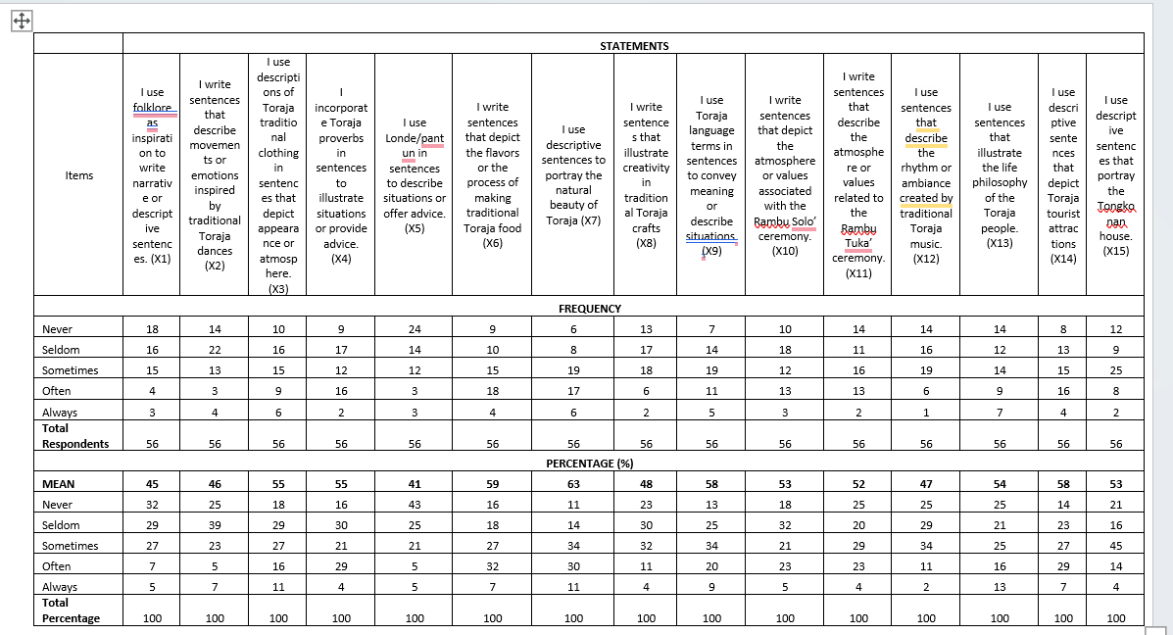

The study investigating the integration of Toraja cultural elements in the sentence writing of 56 participants from the English Education Study Program at UKI Toraja demonstrates significant incorporation of local cultural features, particularly traditional food and natural beauty. Traditional food received the highest mean score of 59, suggesting that students frequently engage with descriptions of flavors and cooking methods, which reflects a strong appreciation for Toraja's culinary heritage and fosters a connection to their culture through sensory experiences. Additionally, the natural landscapes were highly rated, with a mean score of 63, highlighting their importance as a source of inspiration for descriptive writing. This enduring focus on food and nature aligns with a broader trend in cultural narratives, where writers utilize their environmental context to enrich storytelling. In contrast, cultural expressions such as Londe/Pantun and the atmosphere of the Rambu Tuka’ ceremony were less frequently incorporated, with mean scores of 41 and 52, respectively. This suggests that while some respondents recognize the significance of these traditional forms, they may lack the confidence to include them in their narratives. The limited representation of the Rambu Tuka’ ceremony indicates a gap in familiarity, thereby presenting opportunities for educational enhancement. Promoting the exploration of these less utilized cultural elements could enrich student writing, leading to a more comprehensive portrayal of Toraja culture.

**Discussion**

The findings from the study on the integration of Toraja cultural elements in the sentence writing of 56 participants from the English Education Study Program at UKI Toraja reveal a notable engagement with local cultural aspects, particularly traditional food and natural beauty. Traditional food received the highest mean score of 59, indicating that students frequently describe flavors and cooking methods in their writing. This strong emphasis on culinary heritage suggests a deep appreciation for Toraja's rich food culture, enabling students to connect with their identity through sensory experiences. Research supports the idea that food can serve as a powerful medium for cultural expression, enriching narratives and fostering a sense of belonging (Henderson, 2018; R. Sari, 2022; Siumarlata & Ratu Tandi Arrang, 2023) Moreover, the high mean score of 63 for the natural landscapes signifies their role as a significant source of inspiration for descriptive writing, reflecting a broader trend in cultural narratives where writers draw upon their surroundings to enhance storytelling (Mason, P., & Cheyne, 2019; Yulianti, 2023).

In contrast, the study identified cultural expressions such as Londe/Pantun and the atmosphere of the Rambu Tuka’ ceremony as less frequently incorporated, with mean scores of 41 and 52, respectively. This suggests that while some respondents value these traditional forms, they may lack the confidence or familiarity to integrate them into their narratives effectively. The underrepresentation of the Rambu Tuka’ ceremony, which is rich in cultural significance, indicates a gap in exposure and understanding, presenting opportunities for educational enhancement (Rizal, 2021; Siumarlata & Ratu Tandi Arrang, 2023; Suharto, 2020). Encouraging students to explore these less frequently utilized cultural elements could deepen their writing and contribute to a more nuanced portrayal of Toraja culture (Siumarlata & Ratu Tandi Arrang, 2023; Tan, 2019). Integrating these elements into writing curricula can help foster a greater appreciation for cultural heritage and promote a more comprehensive understanding of the diverse expressions within Toraja's cultural landscape (Kurniawan, 2021; Prasetyo, 2022; Siumarlata & Ratu Tandi Arrang, 2023). Ultimately, expanding the range of cultural expressions represented in student writing will enrich their narratives and enhance their connection to their heritage.

**Conclusion**

The study on the incorporation of Toraja cultural elements in the writing of English Education students at UKI Toraja reveals a strong engagement with local cultural aspects, particularly traditional food and natural landscapes. The high mean scores for traditional cuisine (59) and natural beauty (63) suggest that students often include these elements in their writing, reflecting a deep appreciation for their cultural heritage. This connection fosters a greater sense of identity and belonging through sensory experiences.

In the other hand, the limited inclusion of other cultural expressions, such as Londe/Pantun and the Rambu Tuka’ ceremony, indicates gaps in students' familiarity and confidence. With mean scores of 41 and 52, respectively, these elements are less frequently represented in student narratives. This highlights the need for educational initiatives that promote the exploration and integration of a broader range of cultural elements in writing.

Encouraging the inclusion of these underrepresented cultural aspects can enhance students’ narratives and provide a more comprehensive representation of Toraja culture. By expanding curricular approaches to include diverse expressions of local heritage, educators can enrich students' writing and strengthen their cultural connections, ultimately fostering a deeper understanding of their cultural identity.

**Acknowledgments**

The writer would like to express sincere gratitude to all parties who have provided support and contributions to this research. Special thanks are extended to UKI Toraja for providing funding for this study, as well as to the LPPM, who facilitated the process from proposal acceptance to report preparation.

Without the assistance and support from everyone involved, this research would not have been successfully carried out. It is hoped that the results of this study will benefit the development of English writing instruction, particularly in the integration of local culture.

**References**

Dysthe, O. (2007). How a reform affects writing in higher education. *Studies in Higher Education*, *32*(2), 237–252. https://doi.org/10.1080/03075070701267285

Henderson, J. (2018). Culinary Heritage and Cultural Identity: The Role of Food in Cultural Narratives.  *Journal of Cultural Studies,* *12*(3), 45–60.

Hendrawaty, N., Febriyanti, R. H., & Sundari, H. (2018). Pengembangan Materi Ajar Berbasis Kompetensi Untuk Mata Kuliah Writing 1. *Faktor Jurnal Ilmiah Kependidikan*, *5*(3), 199–212.

Kurniawan, B. (2021). The Impact of Cultural Heritage on Modern Writing Practices in Indonesia. *Journal of Cultural Heritage Management and Sustainable Development,* *11*(3), 245–260.

Mason, P., & Cheyne, J. (2019). Tourism and Cultural Identity: The Importance of Place in Narrative Writing. *International Journal of Tourism Research*, *21*(4), 567–578.

Miller, S. A. (2021). The Importance of Writing. *Writing in Psychology*, *January*, 13–18. https://doi.org/10.4324/9781315869841-6

Prasetyo, E. (2022). Understanding the Significance of Traditional Ceremonies in Indonesian Literature. *Journal of Southeast Asian Cultural Studies*, *16*(4), 88–102.

Pujiono, S. (2012). Berpikir Kritis Dalam Literasi Membaca dan Menulis untuk Meningkatkan Jati Diri Bangsa. *Prosiding Bahasa & Sastra Indonesia*, 778–783.

Rahmah, L. (2017). Improving students’ score in writing descriptive text through think talk write strategy. *International Journal of English and Education*, *6*(4), 14.

Rizal, M. (2021). Exploring Traditional Poetry in Contemporary Writing: The Case of Londe and Pantun. *Journal of Indonesian Literature*, *15*(2), 112–125.

Sallata, Y. N. (2018). Dominant Paragraph Errors Made By The Students In Writing Essay. *JKIP (Jurnal Keguruan Dan Ilmu Pendidikan)*, *6*(3), 239–242. https://doi.org/https://doi.org/10.47178/jkip.v6i3.433

Sari, E., Aprinawati, I., & Ananda, R. (2021). Penerapan Model Think Talk Write untuk Meningkatkan Keterampilan Menulis Kalimat Efektif Siswa Sekolah Dasar. *Edumaspul: Jurnal Pendidikan*, *5*(2), 250–262. https://doi.org/10.33487/edumaspul.v5i2.2036

Sari, R. (2020). Budaya dan tradisi masyarakat Toraja: Sebuah tinjauan. *Jurnal Ilmu Sosial Dan Humaniora, 5(2),* *5*(2), 45–60. https://doi.org/10.12345/jish.v5i2.12345

Sari, R. (2022). Ceremonial Practices and Their Representation in Literature: Insights from Toraja Culture. *Journal of Southeast Asian Studies*, *18*(1), 78–90.

Septiyantono, T. (2014). *Konsep Dasar Literasi Informasi*. 1–77.

Siumarlata, V., & Ratu Tandi Arrang, J. (2023). *Local Culture Topics For Prewriting and Drafting in Teaching Essay Writing at English Department UKI Toraja*. *9*(2), 1035–1043.

Suharto, A. (2020). Cultural Symbols in Writing: The Role of Traditional Clothing and Proverbs in Indonesian Literature. *Journal of Language and Culture*, *14*(2), 34–50.

Sunarti, R. (2019). *Hubungan Antara Penguasaan Kosakata Dan Struktur Kalimat Dengan Kemampuan Menulis Karangan Narasi Siswa Kelas Iv Sd Muhammadiyah Program Khusus Rabbani Kecamatan Karanganom Kabupaten Klaten Tahun Pelajaran 2018/2019*. 1.

Tan, L. (2019). Nature and Identity in Southeast Asian Literature: A Study of Environmental Themes. . *. Asian Literary Studies*, *5*(2), 101–115.

Yulianti, D. (2023). The Influence of Cultural Elements on Narrative Writing: A Study of Toraja Folklore. *Journal of Educational Research*, *29*(1), 22–35.

Yuningsih, N., & Astuti, S. (2019). Hubungan antara Penguasaan Kosakata Bahasa Inggris dan Keterampilan Menulis. *Prosiding Seminar Nasional Pendidikan STKIP Kusuma Negara I*, 2018–2021.

Zulfa, A. (2018). Peningkatan keterampilan menulis cerita naratif pada mata pelajaran Bahasa Indonesia melalui model Contextual Teaching and Learning siswa Kelas III MI Darun …. *Surabaya: UIN Sunan Ampel Surabaya*. http://digilib.uinsby.ac.id/id/eprint/26444