Author Statement Form:

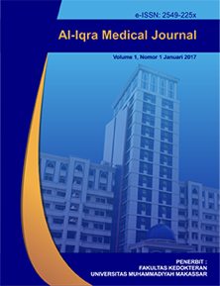

Manuscript Originality and Copyright Transfer Agreement

Al-Iqra Medical Journal : Jurnal Berkala Ilmiah Kedokteran

ISSN [2549-225X](http://u.lipi.go.id/1482292428) (online)

<https://journal.unismuh.ac.id/index.php/aimj/index>

Name of Principal/Corresponding Author*

dr. Fredy Ciputra

Address of Principal/Corresponding Author*

RSUD WANGAYA, DENPASAR, BALI

Telephone*

082281009629

E-mail*

fredyciputra@gmail.com

All author(s) name*

dr. Fredy Ciputra

dr. Ni Made Dwipayani, M. Biomed, Sp.M

Date of submitted*

15 June 2022

Manuscript title*

Computer Vision Syndrome: Sebuah Tinjauan Pustaka

1. Declare that the article above is original. my own thoughts not translated, and has not been published elsewhere or currently not in the process of other journal publications. I am willing to be responsible if there are parties who feel disadvantaged privately and/or based on a lawsuit in the future by the publication of this article.
2. I also declare that any and all rights in and to the article including, without limitation, all copyrights are transferred to Al-Iqra Medical Journal : Jurnal Berkala Ilmiah Kedokteran. Therefore, the copyright transfer hands it the power and authority to edit, reproduce, distribute copies, and to publish the article partly or fully.

Corresponding Author’s Name & Signature

15 June 2022

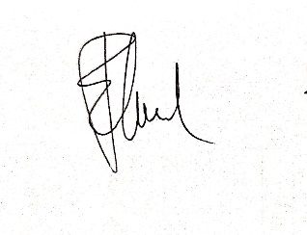

dr. Fredy Ciputra