**Otoritas : Jurnal Ilmu Pemerintahan VOL. 48, NO. 5, 821–841**

**DOI: https://doi.org/10.26618/ojip.v12i2.7415**

**THE EVOLUTION OF DIGITAL GOVERNANCE: A BIBLIOMETRIC ANALISIS**

**Abstract (Segoe UI, 10pt Bold)**

This paper conducts a comprehensive bibliometric analysis of the research environment in digital governance, tracking its evolution over time using the Scopus database and highlighting the main trends, influential publications, most contributing keywords, most contributing authors, most contributing journals, and most contributing and influential countries in digital governance research. Following data collection, a bibliometric analysis is performed, with the results shown using the VOSviewer software. The Scopus database offers 745 papers published between 2006 and 2024, with 1746 authors, 3800 keywords, 460 journal sources, 1385 organizations and affiliates, and partnerships from 94 countries These data reveal a significant growth in publications and collaboration, highlighting the growing importance of digital governance in addressing contemporary problems in the digital age. The analysis also reveals a shift in research priorities, from fundamental theory to practical applications and emerging technology. According to the findings, contemporary research is primarily concerned with issues such as digital governance, digital transformation, e-government, sustainable development, decision-making, governance approach, artificial intelligence, smart cities, digital economy, and digitalization. This paper also finds that China has conducted the most digital governance research (172 publications), yet the United States is the most influential. China has been the most active country in digital research due to numerous factors, including significant investment in research and development, particularly in the field of digital research. The Chinese government and corporate sector actively support research endeavors by providing funding and resources, technical advancement, government policy, a high number of researchers, an emphasis on digital transformation, and international collaboration. Although China has the most publications, the United States has more influence in the field of digital governance due to publication volume versus impact and influence, academic quality and influence, leading innovation and practice, international collaboration and global influence, and diverse research contexts.

**Keywords:** *Digital transformation, E-Government, Artificial Intellegence, Bibliometrics, Technology Adoption.*

*)Penulis Korespondensi

E-mail : [mimin.sundari@lecturer.unri.ac.id](mailto:mimin.sundari@lecturer.unri.ac.id)

**Introduction**

The rise of digital governance is becoming a more popular and relevant topic in political science and government research. Understanding trends, patterns, and developments in digital governance becomes critical as the world transitions to an era where digital technology plays a critical role in governance structures (Liao, H., Tang et al., 2018), (Caviggioli & Ughetto, 2019), (Y. Meng et al., 2022), (Schraven et al., 2021), (Aprilia & Nandiyanto, 2022), (Rasyid, 2022), (F. Ahmed et al., 2024). Bibliometric analysis, a quantitative tool for analyzing academic literature, can help understand the history of digital governance by mapping the research environment, identifying major contributors, and highlighting new trends.

Several prior studies have examined the influence of digital governance on tourism, demonstrating that the capacity and practice of internet shutdowns affect incoming tourism. Tourists are also prevented from entering through social media surveillance with strict guidelines. The study discovered that practical sensors' governance capability and consequences had a negative impact on tourism activities. Some policy concerns for adequate digital communication control are also addressed (Gozgor et al., 2024). Digital finance is a key accelerator for today's economic system, and it plays an important role in developing a resilient city core based on innovation and transformation processes. The depth of digital finance utilization has the greatest influence, followed by the amount of digitalization (Z. Wang et al., 2023), (W. Zhang et al., 2024). Furthermore, decentralized autonomous organizations (DAOs) are a relatively new sort of online entity related to governance or business models that provides a decision-making process aimed at facilitating digital governance and collaboration (Valiente & Pavón, 2024). Electoral organizers should be cognizant of the fact that technology-based recapitulation data has the potential to serve as digital evidence for adversarial parties in electoral courts(Habibi et al., 2023). The recommendations aim to enhance public services by leveraging current digital service applications and incorporating not yet integrated public services with digital-based services (Prihatin et al., 2023).

Another study emphasizes the necessity of technology pathways in digital governance for ensuring economic and legal compliance while managing digital resources, eventually fostering sustainability (Wan et al., 2024). Improving the quality of ecology and the environment is dependent on environmental governance capacities, which can be greatly enhanced by the use of digital technology. The digital economy has hurt regional environmental governance. Furthermore, the mismatch between government website construction and environmental governance capacity can be seen in digital governance (Kong et al., 2023), (He et al., 2024). In an ever-changing digital context, government digital development has become inextricably tied to modern governance frameworks. These data show that the government's digital development considerably increases carbon efficiency. The threshold regression analysis results demonstrate that the government's digital development is negatively connected with carbon efficiency when it falls below a particular level. This detrimental effect, however, diminishes when the government's digital development exceeds the threshold value (Z. Chen et al., 2024). Another study critically investigates the concept of a decentralized, privacy-preserving Bluetooth-based contact tracing framework suggested by global tech companies, which may jeopardize state sovereignty when selecting public health responses to current or future crises (Mann et al., 2024).

Other studies in this paper suggest coping methods to assist stakeholders in cooperatively producing public value through technical, organizational, and environmental (TOE) solutions. The paper contributes to the discipline by describing the contradictory landscape of digital governance and proposing alternative solutions (Y. Wang et al., 2024). Digital governance technologies provide new solutions by allowing for real-time data collection, conflict resolution, and community interaction. To successfully integrate digital governance into animal conservation, a holistic approach is required, which includes infrastructural improvements, education, cultural sensitivity, and economic accessibility. The study sheds light on the obstacles and potential of applying digital solutions, emphasizing the necessity of community engagement in sustainable conservation practices (Tripathi & Singh, 2024).

Estonia is known around the world as a "digital country" or "e-country." Despite its achievements in digital governance, the country has had hurdles in the field of open government data (OGD), but it has made great progress in the OGD ecosystem. This study adds to our understanding of Estonia's dynamic path through the OGD environment, shedding light on accomplishments and areas that need to be addressed further to develop a sustainable open-data ecosystem (Rajamäe-Soosaar & Anastasija, 2024). The term 'digitalization' in public administration, which is a synonym for 'e-government', refers to the application of rapid and secure procedures by administrative authorities. E-governance, often known as digital governance, is the use of innovation and technology in public administration. This article looks at e-government issues such as e-services, e-participation, personal data privacy, and how e-government adoption affects public administration efficiency (Tskhadadze, 2024). Today's digital governance poses challenges in the context of ports, where efficiency and transparency are critical to successful operations. Efficient public-private collaboration on digital governance enhances port competitiveness. Data security requires a regulatory framework, and digital governance is becoming increasingly important for global success (González-Cancelas et al., 2024).

Other research on digital governance suggests that there is a considerable discrepancy in the degree of digital governance in Chinese counties and villages, with each region showing a reduction in the spatial distribution of "east-center-west" (T. Wang et al., 2024). The entropy approach is used to obtain dimensions for assessing digital economic indicators, green technological innovation, and ecological environmental quality. Digital governance and green technology innovation have a fairly direct impact on environmental status and governance (Li et al., 2024). Another paper investigates applicable ideas and practices for improving access to digital justice, as well as opportunities to broaden the use of online dispute resolution (ODR) for dispute prevention in online commercial operations (Y. Zhao & Chen, 2024).

Using information and communication technology in traditional governance systems, such as digital or electronic governance (EGOVT), can help to reduce the negative impact of resource abundance on growth (C. Wang et al., 2024). With the profound integration of technology and finance, the governance impact of digital transformation has become a key topic of discussion in corporate governance. Corporate digitalization promotes corporate governance by providing new governance insights to help drive the evolution of high-quality capital markets (H. Jiang et al., 2024). The empirical impact of digital governance (DIG) on the human development index (HDI) utilizing the ARDL technique is substantiated by causality evaluation results (Zhou et al., 2024). Another model emphasizes the potential mediatory function of people's views of the Digital Governance Footprint (DGF) and Mental and Emotional Models (MEMO)(Vigoda-Gadot & Mizrahi, 2024).

Another study underlines the importance of technology pathways in digital governance for ensuring economic and legal compliance while managing digital resources, thereby promoting sustainability (Wan et al., 2024). Improving the quality of ecology and the environment is dependent on environmental governance capacities, which can be significantly improved through the use of digital technology. The digital economy has harmed regional environmental governance. Furthermore, the gap between government website creation and environmental governance competence is visible in digital governance (Saha, 2024). Other research investigates how environmental legislation and digital governance affect the resource curse. The impact of moderation demonstrates that e-governance and environmental restrictions are critical to promoting economic growth. The usual smallest feasible square yields a similar result. Granger's causality test demonstrates bidirectional causality among all model variables and provides useful policy implications (Ding, 2022).

Government digital development has become inextricably tied to modern governance frameworks in a quickly changing digital context. These findings show that government digital progress is inversely connected with carbon efficiency when it falls below a specific level. This detrimental effect, however, diminishes when the government's digital development exceeds the threshold value (Lu et al., 2024). Then (Mann et al., 2024) critically analyze the concept of a decentralized and privacy-preserving Bluetooth-based contact tracing framework suggested by global technology corporations, which could jeopardize a country's sovereignty when selecting public health responses to present or future crises. Meanwhile, (Y. Wang, Qi, et al., 2024) investigate the complexities of the conundrum in digital governance and propose viable solutions. Digital governance and green technology innovation have a fairly direct impact on environmental status and governance. These findings lay the groundwork for fostering coordinated collaboration between the digital economy and green technology innovation, as well as advancing the formation of a win-win scenario between economic development and environmental protection (C. Wang et al., 2024).

An interpretive approach to investigating how local policymakers describe and justify their own visions of digital governance initiatives at the city level helps to understand the various interpretations that underpin the development of digital governance initiatives.Local governments can adaptably use smart technology as an instrument to address a wide range of environmental, social, and economic problems based on where smart urban technologies should be framed as a means to solve different social problems and achieve different policy goals—not the goals themselves (Esposito et al., 2024).

Digitalization presents new challenges to liability standards as traditional actors, such as newspapers, fade into the background and new players, such as platforms, take the stage. The following article investigates how liability laws respond to the transfer of power from one group of actors to another, with a focus on autonomous systems and digital platforms (Wagner, 2024). Climate governance ability is vital to long-term progress, and data aspects play a significant role in current governance. The study (Wen et al., 2024). investigates the trajectory and options for digital transformation in climate governance. At the same time, energy prices and open trade have a major negative impact on natural resource management (Si Mohammed et al., 2024).

A robust digital governance mechanism that prioritizes the well-being of customers and society demonstrates the strengthening of guidelines through the process of understanding the organization and encourages the integration of responsible CAs that adhere to ethical principles and social values (Sidaoui et al., 2024). In recent years, Bangladesh has experienced a revolutionary shift toward digitalization as a key driver of citizen security and economic growth. The implementation of digital governance has streamlined administrative processes, reduced bureaucratic bottlenecks, and increased the efficiency of public services. Bangladesh's ongoing digitalization initiatives have emerged as a powerful catalyst for citizen safety and economic prosperity. As the country continues to embrace digital transformation, a deliberate and inclusive approach is required to fully realize the potential of digitalization and provide a resilient, secure, and prosperous future for its residents (Abdullah-Al-Faruk, 2024) .

Increasing the government's digital governance capacity makes a substantial contribution to green and sustainable development. The government's digital governance primarily encourages natural resource management through two mechanisms: green technology innovation and intellectual property protection, with quality taking precedence over quantity. The impact of improved government digital governance on natural resource management varies greatly depending on city types, political levels, urban locations, and human capital levels (K. Chen et al., 2024). Ethical and governance issues concerning the development of digital innovations such as artificial intelligence have sparked much debate and research, with opportunities and relevance in driving effective digital innovation governance that considers the potential risks of AI while identifying business and social opportunities (Salgado-Criado et al., 2024).

The importance of contextualizing the pandemic response's digital transformation within a democratic framework. Taiwan's history differs dramatically from that of other Asian authoritarian countries, illustrating the feasibility of taking digital measures without relying solely on the virus and society to oversee the digital pandemic and its repercussions in general (Perng et al., 2024). Digital governance covers a wide range of topics, including the use of digital technology in public administration, e-governance projects, data-driven decision-making procedures, and the digital transformation of entire government activities. In addition, to achieve meaningful progress, global collaboration and the establishment of universal digital governance standards are essential. By focusing on creating an inclusive digital ecosystem, encouraging policy innovation, and ensuring broad digital literacy, governments can lay the foundations for a sustainable, economically prosperous, and gender-inclusive digital society (Bhattacharya, 2024). This highlights the potential of the digital government approach, which is increasingly prioritizing public participation. With an overarching goal, this study seeks to expand our understanding of the growth of digital governance in China, providing useful insights into its likely future path. This contribution greatly informs discussions on policy formulation and the sustainable growth of digital governance, presenting nuanced viewpoints with a sharp focus on Chinese practices that illuminate the contemporary digital governance (Guo & Zhang, 2024).

The study adds vital empirical evidence to the subject of e-government and cybersecurity, providing insights that can help influence evidence-based policy decisions and resource allocation. Understanding the complicated factors at play allows Saudi Arabia to strengthen its digital governance infrastructure and provide safe and high-quality e-government services to its constituents (Al-Hawamleh, 2024).It also dives into Morocco's tax issues, which are highlighted by huge revenue shortages revealed by the IMF. In essence, this study investigates the relationship between digitization in tax administration and taxpayer behavior, with a particular emphasis on tax avoidance (Belahouaoui & Attak, 2024).

Researchers can use bibliometric analysis to follow the evolution of digital governance research, from its genesis to its current status. Scholars can gain a thorough understanding of how knowledge in the field of digital governance has evolved and diversified by analyzing publishing trends, citation patterns, and collaboration networks (C. Meng et al., 2020),(Z. Jiang, 2023). Researchers can analyze the progress of publications in this domain, discover works that have affected the discourse, and uncover gaps in existing research that need to be filled (Wahyudin, 2023)(Qirani, 2023). Understanding the global landscape of digital governance research is critical for fostering collaboration, exchanging best practices, and solving common difficulties encountered by governments worldwide (Raman et al., 2024). In addition to mapping the existing body of knowledge regarding digital governance, bibliometric analysis can aid in identifying emerging research subjects and areas for innovation in the field (Máté et al., 2024). Researchers in digital governance can uncover hot themes, innovative techniques, and prospective future directions by displaying the network of co-citations and keyword groupings (Hassan & Duarte, 2024) This foresight is crucial as it guides policymakers, practitioners, and scholars in designing the future of digital governance efforts.

Digital governance is becoming increasingly vital in an age when information and communication technology play a critical role in many facets of modern society's life. This notion not only calls for the use of technology to promote government efficiency and openness, but it also introduces new issues in data management, privacy, and information security. Rapid advances in information technology have altered the landscape of public governance, influencing how governments communicate with their constituents, offer public services, and allocate resources. In this context, bibliometric studies can provide useful information about the evolution of the scholarly literature on digital governance. Bibliometric analysis allows you to detect research patterns, dominant themes, and changes in major concepts throughout time.

Rapid advances in information technology have altered the landscape of public governance, influencing how governments communicate with their constituents, offer public services, and allocate resources. In this context, bibliometric studies can provide useful information about the evolution of the scholarly literature on digital governance. Bibliometric analysis allows you to detect research patterns, dominant themes, and changes in major concepts throughout time.

Previous studies have revealed a growing interest in this area, particularly as new technologies such as artificial intelligence, big data analytics, and blockchain technology are increasingly used in the context of digital governance. Nonetheless, a thorough study of the current research is required to gain a better understanding of how these notions emerge and interact in the academic literature. This study attempts to fill this information gap by conducting a complete bibliometric analysis of the most recent scientific articles in the field of digital governance, focusing on the development or publication patterns connected to the issue of digital governance research. What are the current research trends and mappings on digital governance? What are the keywords and citation trends for these topics? What are the trends in digital governance research in terms of co-authors, author collaboration across borders, organizational collaborations, and publisher journals?

It is predicted that using a bibliometric methodology, it will significantly contribute to our understanding of evolutionary dynamics and trends in digital governance, as well as provide recommendations for future study and policy development. The study of the literature on digital governance requires a variety of methodologies and research areas. By paying attention to current research advances and trends, academics can acquire a better grasp of the difficulties, possibilities, and innovations in the field of digital governance. In recent decades, digital transformation has dramatically altered the landscape of government. Digital governance, which refers to how governments and public institutions use digital technology to handle information, interact with citizens, and offer public services, is becoming more vital in a more connected and digital society.

However, despite extensive research on digital governance, there is no clear consensus on how the notion has evolved over time. As a result, a comprehensive bibliometric review of the scientific literature can provide a thorough picture of how this topic has progressed from the beginning of the twenty-first century to the present. By analyzing scientific publications from the Scopus database, it was discovered that research on digital governance topics existed between 2006 and 2024. Using this data, the author identified the main trends in digital governance research, significant contributions from various disciplines, and their impact on public policy. This article's methodology intends to provide significant insights for practitioners, scholars, and policymakers interested in building effective and long-term digital governance policies.

**Research Methods**

VOSviewer is reliable software that can analyze bibliometric data and present the results with a variety of features. A specific ranking algorithm and complex dynamic analysis are utilized to undertake prestige, cocitation, and dynamic co-citation analysis (Khanra, S. et al., 2020). The VOSviewer program employs a variety of approaches and tools for bibliometric analysis across several parameters; the review will benefit potential contributors, editors, and other journal stakeholders (Kumar et al., 2024). In an era of rapid scientific production, bibliometric analysis (BA) has emerged as an important technique for understanding the dynamics of research domains (Hassan & Duarte, 2024), (J. Ahmed, 2023), (Alkathiri et al., 2024).

Previous studies used bibliometric analyses to synthesize existing information on management themes such as addictive manufacturing (Caviggioli, F. & Ughetto, 2019), tourism (Koseoglu et al., 2019), and sustainability (Bhatt, Y. et al., 2020). Previous bibliometric analysis research used methods such as bibliometric coupling, citation and citation analysis, and co-keyword and coauthorship analysis. Scopus is a world-renowned database (Y. N. Zhang, 2021). This strategy entails systematically reviewing relevant literature on rural economic development using the bibliometric methodology and the Scopus database. The Scopus database contains bibliometric analysis data (Rasyid, 2022).

Figure 1 depicts the investigation's mechanism. From start to finish, the steps are divided into three stages: The first stage is data gathering, followed by bibliometric analysis and visualization, and finally formulating or interpreting the results. This study's Phase 1 data came from the Scopus database, which contains 745 documents of various types, including articles, letters, reviews, book reviews, book chapters, and more. The keywords "digital governance" yielded 396 articles, 173 conference papers, 110 book chapters, 23 reviews, one retraction, 20 books, ten conference reviews, seven editorials, and three notes. Following data collection, a bibliometric analysis is conducted, and the results are displayed using the VOSviewer software. Scopus publications include a lot of data (full notes and citations are saved to a text file), including the publication year, author, author address, title, abstract, source journal, subject area, and reference. As a result, all of the data from Stage 1 can be successfully used for bibliometric analysis and information visualization in Stage 2, followed by a conclusion drawing in Stage 3. Figure 1 displays the procedure's Stage.

The bibliometric analysis of digital governance research involved the following steps:

1. Set research objectives, identify them, and gather data. The first step in doing bibliometric analysis is to determine which research objectives will be met. Possible research objectives include identifying research trends, evaluating researchers' contributions, and investigating researcher collaboration patterns. The next step is to choose the data for the bibliometric analysis. Data can take the form of journal articles, conferences, books, or other scientific materials pertaining to the established study topic. Data Collection: After identifying the data, the next step is to collect it. The data collection strategy could include looking for and gathering information from databases sourced from the Scopus database using the search term "digital governance." The search returned 745 papers on related topics published between 2006 and 2024.
2. Data Analysis: This is the basis for bibliometric analysis. At this point, the data is evaluated using bibliometric techniques such as citation analysis, co-keyword analysis, co-author analysis, and data visualization with VOSViewer.
3. Interpretation of results and conclusions: After assessing the data, use the bibliometric analysis results to identify research trends, contributions, and collaboration patterns. The data can be analyzed to identify key discoveries, study areas that need further exploration, and recommendations for future research.

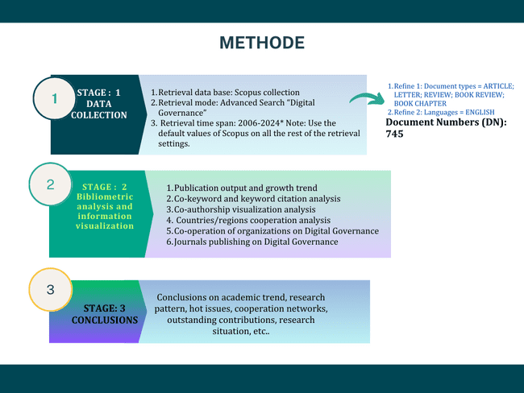

**Figure 1.** Stages of bibliometric analysis in Digital Governance research. Note: "*" The Scopus core collection was last updated in July 2024.

**Results and Discussion**

**Results**

## Evolution of Publication Trends

VOSviewer enables bibliometric analysis of digital government research, as well as an understanding of the publishing industry's history. The emergence and development of digital governance research has slowed the rapid advancement of information and communication technology (TIK) and its implications for governments, businesses, and the general public. Utama Development The field of digital governance is growing in parallel with governments' worldwide adoption of digital technologies. It focuses on the use of e-government, smart city projects, and digital transformation to improve public sector efficiency. Organizations, whether public and commercial, face the challenge of adapting to the digital age through digital transformation. However, a previous study on digital governance from the WoS Database revealed A future study on digital governance is expected to focus on the usability and dependability of systems, investigating user adoption, system performance, and service quality.  (Zhao Lin & Yaakop, 2024)

The most recent trends in digital governance studies are AI and machine learning. The application of artificial intelligence (AI) and machine learning in digital governance has been identified as a top priority by the publication in 2024. This study investigates how technology can increase operational efficiency, data analysis for decision-making, and service automation. Blockchain and cybersecurity: Blockchain technology is being utilized to enhance security and transparency in public administration and data management. The study also looks at novel cyber risk mitigation measures and data security.

The research focuses on the application of the Internet of Things (IoT) to smart governance and smart cities. This includes enhancing municipal infrastructure, providing public services, and analyzing sensor data for better urban planning.

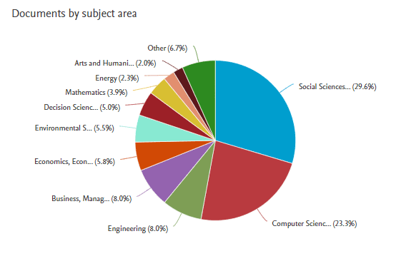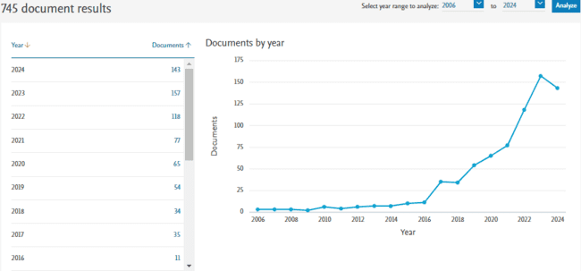

a

b

**Figure 2** : Development and Trends of Digital Governance Publications; (a). Number of Publication Documents on digital governance per year; (b).Subject of Publication Area related to digital governance

The number of publications is an essential indicator of the growth trend in scientific research. A record of how frequently articles are mentioned as sources by others indicates the quality of a publication. Figure 2a depicts the evolution of articles on productive digital governance in its publications. Until 2024, there will be 745 published documents, of which 53.2% are articles, 23.2% are conference papers, 14.8% are book chapters, 3.1% are reviews, 2.7% are books, 1.3% are conference reviews, 0.9% are editorials, 0.4% are notes, 0.3% are letters, and 0.1% are retractions. The data shows that this kind of article is the most common form of content in digital governance publications. While the digital governance publication area covers a wide range of topics, this research on digital governance has had an impact on a number of other studies in the field. Figure 2b demonstrates that the social science area publishes the most on the topic of digital governance, accounting for 29.6%. Computer science is the second most published subject on the topic, with 23.3%. Engineering: 8.0%; Business Management: 8.0%; Economics: 5.8%; Environmental Science: 5.5%; Decision Science: 5.0%; Mathematics: 3.9%; Energy: 2.3%; Art and Humanities: 2.0%; and Others: 6.7%.

Table 1. Top 10 most productive and influential sources, authors, organizations, and countries in

the development of research on digital governance topics from 745 publications (2006-2024)

|  |  |  |  |  |  |  |  |  |
| --- | --- | --- | --- | --- | --- | --- | --- | --- |
| **RO** | **Source Titles** | | **Authors** | | | **Countries/Region** | | |
| **ST** | **PC** | | **Name** | **PC** | **Coutries** | **PC** |
| Top 1 | Small business economics | 626 | | Acs, Zoltan j. | 490 | United States | 2019 |
| Top 2 | Sustainability (Switzerland) | 249 | | Sussan, Fiona | 490 | United Kingdom | 1123 |
| Top 3 | Sociologis Ruralis | 234 | | Williamson, Ben | 302 | China | 485 |
| Top 4 | City | 212 | | Wiig, alan | 212 | India | 271 |
| Top 5 | ACM International conference proceeding | 181 | | Floridi, luciano | 168 | Switzerland | 211 |
| Top 6 | Big Data and Society | 164 | | Song, Abraham K. | 136 | Germany | 199 |
| Top 7 | Government information Quarterly | 159 | | Chopra, Ritika | 120 | Spain | 186 |
| Top 8 | Sustainable Futures | 126 | | Sharma, Gagan deep | 120 | Australia | 167 |
| Top 9 | Learning, media dan technology | 104 | | Yadav, anshita | 118 | Netherlands | 161 |
| Top 10 | Human Genetic | 95 | | Florin, Marie-valentine | 118 | Italy | 144 |

Note : ST : Source Title; PC : Publication Citation

According to Table 1, there are some factors that are highly significant and contribute to digital governance research. Table 1 lists the top ten publications that have made significant contributions to the study of digital governance, including Small Business Economics, which has a citation count of 626. Meanwhile, the most influential author is Acs Zoltan, who has received 490 citations. Furthermore, it is affiliated with or organized by the Scharr School of Policy and Government at George Mason University. The United States is the leading publishing country, with a 2019 citation count.

According to the Scopus database, between 2006 and 2024, there were 745 published documents, 1746 authors, 3800 keywords, 460 journal sources, 1385 organizations and affiliates, and collaborations from 94 countries. Meanwhile, the keyword trend in the most recent research on the topic of digital governance, specifically in 2024, includes keywords such as digital strategy, green technology, technological innovation, human-machine-organization interaction, virtual assistance, damage, environmental governance, and others.

## Analyzing co-keyword and keyword citations

Co-keyword analysis (or co-occurrence analysis) is a technique for discovering and visualizing the link between keywords that appear frequently in literature or scientific papers. The primary purpose is to investigate thematic links among issues that are frequently mentioned in a certain setting. Keyword citation analysis examines how frequently specific terms are mentioned in the context of specific research. This assists in determining the popularity or significance of terms in academic or research literature, as well as identifying trends and study topics. The combination of these two methods of analysis can provide a deeper understanding of the structure and growth of knowledge in a particular topic, as well as aid in defining research strategies and developing new concepts, particularly in the field of digital governance (Y. Wang, Ran, et al., 2024) (Stelzle & Noennig, 2017), (Dupre, 2019), (Garton, 2021), (Y. Zhang et al., 2021) (Jafrin et al., 2024).

To thoroughly investigate the research topic, bibliometric analysis studies frequently employ a variety of methodologies, including co-author analysis, co-citation analysis, and general keyword analysis (Steadman, 2021), (Jnr, 2022). This study aids in understanding the productivity of authors, countries, and organizations while also exposing worldwide distributions, collaboration patterns, and knowledge hierarchies within specific domains (Dadson et al., 2017) (C. Meng et al., 2020)(Fu et al., 2022), (Fu et al., 2022). Furthermore, keyword co-emergence analysis can identify keyword relevance based on frequency of occurrence in research databases, offering useful insights into research trends and emerging concepts (Fu et al., 2022).

Keyword co-occurrence analysis can also be used to detect hotspots and trends within specific study areas, allowing academics to better understand how research subjects evolve (Xuemin, 2022). This form of analysis is critical for mapping the scientific environment, displaying research production, and identifying significant priority areas within a certain field (Fang, 2022). Researchers can create reference groups by evaluating the co-citations of references in order to discover the relationship between various studies and concepts (Huang, 2022), (Cai et al., 2024) (H. Wang et al., 2021) (Guo & Zhang, 2024). In the study of digital governance, the visualization of keywords and clustering can be shown in Figure 3, with the top keywords and clustering numbers in Table 2.

Table 2: Top-ranking keywords with occurrence weight and excellent link strength.

|  |  |  |  |  |  |  |  |  |  |  |  |
| --- | --- | --- | --- | --- | --- | --- | --- | --- | --- | --- | --- |
| RO | Keywords | Occurances | Link | | Total Link strenght | | APY | | APC | |  |
| Top 1 | Digital Governance | 267 | | 667 | | 1400 | | 2021 | | 8,43 | |
| Top 2 | Digital transformation | 58 | | 184 | | 303 | | 2021 | | 4,66 | |
| Top 3 | E-Government | 57 | | 194 | | 334 | | 2019 | | 4,4 | |
| Top 4 | Sustainable Development | 39 | | 293 | | 433 | | 2022 | | 5,87 | |
| Top 5 | Decision making | 36 | | 275 | | 378 | | 2021 | | 3,17 | |
| Top 6 | Governance Approach | 35 | | 282 | | 428 | | 2021 | | 11,31 | |
| Top 7 | Artificial Intelegent | 34 | | 188 | | 257 | | 2021 | | 10,53 | |
| Top 8 | Smart City | 34 | | 169 | | 239 | | 2021 | | 13,32 | |
| Top 9 | Digital Economy | 33 | | 154 | | 214 | | 2022 | | 3,39 | |
| Top 10 | Digitization | 30 | | 246 | | 368 | | 2022 | | 8,7 | |

*RO : Rangking Order*

*APY : Average Publication year*

The digital governance investigation detected a total of 3800 keywords. Of the 3800 keywords available, the keyword digital governance appears the most frequently (267 times), with the highest overall network strength among others, up to 1424, as shown in Figure 3a. Between 2006 and 2023, research on digital governance evolved keywords, leading to the birth of new terms such as sustainable development and digital transformation. This is extremely useful information for digital governance studies. This is illustrated in Figure 3b. Over time, the most often used keywords have remained Digital Governance (267) and Digital Transformation (58). This suggests that the terms digital governance and digital transformation have had a significant impact on digital governance research thus far. Figure 3c depicts this clearly.

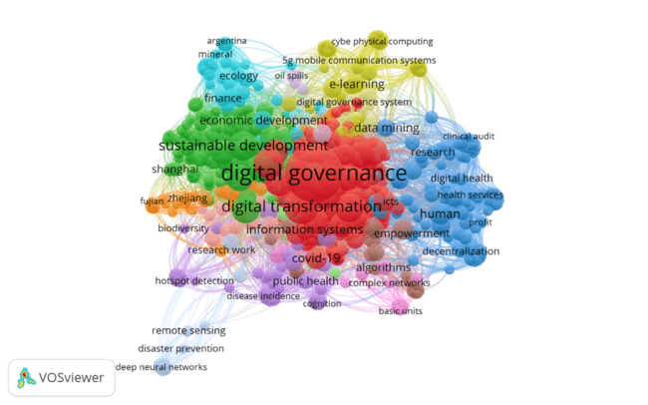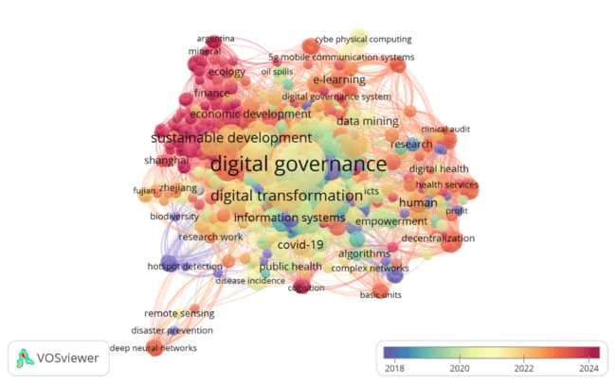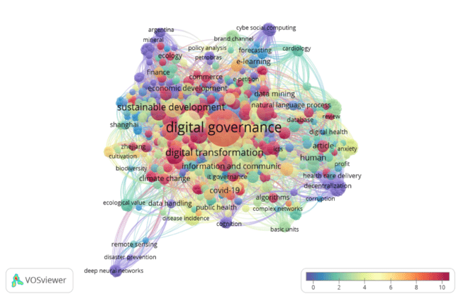

a

b

c

**Figure 3**. Co-keyword network visualization on Digital Governance research : **(a)** Co-Keyword network visualization was based on occurances; **(b)** Co-keyword overlay visualization was Based on the occurances and averages publication per year scores; (c) Overlay visualization was based on Co-Occurrence citation and average publication citation score

* 1. **Co-authorship visualization analysis**

Co-authorship visualization analysis is a bibliometrics technique used to investigate collaboration relationships between writers in academic literature. By evaluating the co-authorship network, researchers can obtain insight into collaboration patterns, identify major contributors in a field, and comprehend the structure of the research community. One study by (C. Meng et al., 2020) used VOSviewer to create and show a network map of co-authorship and pertinent terms retrieved from the publication's title and abstract, allowing for a thorough examination of the author's relationships and research issues. This method enables researchers to see the relationships between authors and their contributions to scientific work, resulting in a clear picture of collaboration patterns in certain research domains (Vrydagh, 2023).

Table 3: Top 10 ranking of Co-Authors based on the most citations in the topic of Digital Governance

|  |  |  |  |  |  |
| --- | --- | --- | --- | --- | --- |
| RO | Co-Author | Citation | Document | Cluster | APY |
| Top 1 | Floridi, Luciano | 168 | 7 | 11 | 2022 |
| Top 2 | Sharma, gagan deep | 120 | 1 | 196 | 2020 |
| Top 3 | Yadav, anshita | 120 | 1 | 196 | 2020 |
| Top 4 | Florin, marie-valentine | 118 | 1 | 140 | 2018 |
| Top 5 | Linkov, igor | 118 | 1 | 140 | 2018 |
| Top 6 | Poinsatte-jones,kelsey | 118 | 1 | 140 | 2018 |
| Top 7 | Trump, benyamin d | 118 | 1 | 140 | 2018 |
| Top 8 | Elliman, tony | 82 | 3 | 82 | 2011 |
| Top 9 | Panagiotopoules, panagiotis | 82 | 3 | 82 | 2011 |
| Top 10 | Cowls, josh | 67 | 3 | 67 | 2022 |

*RO : Rangking Order*

*APY : Average Publication year*

Table 3 displays the top ten co-authorships in digital governance research that entail author collaboration in academic or research publications, along with visualizations similar to those in Figure 4. According to Table 1, Floridi has the highest citation rate for digital governance research, as well as the most publications on the subject. Meanwhile, Josh Cowls has an extensive network of collaborators. The author cluster with the most citations is 140, which includes Marie Valentine, Linkov Igor, Ponsatte-Jones, and Trump Benyamin D. However, cluster 168 is the author cluster with the most recent publications, and while there will be some new publications in 2024, they will not be in the Top Ten.

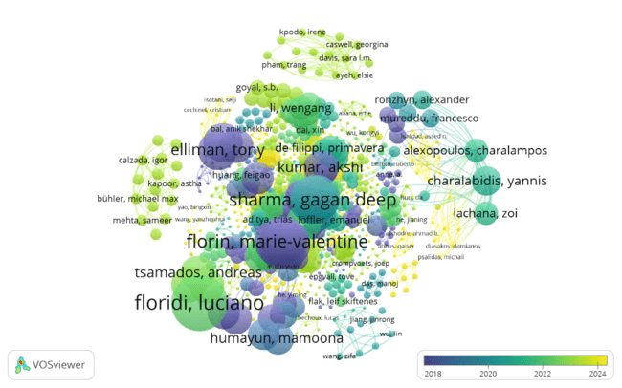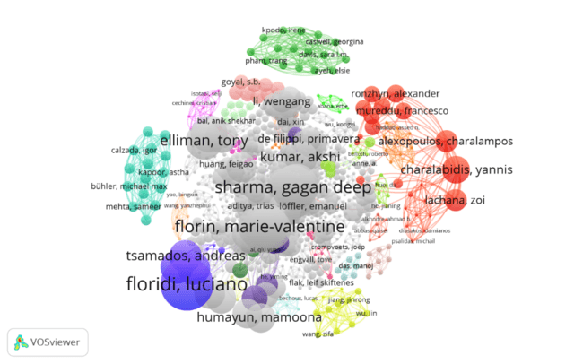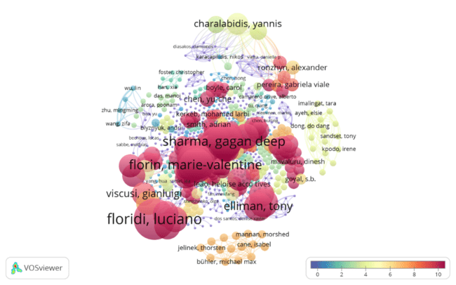

a

b

c

**Figure 4**: Co Author Network for Digital Governance. Note: **(a)** Network visualization was based on Co-author Citation weights; **(b)** Overlay visualization was based on author citation weights and average year score; and **(c).** Overlay visualization was based on Citation weights and the average publication citation score

Figure 4 shows the collaborative network of 1746 co-authors on digital governance topics. Figure 4a reveals that Floridi and Luciano are the co-authors with the most published papers. He is the co-author who has made the most significant contribution to research on digital governance, followed by the other co-authors. Meanwhile, figure 4b demonstrates that the co-author has the most publications but not the most recent ones. Figure 4b displays some of the most recent published documents in yellow clusters. Figure 4c illustrates that the co-authors who have the greatest citations as co-authors are influential, as shown in Table 3 with network limitations.

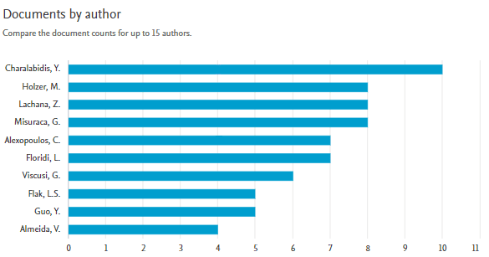

Figure 5 : Top 10 Authors Based On Document Publication

According to the Scopus database as of July 2024, there are ten authors who have made significant contributions to publications on digital governance subjects, such as Figure 5. Charalabidis, Y, and Holzer M have 10 publication documents, as do Lachana Z and Misurac G, while Alexopoulus C and Floridi have 7 publication documents, Viscusi G has 6 publication documents, Flak L.S. and Guo Y have 5 publication documents, and Almeida has 4 publication documents

## Analysis of cooperation between countries or regions.

Cooperation Analysis by Countries or Regions is a method for evaluating and visualizing patterns of scientific cooperation among countries or regions using data from scientific publications or research collaborations. This analysis helps to understand how extensive and diversified international collaboration is in digital governance research.

### Co-authors' visualization of countries and regions.

Co-Author Visualization Analysis by Country or Region is a tool for visualizing and analyzing collaboration patterns among authors from various nations or areas in scientific publications. The primary goal of this investigation is to detect and comprehend the cross-border scientific collaboration relationships that occur between authors fromdifferent geographical regions (S.-H. Zhao et al., 2024).Co-author visualization for countries and regions entails collaborative network analysis involving authors from various geographic areas in academic research. This form of study aids in identifying the most productive countries and organizations conducting digital governance research, as well as analyzing trends in international research collaboration. In addition to visualizing co-authorship networks at the country or region level, it has helped to map research trends and identify key authors and research themes in specific geographical contexts (Máté et al., 2024). In conclusion, the co-authors' visualization of countries and regions is significant for comprehending international research collaborations, recognizing research trends in different geographic locations, and charting the dissemination of global scientific knowledge. By leveraging tools such as VOSviewer and conducting in-depth analysis of co-authorship networks, researchers can gain valuable insights into the research dynamics of digital governance in international research, the distribution of research results among countries and regions, and the impact of collaboration on scientific progress.

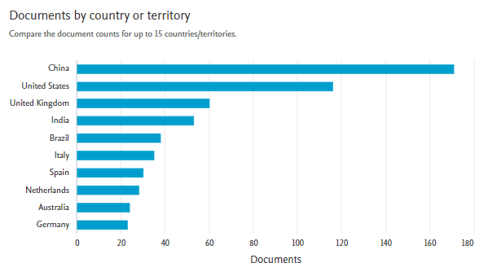

Figure 6 : Top 10 countries with the most published documents based on the Scopus database

Figure 6 explains that China is the country that contributes the most to research on the topic of digital governance by producing the most publication documents among other countries. Meanwhile, the United States and the United Kingdom and other countries that are in the top 10 countries that contribute the most can be seen in figure 6.

Table 4 : Top country rankings based on the number of joint publication collaboration documents

|  |  |  |  |  |  |  |
| --- | --- | --- | --- | --- | --- | --- |
| **RO** | **Country** | **Document** | **Citation** | **Total Link Strength** | **APC** | **APY** |
| Top 1 | United States | 117 | 2019 | 63 | 17,26 | 2019 |
| Top 2 | United Kingdom | 59 | 1123 | 57 | 19,03 | 2019 |
| Top 3 | China | 172 | 485 | 41 | 2,82 | 2022 |
| Top 4 | India | 53 | 271 | 16 | 11,72 | 2020 |
| Top 5 | Switzerland | 18 | 211 | 27 | 5,11 | 2021 |
| Top 6 | Germany | 23 | 199 | 29 | 8,65 | 2020 |
| Top 7 | Spain | 30 | 186 | 25 | 6,2 | 2021 |
| Top 8 | Australia | 24 | 167 | 24 | 6,96 | 2022 |
| Top 9 | Netherlands | 28 | 161 | 34 | 5,75 | 2021 |
| Top 10 | Italy | 35 | 144 | 31 | 4,11 | 2021 |

*RO : Rangking Order*

*APY : Average Publication year*

Based on table 4 which is initialized in figure 7, it can be explained that the country with the highest number of joint publication colloquial documents is China, followed by the United States, the United Kingdom, India, and Italy as the top 5 rankings. This can be seen in the visualization of figure 7c. The countries with the highest number of citations in joint publications are the United States, the United Kingdom, China, India, and Switzerland. This can be seen in the visualization of figure 7a. The latest publications in digital governance research are Azerbaijan (2023), Kazakhstan (2023), Ghana (2023), Cambodia (2023), China (2022), and Australia (2022). And the number of publication documents per country is according to figure 7b.

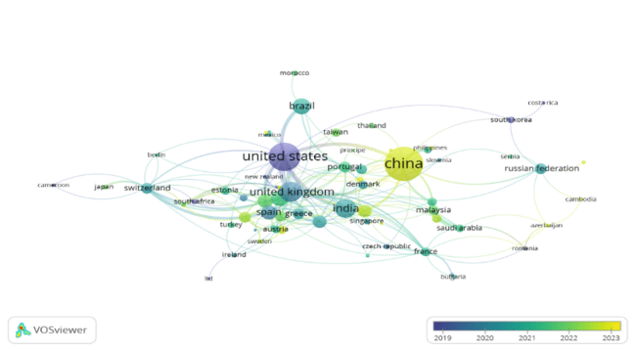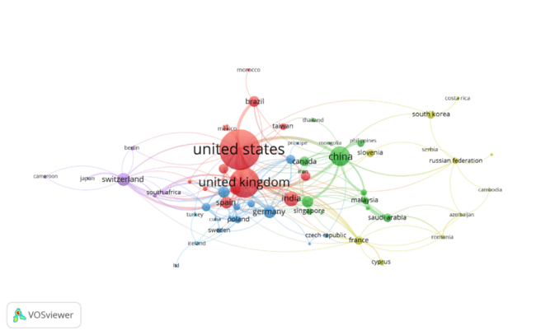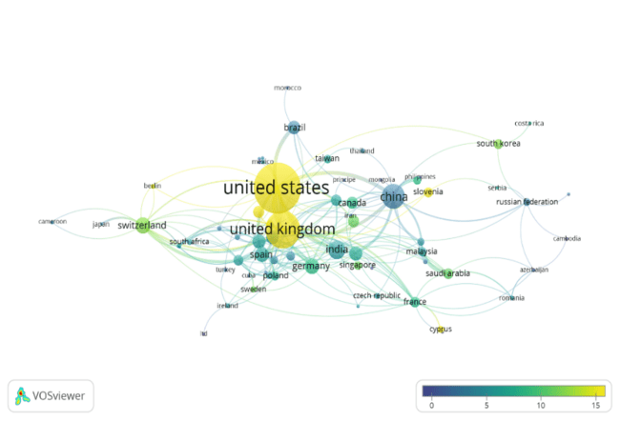

a

b

c

***Figure 7 :*** *Co-author visualization map of countries/ regions. Note:* ***(a)*** *Overlay visualization map was based on Citation -weights and Average Publication Citation score;* ***(b)*** *network visualization map was based on total link strength weights;* ***(c)*** *Overlay visualization map was based on Document -weights and Average Publication year score*

Figure 7 illustrates the involvement of author partners from diverse nations and regions in digital governance research. China appears to have the most published documents, ranking first among other countries. Total publication documents China has 172 published documents, including those by other authors. The United States (117 publication documents) came next, followed by the United Kingdom (59 joint publication documents). This demonstrates that the three countries provide the most significant contributions to research on digital governance. Figure 7 shows that 94 countries collaborate on scientific publications.

Figure 7a depicts the number of citations in each nation's joint publication document. So far, the United States looks to have the most citations (2019 number of citations), followed by the United Kingdom (1123 citations) and China (485 citations). This demonstrates that the three countries have the most effect on the production of documents on digital governance research issues among the 94 countries that engage with one another.

Figure 7b shows the network and co-authoring collaboration. The network's strength lies in the United States (63 total networks), the United Kingdom (57 networks), and China (41 networks). These three countries have a very strong collaboration of author partners compared to 94 other countries in research on the topic of digital governance.

Figure 7c shows the documents published with the co-author, as well as their average year of publication. According to this image, China has the most recent and largest number of papers in the digital governance research, which includes 94 contributing countries. China's average year of publishing is 2022, the United States' average is 2019, and the United Kingdom's median is also 2019. The two countries have identical rankings for the novelty of research on digital governance

### Visualization of citations by country or region

The literature review on Citation Visualization Analysis by Country or Region contains several sources that might provide in-depth insights into publishing patterns and research collaborations from various nations or regions (Schraven et al., 2021), (Wahyudin, 2023), (Chowdhry, A. et al., 2023). This analysis offers useful insights into the dynamics of global research and maps the contributions of scholars from across the world to the advancement of knowledge on the issue of digital governance research.

A citation visualization map for a country or region is a graphical representation that depicts the flow and distribution of scholarly citations across different geographic locations. This map was built using data from Scopus scientific publications, which track and map citations from one research article to the next based on the author's affiliation or the institutions involved. Citation visualization tools can use this affiliate data to map citations between articles on a geographic map. Each reference is tracked from the author's affiliate to the author's affiliation cited, resulting in a visual relationship across countries or regions. This enables researchers to investigate citation flow patterns in various regions of the world, gaining insights into global research collaborations, information diffusion patterns, and the influence of research across boundaries. They can identify research centers, collaborative networks, and places where digital governance study themes are more prevalent.

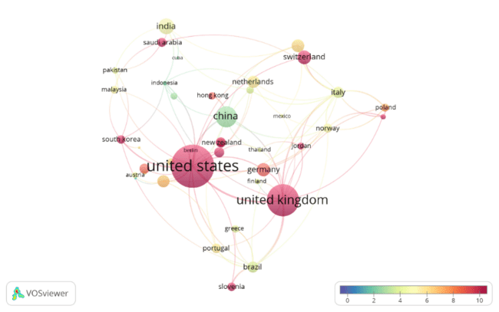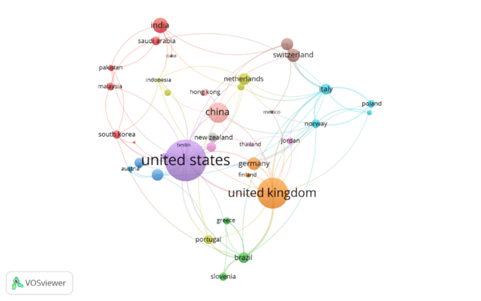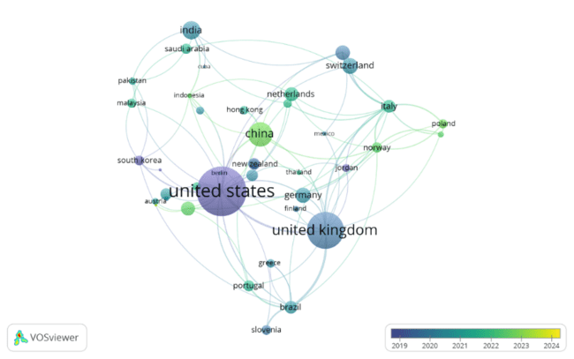

a

b

c

***Figure 8.*** *Citation visualization map of countries/regions. Note: (****a****) network visualization map was based on citation-weights; (****b****) Overlay visualization map was based on citation-weights and Avarage Citation, (****c****) Overlay visualization map was based on citation-weights and Avarage Publication Year Score*

In the study of digital governance, 94 countries or regions were identified, as detailed in the published article. The United States is the top Kutipan country in 2019, with a Kutipan score of 17.26 per year. Citations based on a single country, such as the United States, outnumber 94 other countries, implying that the United States has a significant impact on worldwide digital governance research. The visualization of the Kutipan score based on country can be seen in Figure 8.

## Research Organization

In the context of VOSviewer's bibliometric analysis, "research organization" refers to entities such as universities, research institutes, or other academic organizations that do research and publish scientific articles. Thus, in the context of bibliometric analysis using VOSviewer, a "research organization" is an academic or research body that may be identified and researched based on the author's scientific literature affiliation. This analysis helps to improve our understanding of the structure and dynamics of inter-organizational collaboration in the context of global digital governance research. An analysis of the literature on research organizations in digital governance yields a number of sources that provide detailed insights into the function of research organizations in the development of digital governance.

One of the study's key sources is (Lawelai, 2023) Study on Understanding Digital Governance in Smart Cities. This work makes a valuable contribution by providing a comprehensive analysis of digital governance in smart cities, highlighting key research areas, and proposing potential paths for future exploration. (Kunviroteluck et al., 2023) implementation of the Digital Governance Tree intends to provide the government and citizens with greater access to and control over governance tools that enhance transparency, accessibility, and citizen participation. Furthermore, (Lei, 2019) reference to Digital Government Models for the Big Data Era: Based on Specific Practices in Singapore provides valuable insights. They define digital governance as the interaction of government information technology with civil society, economic society, and internal government operations, reshaping the relationship between government and administrative processes, simplifying public affairs management, and increasing the level of democratization of government models. (Zhou et al., 2024) are among the sources that can provide in-depth insights into research trends, researcher collaborations, and contributions from a variety of key research organizations.

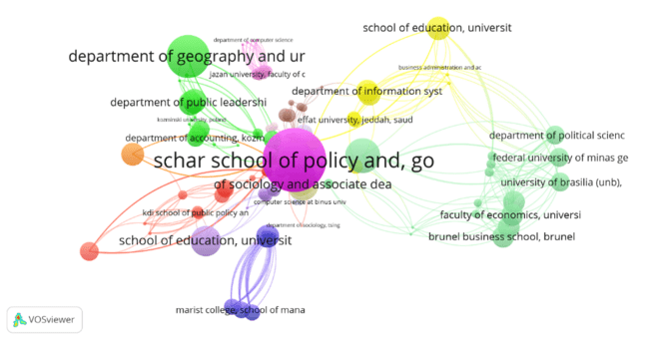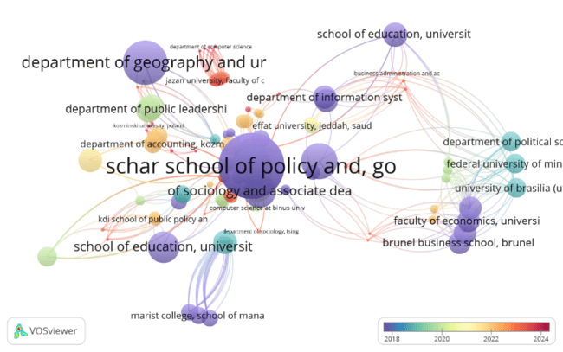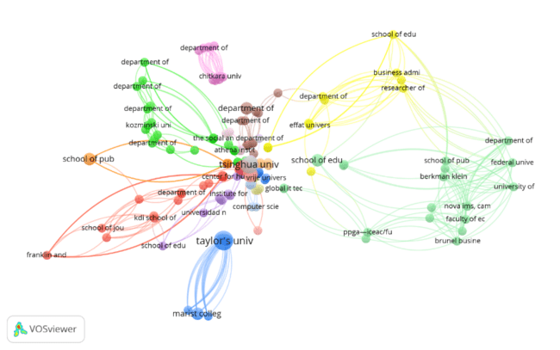

a

b

c

***Figure 9.*** *Citation visualization map of research organizations on Digital Governance Note: (****a****) network visualization map was based on citation-weights;, (****b****) network visualization map was based on Document-weights; (c). Network visualization map was based on citation-weights and Avarage Publication Year Score*

Between 2006 and 2024, digital governance research identified 1385 research organizations. The Schar School of Policy and Government at George Mason University (490 citations), the School of Advanced Studies at the University of Phoenix (490 citations), and the Ecole Polytechnique Federale de Lausanne in Switzerland (118 citations) are the most notable research institutions. This organization has a significant influence on digital governance research, despite the fact that its papers are not new. This can be seen in figure 9.

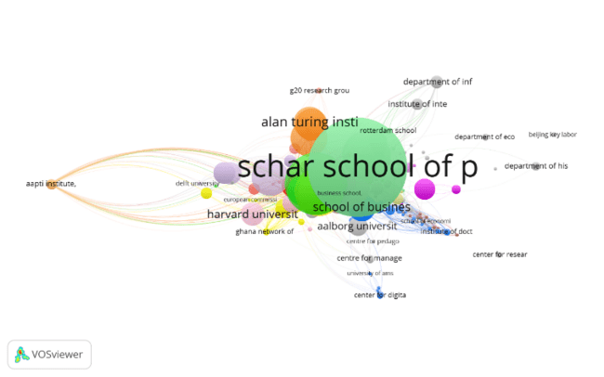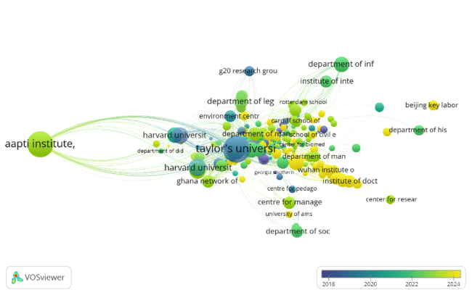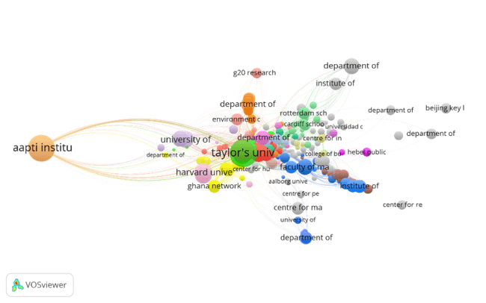

a

b

c

***Figure 10.*** *The Bibliographic Coupling visualization map of research organizations on Digital Governance. Note: (****a****) organizational network visualization map was based on Total Link - weights; (b) organizational network visualization map was based on Citation weights; (****c****) Overlay visualization map of organizations was based on Document weights and average publication year score*

Figure 10 depicts bibliographic coupling, a bibliometric analysis technique that calculates the proximity of two papers based on the identical reference mentioned by both. In the context of "The Bibliographic Coupling Visualization Map of Research Organizations on Digital Governance," this refers to a visual map that depicts the relationship between various research organizations in the field of digital governance based on common bibliographic patterns. Each dot symbolizes a research organization, and the lines connecting the dots indicate how tight their bibliographic link is. This indicates that the more frequently two organizations refer to the same or similar publications in the scientific literature, the closer they will be to each other. The goal of this visualization map is to provide a more detailed view of the network of collaborations or interactions between research organizations working in the field of digital governance. By showing these bibliographic trends, the map can assist in identifying research clusters 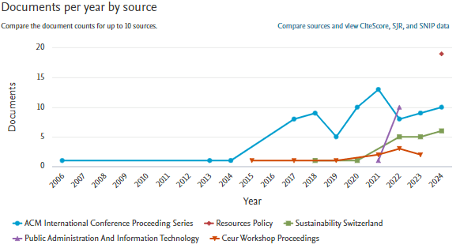or organizations that interact regularly or share similar research interests on the issue

Figure 11 : Documents Per year by Source

Digital governance is the administration and application of digital technology in government, organizations, and society. Digital governance research spans a wide range of topics, including information technology policy, e-government, data privacy, cybersecurity, and digital transformation. Bibliographic coupling is a way of determining how closely two documents are related based on the same or similar references they mention. In this context, if two research organizations are frequently cited together in papers discussing digital governance, it can be argued that the two organizations have comparable or closely connected research interests in the subject.

The bibliographic coupling visualization map is used to graphically represent this relationship. In this map, each research organization is represented as a network node. The edges between two nodes (lines linking nodes) represent the degree of bibliographic connectivity between the organizations. The tighter the bibliographic coupling between the two companies, the closer they appear to each other on the visualization map. Figure 8 shows that the Taylor's University Malaysia research organization produces the most collaborative publishing papers, with 1765 networks and other publication documents. This is demonstrated in Figure 10a, whereas the Schar School of Policy and Government at George Mason University is the publication collaborative organization with the greatest citations and influence in digital government research, as shown in Figure 10b. Taylor's University Malaysia has the most collaborative publication documents compared to other organizations, but the average score of the publication year is not particularly recent, as many other research organizations have had little influence on the world of digital government research. Figure 10c illustrates this visually

## Journal Publishing

A citation visualization map depicts how a certain source (such as a research paper, book, or article) is discussed or cited in other works. The goal of making this visualization map is to visually investigate and comprehend the relationship between citations in different academic works. In bibliometric analysis with VOSviewer, "journal publishing" refers to an analysis and visualization method that leverages scientific journals as the major source of research publications. Merigó et al. (2016). In this regard, VOSviewer is used to identify and evaluate patterns and relationships in scientific data published in various papers on digital governance.VOSviewer enables academics to assess journal performance using a variety of bibliometric indicators, such as citation count, co-citation networks, and keyword co-occurrence. Furthermore, VOSviewer is useful in reviewing journal publications since it illustrates the relationships between journals, authors, and study subjects. Visualizing the journal co-citation network enables scholars to identify the most influential journals in a certain subject and comprehend the flow of knowledge across various publications (Morçöl, 2021), (C. Meng et al., 2020), (Cai et al., 2024), Such analyses provide valuable insights into the distribution of knowledge in scientific publications and help scholars navigate the vast academic literature on digital governance.

Figure 12 visualizes 460 sources provide information about digital governance. Small business economics received the most citations (626), followed by the Sustainability Journal (Switzerland) (249), Sociologia Ruralis (234), Jurnal City (212), and other publications. However, ACM International Conference Proceedings has the most joint articles, with 75 publications, 181 citations, and 967 collaboration networks. Then came resources policy as a source for digital governance research, with 19 publications, including the second-most papers (18 citations) and 190 collaborative networks. This

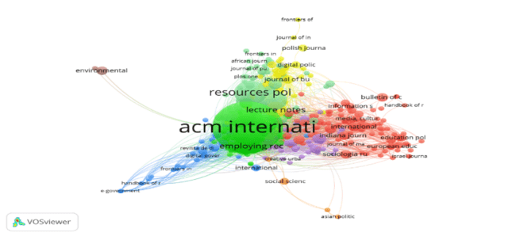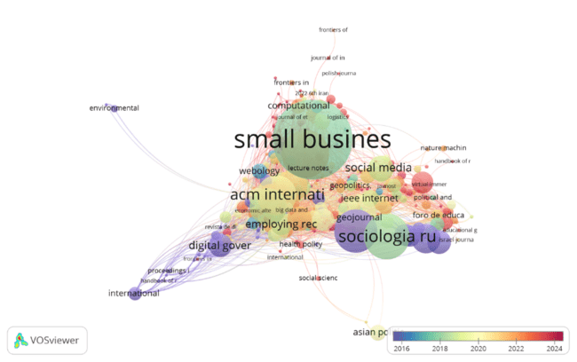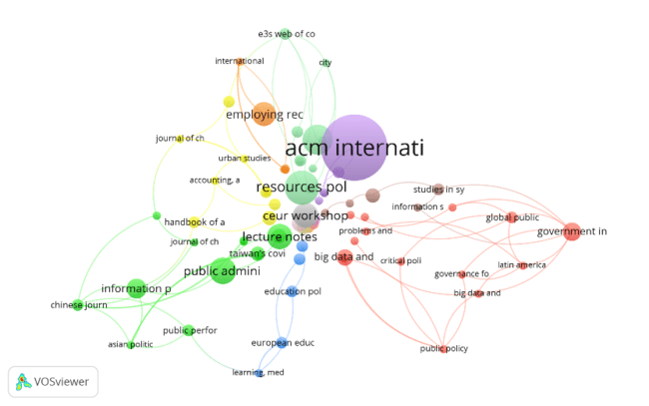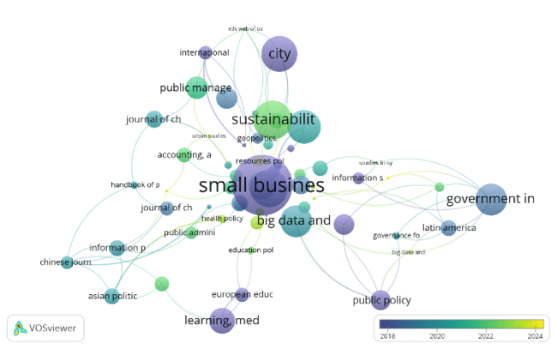

a

b

c

d

corresponds to the visualizations in Figures 12b and 12d.

***Figure 12.*** *Citation visualization map of Source and Bibliographic Coupling visualization map of Source. Note: (****a****) Bibliographic Coupling Overlay visualization map was based on citation-weights and Avarage Publication Year Score, (b) Bibliographic Coupling Network visualization map was based on Document-weights; (****c****) Citation Overlay visualization map of source was based on citation-weights and Avarage Publication Year Score; (****d****) Citation network visualization map of source was based on Document-weight*

Figure 12 also describes the bibliographic coupling visualization map (figures 12a and 12b), which shows the relationships between scientific documents based on the references they share. Each source (document or publication) is displayed as a node on the map. Nodes often contain titles, author, and other metadata relating to digital governance subjects. The line linking the nodes symbolizes bibliographic coupling, which means that two nodes are coupled if they have the same reference. The more references the two texts have, the stronger the association (thicker or darker lines). Documents that are tightly related (with many references to one another) create clusters or groups on a map. This cluster represents study fields or themes connected to digital governance.

Figure 12a demonstrates that the Small Business Economic Journal is the most influential in the research field, receiving a total of 626 citations from two publications. This demonstrates how closely related scientific documents are based on the references they share. Furthermore, the journal Sustainability (Switzerland) has received 249 citations for the 14 papers it has published, indicating that the relationship between the documents it publishes is equally strong. The Sociologia Ruralis Journal incorporates 234 citations from three published documents. Journal City includes 212 citations from one publication and various journals, including Figure 9a. Figure 9a further demonstrates that the average year of publication for small business economics journals is 2019. Following that year, numerous more publications continued to publish documents on the issue of digital governance. Figure 12a is similar to Figure 12c, but it depicts a deeper network of papers. This also illustrates the connections between scientific documents based on the references they share.

Although Figure 12b shows that among the 460 journal sources that publish themes on digital governance, ACM International Conference Proceedings is the No. 1 journal that contributes the most as a journal, publishing 75 publication documents and receiving 181 citations. Furthermore, the Resource Policy Journal is the second-largest contributor, with 19 papers and citations out of only 18 in total. Jurna Sustainability (Switzerland) has received 249 citations for its 14 published works. Public Administration and Information is the next most cited journal, with 23 citations out of 11 published documents. Furthermore, the source of computer science class notes cited 25 out of the 10 published documents.

Figure 12c depicts the source of digital management publications, including a representation of the journal's most recent publication, which is indicated in yellow. Figure 12d depicts a citation network of documents from published journals. Most publications indicate that the visualization map of the source citation network is based on document weight. When it comes to the number of published documents, the ACM international conference contributes the most.

**DISCUSSION**

**4.1. The role of keywords in the development of Digital Governance**

Key digital governance topics include digital governance, digital transformation, e-government, sustainable development, decision-making, governance approach, artificial intelligence, smart cities, digital economy, and digitization. The following sections explain each topic and its importance in the evolution of digital governance. *Digital governance* refers to the institutions, policies, and processes used to control and regulate the use of digital technology in government and organizations. This involves how technology is utilized to improve governance, transparency, and public services. The role of digital governance is to provide a framework for implementing technology in ways that promote efficiency, accountability, and participation in the governance process.

*Digital transformation* is a fundamental change process in an organization that involves the use of digital technology. It encompasses changes in culture, processes, and business models to capitalize on the possibilities of new technologies. Role: Digital transformation enables firms to adapt to technical advancements and market demands, enhance efficiency, and generate value through innovation.   
*E-government* is the use of information and communication technology (ICT) by the government to improve public services, citizen interactions, and internal operations. E-government improves access and openness to public services, lowers bureaucracy, and encourages citizen participation in the government process. *Sustainable development* refers to strategies and policies that promote economic and social progress while maintaining environmental balance. Sustainable development in digital governance guarantees that technology is used with consideration for environmental and social implications, hence ensuring long-term growth and sustainability.

*Decision-making* in the context of digital governance entails the use of data and technology to facilitate faster and more accurate decision-making. Role: The use of technology, such as data analytics and AI-powered systems, improves decision-making capacities by delivering relevant information and in-depth analysis. *The governance approach* encompasses the methods and strategies used to control and regulate the development and usage of digital technology in businesses and government. Role: This strategy entails policy development, monitoring, and evaluation to ensure that technology is applied successfully and in line with strategic goals. *Artificial intelligence (AI)* is a technology that enables machines to perform human cognitive capabilities like learning, comprehension, and decision-making. AI plays a crucial role in digital governance by enhancing efficiency, process automation, data analysis, and decision-making, as well as public service delivery through chatbots and predictive algorithms.

The term "Smart City" refers to the use of digital technology to improve urban residents' quality of life, infrastructural efficiency, and public services. Smart city implementations use sensors, IoT, and data analytics to control and monitor city characteristics, including traffic, electricity, and public services, in a more efficient and integrated manner. *The digital economy* is an economy that emphasizes the use of digital technologies to boost economic activity, such as electronic commerce, digital services, and corporate innovation. The digital economy promotes economic growth by stimulating innovation, increasing market access, and opening up new options for firms and consumers. Digitization is the process of transferring analog information to digital formats so that it may be processed, stored, and sent electronically. Digitization is the initial phase in digital transformation, allowing for more efficient data access, processing, and analysis while also aiding the integration of technology into numerous operational elements.

These themes demonstrate the broad scope of digital governance and how digital technologies can affect several parts of government and enterprises. They demonstrate how connected technologies and tactics can increase efficiency, transparency, and public involvement while solving sustainability issues and adding value to society. Effective management of these themes is critical for achieving strategic and operational objectives in the digital age.

**4.2 China is the country with the most publications, while the United States has more influence.**

Although China has the most publications on digital governance, the United States has more influence on this subject. This disparity can be explained by several major factors.

**4.2**.1 Publication Volume vs. Impact and Influence

China produces more articles on digital governance because of its strong emphasis on research, development, and investment in information technology. This demonstrates the country's attempts to advance and execute digital governance policies within the country. Influence and effect: The United States, on the other hand, may wield more influence in the sphere of digital governance due to the quality and effect of its publications. US research is frequently cited and has a substantial impact on worldwide discussions around digital governance.

4.2.2 Academic Quality and Influence

Prestigious Journals and Conferences: Many notable studies in the subject of digital governance are published in leading academic journals and international conferences that are frequently based in the United States or feature significant contributions from American scholars. This means that scientific works from the United States frequently become global reference standards. Key Thinker Leadership: Often, leading scholars and key thinkers in digital governance are from the United States. Their contributions, including theories, techniques, and frameworks, have a significant impact on the growth of this discipline.

4.2.3 Innovation and Leading Practices

Technological Innovation: The United States is a hotbed of technological innovation, with many corporations and research organizations at the forefront of technology advancements affecting digital governance. Practices and technology created in the United States frequently serve as global examples or standards. Practices and Policies: Digital governance policies and practices enacted in the United States are frequently used as benchmarks or case studies in worldwide studies. Other countries frequently look to them for guidance on data privacy, cybersecurity, and public participation.

4.2.4 International Collaboration and Global Influence

Researchers and institutions in the United States frequently participate in international collaborations, contributing to global projects and research networks that broaden their scope of influence. Global Influence: The United States plays a key role in the establishment of international standards and global regulations affecting digital governance, making it a hub for debate and thought on this subject.

4.2.5 Diverse Contexts and Research

Research Focus: Research in China may be more focused on local applications and implementations, whereas research in the United States frequently focuses on wider theoretical concepts and internationally applicable applications. Overall, while China leads in terms of publication volume, the United States has a stronger effect in digital governance due to the impact and quality of research, as well as their contribution to globally adopted theories, standards, and practices.

4.3 Digital Governance: China excels in the number of publications

# China has become the country that publishes the most digital governance research for numerous reasons: 1). China has made significant investments in R&D, particularly in digital governance. China's government and corporate sector actively fund and support research projects. 2) Technological advancements: China is a global leader in digital and information technologies. Rapid technological advancements such as big data, artificial intelligence, and blockchain are fueling research and publications in digital governance. 3). Government Policies: The Chinese government actively promotes innovation in information technology and digital governance through strategic policies and initiatives such as the Five-Year Plan and advanced technology development strategies. This generates a conducive setting for research. 4). Big Number of Researchers: Due to its big population and numerous universities and research organizations, China has a great number of researchers and academics who contribute to the study of digital governance. 5). Focus on Digital Transformation: China is dedicated to digital transformation and economic development. Many studies have focused on how digital technologies might improve efficiency and transparency in both the public and private sectors. 6). International partnerships: China actively participates in international partnerships and scientific conferences, which increases the number of publications and the visibility of their digital governance research.

China has become the country that publishes the most digital governance research for numerous reasons: 1). China has made significant investments in R&D, particularly in digital governance. China's government and corporate sector actively fund and support research projects. 2) Technological advancements: China is a global leader in digital and information technologies. Rapid technological advancements such as big data, artificial intelligence, and blockchain are fueling research and publications in digital governance. 3). Government Policies: The Chinese government actively promotes innovation in information technology and digital governance through strategic policies and initiatives such as the Five-Year Plan and advanced technology development strategies. This generates a conducive setting for research. 4). Big Number of Researchers: Due to its big population and numerous universities and research organizations, China has a great number of researchers and academics who contribute to the study of digital governance. 5). Focus on Digital Transformation: China is dedicated to digital transformation and economic development. Many studies have focused on how digital technologies might improve efficiency and transparency in both the public and private sectors. 6). International partnerships: China actively participates in international partnerships and scientific conferences, which increases the number of publications and the visibility of their digital governance research.

**Conclusion**

# The bibliometric study of digital governance is constantly growing. According to the Scopus database, 745 documents were published between 2006 and 2024, with 1746 authors, 3800 keywords, 460 journal sources, 1385 organizations and affiliates, and collaborations from 94 countries. Meanwhile, the most recent digital governance research, published in 2024, covers topics such as digital governance, digital transformation, e-government, sustainable development, decision-making, governance approach, artificial intelligence, smart cities, digital economy, digitization, and others. Each of these major topics serves its own purpose in the advancement of digital governance. Charalabalis Yanis wrote the most papers on digital governance, with ten, while Acs Zoltan was the most influential, with one publication and 490 citations. The keywords with the greatest network strength are digital governance (1422 keyword collaboration networks), sustainable development (443 networks), and governance approach (443 networks), followed by digital transformation, e-government, digitization, decision-making, public policy, and artificial intelligence. The ACM International Conference Proceedings is the most widely used publication or source for digital governance research. Meanwhile, Small Business Economics has 626 citations, making it the most influential article. With 58 published articles, the group has made the most significant contribution to digital governance research. Meanwhile, the Schar School of Policy has garnered the most citations (490). China has made the largest contributions to digital governance research, with 172 published articles, but the United States is the most influential (as indicated by the number of citations, which equals that of 2019). Although China has the highest number of publications, the United States has a greater influence in the field of digital governance because of publication volume versus impact and influence, academic quality and influence, innovation and leading practices, international collaboration and global influence, diverse contexts, and research. For a variety of reasons, China has become the country that publishes the most digital governance research: significant investments in R&D, technological advancements, government policies, a large number of researchers, a focus on digital transformation, and international partnerships.

**Acknowledgement**

# We would like to convey our heartfelt appreciation to Dr. Adianto, Professor Almasdi Syahza and Professor Zaili Rusli and Professor Sujianto for their important guidance, assistance, and mentorship throughout this research project on the publication Digital Governance.

**References**

Abdullah-Al-Faruk, M. (2024). Safeguarding Citizen Security and Fostering Economic Prosperity in Bangladesh through Digitization. *Economic Affairs (New Delhi)*, *69*(1), 469–477. https://doi.org/10.46852/0424-2513.2.2024.9

Ahmed, F., Zapata, O., & Poelzer, G. (2024). Sustainability in the arctic: a bibliometric analysis. *Discover Sustainability*, *5(1)*, *121*. https://doi.org/10.1007/s43621-024-00312-4

Ahmed, J. (2023). POLICY PERSPECTIVE ON GOVERNANCE STANDARDS SETTING USING COMMUNITY PARTICIPATION FOR SUSTAINABLE MANGROVE MANAGEMENT IN LAMU KENYA. *International Journal of Conservation Science*, *14*(1), 315–326. https://doi.org/10.36868/IJCS.2023.01.20

Al-Hawamleh, A. M. (2024). Investigating the multifaceted dynamics of cybersecurity practices and their impact on the quality of e-government services: evidence from the KSA. *Digital Policy, Regulation and Governance*, *26*(3), 317–336. https://doi.org/10.1108/DPRG-11-2023-0168

Alkathiri, N. A., Said, F. B., Meyer, N., & Soliman, M. (2024). Knowledge management and sustainable entrepreneurship: a bibliometric overview and research agenda. *Journal of Innovation and Entrepreneurship*, *13*(1), 38. https://doi.org/10.1186/s13731-024-00387-3

Aprilia, M., & Nandiyanto, A. (2022). Analisis bibliometrik penelitian pengaruh edible coating nanopartikel kitosan terhadap masa simpan buah tomat menggunakan vosviewer. *Fraction Jurnal Teori Dan Terapan Matematika*, 38–45. https://doi.org/https://doi.org/10.33019/fraction.v2i2.29

Belahouaoui, R., & Attak, E. H. (2024). Digitalization of tax administration and tax avoidance: Evidence on tax reform dynamics in Morocco. In *Impact of Digitalization on Reporting, Tax Avoidance, Accounting, and Green Finance* (p. 26). https://doi.org/DOI: 10.4018/979-8-3693-1678-8.ch009

Bhattacharya, S. (2024). Government strategies for sustainability, socioeconomic progress, and genderbiased citizen participation in global digital governance. In *Emerging Developments and Technologies in Digital Government*. https://doi.org/10.4018/979-8-3693-2363-2.ch008

Cai, Y., Huang, Z., & Zhang, X. (2024). FinTech adoption and rural economic development: Evidence from China. *Pacific Basin Finance Journal*, *83*. https://doi.org/https://doi.org/10.1016/j.pacfin.2024.102264

Caviggioli, F., & Ughetto, E. (2019). A bibliometric analysis of the research dealing with the impact of additive manufacturing on industry, business and society. *International Journal of Production Economics*, *208*, *254*–*2*, 254–268. https://doi.org/https://doi.org/10.1016/j.ijpe.2018.11.022

Chen, K., Li, Q., Shoaib, M., Ameer, W., & Jiang, T. (2024). Does improved digital governance in government promote natural resource management? Quasi-natural experiments based on smart city pilots. *Resources Policy*, *90*. https://doi.org/10.1016/j.resourpol.2024.104721

Chen, Z., Tang, Y., Shen, H., Liu, J., & Hu, Z. (2024). Threshold effects of Government digital development and land resource disparity on Urban carbon efficiency in China. *Resources Policy*, *94*. https://doi.org/10.1016/j.resourpol.2024.105107

Chowdhry, A., K., Bhargava, D., & Bagga, D. (2023). Mapping of journal of oral and maxillofacial pathology from 2011 to 2022: a vosviewer-based bibliometric visualisation. *Journal of Oral and Maxillofacial Pathology*, *27(1)*, *204*. https://doi.org/https://doi.org/10.4103/jomfp.jomfp_398_22

Dadson, S. J., Hall, J. W., Murgatroyd, A., Acreman, M., Bates, P., Beven, K., Heathwaite, L., Holden, J., Holman, I. P., Lane, S. N., O’Connell, E., Penning-Rowsell, E., Reynard, N., Sear, D., Thorne, C., & Wilby, R. (2017). A restatement of the natural science evidence concerning catchment-based “natural” flood management in the UK. *Proceedings of the Royal Society A: Mathematical, Physical and Engineering Sciences*, *473*(2199). https://doi.org/10.1098/rspa.2016.0706

Ding, R. (2022). Polycentric Collaborative Governance, Sustainable Development and the Ecological Resilience of Elevator Safety: Evidence from a Structural Equation Model. *Sustainability (Switzerland)*, *14*(12), 7124. https://doi.org/10.3390/su14127124

Dupre, K. (2019). Trends and gaps in place-making in the context of urban development and tourism: 25 years of literature review. *Journal of Place Management and Development*, *12*(1), 102–120. https://doi.org/10.1108/JPMD-07-2017-0072

Esposito, G., Terlizzi, A., Guarino, M., & Crutzen, N. (2024). Interpreting digital governance at the municipal level: Evidence from smart city projects in Belgium. *International Review of Administrative Sciences*, *90*(2), 301–317. https://doi.org/10.1177/00208523231167538

Fang, Y. (2022). A game theoretical model for the stimulation of public cooperation in environmental collaborative governance. *Royal Society Open Science*, *9*(11), 221148. https://doi.org/10.1098/rsos.221148

Fu, R., Xu, H., Lai, Y., Sun, X., Z., Z., Z., & Wu, Y. (2022). A vosviewer-based bibliometric analysis of prescription refills. *Frontiers in Medicine*, *9*, 856420. https://doi.org/https://doi.org/10.3389/fmed.2022.856420

Garton, P. (2021). Types of Anchor Institution Initiatives: An Overview of University Urban Development Literature. *Metropolitan Universities*, *32*(2), 85–105. https://journals.iupui.edu/index.php/muj/article/view/25242

González-Cancelas, N., Camarero Orive, A., Vilarchao, A. R., & Vaca-Cabrero, J. (2024). Use of End-to-End Tool for the Analysis of the Digital Governance of Ports. *Logistics*, *8*(2), 58. https://doi.org/10.3390/logistics8020058

Gozgor, G., Lau, C. K., Lin, Z., & Zeng, Y. (2024). The impact of digital governance on tourism development. *Journal of Digital Economy*, *3*, 1–13. https://doi.org/10.1016/j.jdec.2024.05.003

Guo, Y., & Zhang, T. (2024). The present of digital government: Insights from Chinese practices. In *Emerging Developments and Technologies in Digital Government* (p. 21). https://doi.org/10.4018/979-8-3693-2363-2.ch002

Habibi, M., Mahadika, A., & Widia Astuti. (2023). Digital dilemma: technology in the vote counting process for general elections and local head elections in Indonesia. *Otoritas : Jurnal Ilmu Pemerintahan*, *13*(3). https://doi.org/https://doi.org/10.26618/ojip.v13i3.12729

Hassan, W., & Duarte, A. E. (2024). Bibliometric analysis: A few suggestions. *Current Problems in Cardiology*, *49*(8), 102640. https://doi.org/10.1016/j.cpcardiol.2024.102640

He, G., Jiang, H., & Zhu, Y. (2024). The effect of digital technology development on the improvement of environmental governance capacity: A case study of China. *Ecological Indicators*, *165*, 112162. https://doi.org/10.1016/j.ecolind.2024.112162

Huang, C. (2022). Networked environmental governance: formal and informal collaborative networks in local China. *Policy Studies*, *43*(3), 403–421. https://doi.org/10.1080/01442872.2020.1758306

Jafrin, N., Saif, A. N. M., Masud, M. M., Ghosh, D., & Nesa, M. (2024). Nexus between demographic dividend and economic growth: A systematic review with bibliometric exploration. *Multidisciplinary Reviews*, *7*(8), 20241. https://doi.org/10.31893/multirev.2024182

Jiang, H., Qian, X., Ren, D., & Peng, C. (2024). Tunneling motivation or legitimacy motivation? The impact of digital transformation on controlling shareholders’ share pledging. *Economic Analysis and Policy*, *82*, 1204. https://doi.org/10.1016/j.eap.2024.05.014

Jiang, Z. (2023). Public Performance & Management Review Cross-level Effects of Diversity Climate on Employee Organizational Identification : Evidence from Law Enforcement Units Cross-level Effects of Diversity Climate on Employee Organizational Identification : Evidence f. *Public Performance & Management Review*, *0*(0), 1–33. https://doi.org/10.1080/15309576.2023.2184401

Jnr, B. A. (2022). Toward a collaborative governance model for distributed ledger technology adoption in organizations. In *Environment Systems and Decisions* (Vol. 42, Issue 2, pp. 276–294). https://doi.org/10.1007/s10669-022-09852-4

Khanra, S., Dhir, A., Islam, A. N., & M¨ antym¨ aki, M. (2020). Khanra, S., Dhir, A., Islam, A. N., & M¨ antym¨ aki, M. (2020). Big data analytics in healthcare: A systematic literature review. Enterprise Information Systems, 14(7), 878–912. *Enterprise Information Systems,* *14(7)*, *878*.

Kong, H., Li, M., Deng, C., Wu, Y., He, S., & Mu, D. (2023). A comprehensive overview of clinical research on dexmedetomidine in the past 2 decades: a bibliometric analysis. Frontiers in Pharmacology. *Frontiers in Pharmacology*, *14*, 1043956. https://doi.org/https://doi.org/10.3389/fphar.2023.1043956

Kumar, V., Joshi, S., & Sharma, M. (2024). A retrospective overview of Transnational Corporations Review: An analysis of past, present and future contributions. *Transnational Corporations Review*, *16*(4), 200075. https://doi.org/10.1016/j.tncr.2024.200075

Kunviroteluck, B., Kongthon, A., & SaeLim, P. (2023). Applying Decision Tree and Bibliometric Analysis: The Analysis of Digital Governance Determinants. *Journal of Current Science and Technology*, *14*(1). https://doi.org/10.59796/jcst.V14N1.2024.8

Lawelai, H. (2023). Understanding digital governance in smart cities: in-depth study utilizing vosviewer and citespace. *E3s Web of Conferences,* *440*(11), 07003. https://doi.org/https://doi.org/10.1051/e3sconf/202344007003

Lei, T. (2019). Digital governance model for big data era----based on typical practices in singapore. *Humanities and Social Sciences Communications*, *7*(2), 76–82. https://doi.org/https://doi.org/10.11648/j.hss.20190702.15

Li, X., Deng, H., Yu, X., Li, J., & Yu, Y. (2024). Research on the Coordinated Development of Digital Economy, Green Technology Innovation, and Ecological Environment Quality—A Case Study of China. *Sustainability (Switzerland)*, *16*(11), 4779. https://doi.org/10.3390/su16114779

Liao, H., Tang, M., Luo, L., Li, C., Chiclana, F., & Zeng, X. (2018). A bibliometric analysis and visualization of medical big data research. *Sustainability (Switzerland)*, *10*(1), 166. https://doi.org/https://doi.org/10.3390/su10010166

Lu, J., Cheng, Y., Qi, X., Chen, H., & Lin, X. (2024). Rethinking urban wilderness: Status, hotspots, and prospects of ecosystem services. *Journal of Environmental Management*, *364*. https://doi.org/10.1016/j.jenvman.2024.121366

Mann, M., Mitchell, P., & Foth, M. (2024). Between surveillance and technological solutionism: A critique of privacy-preserving apps for COVID-19 contact-tracing. *New Media and Society*, *26*(7), 4099-4117. https://doi.org/10.1177/14614448221109800

Máté, D., Estiyanti, N. M., & Novotny, A. (2024). How to support innovative small firms? Bibliometric analysis and visualization of start-up incubation. *Innovation and Entrepreneurship*, *13*(1). https://doi.org/10.1186/s13731-024-00361-z

Meng, C., Du, X., Ren, Y., Shen, L., Cheng, G., & Wang, J. (2020). Sustainable urban development: An examination of literature evolution on urban carrying capacity in the Chinese context. *Journal of Cleaner Production*, *277*. https://doi.org/10.1016/j.jclepro.2020.122802

Meng, Y., Liu, L., & Ran, Q. (2022). Can Urban Green Transformation Reduce the Urban–Rural Income Gap? Empirical Evidence Based on Spatial Durbin Model and Mediation Effect Model. *Sustainability (Switzerland)*, *14*(24), 122802. https://doi.org/10.3390/su142416350

Morçöl, G. (2021). The collaborative governance networks literature: A comprehensive and systematic review. In *Handbook of Collaborative Public Management* (pp. 36–49). https://api.elsevier.com/content/abstract/scopus_id/85114015948

Perng, S.-Y., Chen, Y.-Y., Fan, M.-F., Pan, M.-L., & Tsai, H.-Y. S. (2024). Digital Pandemic Governance in Taiwan. In *Taiwan’s COVID-19 Experience: Governance, Governmentality, and the Global Pandemic* (pp. 134–152). https://doi.org/10.4324/9781003438380-9

Prihatin, P. S., Amri, P., & Agung Wicaksono. (2023). Public service transformation trough digital-based services during Covid-19 pandemic in Riau Province, Indonesia. *Otoritas : Jurnal Ilmu Pemerintahan*, *13*(111–124). https://doi.org/https://doi.org/10.26618/ojip.v13i1.9861

Qirani, M. (2023). Analisis bibliometrik keterampilan berpikir kritis siswa pada pembelajaran ipa smp menggunakan aplikasi vosviewer. *Physics and Science Education Journal*, *135*–*141*. https://doi.org/https://doi.org/10.30631/psej.v3i3.2159

Rajamäe-Soosaar, K., & Anastasija, N. (2024). Exploring Estonia’s Open Government Data Development as a Journey towards Excellence: Unveiling the Progress of Local Governments in Open Data Provision. *ACM International Conference Proceeding Series*, 920–931. https://doi.org/10.1145/3657054.3657161

Raman, R., Lathabhai, H., Pattnaik, D., Kumar, C., & Nedungadi, P. (2024). Research contribution of bibliometric studies related to sustainable development goals and sustainability. *Discover Sustainability*, *5*(1). https://doi.org/10.1007/s43621-024-00182-w

Rasyid, S. (2022). (2022). Gender equality in the global research publication: the bibliometric review and scientific visualization. *Humanus*, *21(1)*, *41*. https://doi.org/https://doi.org/10.24036/humanus.v21i1.115645

Saha, S. K. (2024). Assessing the impact of rural electrification on economic growth: a comprehensive analysis considering informal economy and income inequality in Bangladesh. *Asia-Pac J Reg Sci*, *8*, *551*–*583*. https://doi.org/https://doi.org/10.1007/s41685-024-00336-8

Salgado-Criado, J., Mataix-Aldeanueva, C., Nardini, S., ..., Balestrini, M., & Rosales-Torres, C. S. (2024). How should we govern digital innovation? A venture capital perspective. *Technological Forecasting and Social Change*, *200*. https://doi.org/10.1016/j.techfore.2023.123198

Schraven, D., Joss, S., & de Jong, M. (2021). Past, present, future: Engagement with sustainable urban development through 35 city labels in the scientific literature 1990–2019. *Journal of Cleaner Production*, *292*. https://doi.org/10.1016/j.jclepro.2021.125924

Si Mohammed, K., Abddel-Jalil Sallam, O. A., Abdelkader, S. B., & Radulescu, M. (2024). Dynamic effects of digital governance and government interventions on natural resources management: Fresh findings from Chinese provinces. *Resources Policy*, *92*. https://doi.org/10.1016/j.resourpol.2024.105004

Sidaoui, K., Mahr, D., & Odekerken-Schröder, G. (2024). Generative AI in Responsible Conversational Agent Integration: Guidelines for Service Managers. *Organizational Dynamics*, *53*(2), 101045. https://doi.org/10.1016/j.orgdyn.2024.101045

Steadman, D. (2021). Towards ecological and social impact through collaborative governance of a seascape of marine protected areas in Honduras. In *ORYX* (Vol. 55, Issue 4, pp. 507–518). https://doi.org/10.1017/S0030605320001155

Stelzle, B., & Noennig, J. R. (2017). A Database for Participation Methods in Urban Development. *Procedia Computer Science*, *112*, 2416–2425. https://doi.org/10.1016/j.procs.2017.08.173

Tripathi, S., & Singh, T. (2024). Empowering Local Communities through Digital Governance: A Capacity Building Approach for Inclusive Participation and Sustainable Development. *ACM International Conference Proceeding Series*, 352–360. https://doi.org/10.1145/3657054.3657097

Tskhadadze, K. (2024). E-Government Implementation on the Example of Georgia. *TalTech Journal of European Studies*, *14*(1), 253–270. https://doi.org/10.2478/bjes-2024-0012

Valiente, M.-C., & Pavón, J. (2024). Web3-DAO: An ontology for decentralized autonomous organizations. *Journal of Web Semantics*, *82*, 100830. https://doi.org/10.1016/j.websem.2024.100830

Vigoda-Gadot, E., & Mizrahi, S. (2024). The digital governance puzzle: Towards integrative theory of humans, machines, and organizations in public management. *Technology in Society*, *77*. https://doi.org/10.1016/j.techsoc.2024.102530

Vrydagh, J. (2023). The Integration of Deliberative Mini-publics in Collaborative Governance Through the Perspectives of Citizens and Stakeholders: The Case of the Education Reform in French-speaking Belgium. In *Representation* (Vol. 59, Issue 1, pp. 95–116). https://doi.org/10.1080/00344893.2020.1853599

Wagner, G. (2024). Digital Governance—Liability and Responsibility [Digitale Ordnungspolitik – Haftung und Verantwortung]. *List Forum Fur Wirtschafts- Und Finanzpolitik*, *50*. https://doi.org/10.1007/s41025-022-00237-8

Wahyudin, C. (2023). A BIBLIOMETRIC ANALYSIS COLLABORATIVE GOVERNANCE OF PLASTIC REDUCTION THROUGH THE TRANSFORMATION INDUSTRY. *Journal of Engineering Science and Technology*, *18*(4), 85–93. https://api.elsevier.com/content/abstract/scopus_id/85171570045

Wan, J., Ma, W., & Mao, C. (2024). Navigating economic and legal compliance in digital resource management: Technological Pathways to sustainability with digital government. *Resources Policy*, *95*, 105110. https://doi.org/10.1016/j.resourpol.2024.105110

Wang, C., Wang, D., & Deng, X. (2024). Role of digital government interfaces in mitigating the resource curse in selected OPEC countries. *Resources Policy*, *93*. https://doi.org/10.1016/j.resourpol.2024.105089

Wang, H., Qin, F., Xu, C., Li, B., Guo, L., & Wang, Z. (2021). Evaluating the suitability of urban development land with a Geodetector. In *Ecological Indicators* (Vol. 123, p. 107339). Elsevier. https://doi.org/10.1016/j.ecolind.2021.107339

Wang, T., Wang, D., & Zeng, Z. (2024). Research on the Construction and Measurement of Digital Governance Level System of County Rural Areas in China—Empirical Analysis Based on Entropy Weight TOPSIS Model. *Sustainability (Switzerland)*, *16*(11), 4374. https://doi.org/10.3390/su16114374

Wang, Y., Qi, Y., & Li, Y. (2024). How does digital inclusive finance influence non-agricultural employment among the rural labor force? ——Evidence from micro-data in China. *Heliyon*, *10*(13), e33717. https://doi.org/10.1016/j.heliyon.2024.e33717

Wang, Y., Ran, B., & Ma, L. (2024). Paradoxes in Digital Government: A Systematic Literature Review. *ACM International Conference Proceeding Series*. https://doi.org/10.1145/3657054.3657144

Wang, Z., Ma, Y., Wang, S., Luo, C., & Wang, Y. (2023). The Evolution of the Collaborative Environmental Governance Network in Guizhou Province, China. *Sustainability*, *15*(13), 10012. https://doi.org/10.3390/su151310012

Wen, H., Hu, K., & Zhou, F. (2024). Progress in Digital Climate Governance in China: Statistical Measurement, Regional Differences, and Dynamic Evolution. *Systems*, *12*(5), 181. https://doi.org/10.3390/systems12050181

Xuemin, L. (2022). Heterogeneous and synergistic effects of environmental regulations: Theoretical and empirical research on the collaborative governance of China’s haze pollution. *Journal of Cleaner Production*, *350*. https://doi.org/10.1016/j.jclepro.2022.131473

Zhang, W., Wang, J., & Jin, H. (2024). Digital finance, innovation transformation, and resilient city growth. *Scientific Reports*, *14*(1), 7056. https://doi.org/10.1038/s41598-024-56998-z

Zhang, Y., Li, X., Wang, S., Yao, Y., Li, Q., Tu, W., Zhao, H., Zhao, H., Feng, K., Sun, L., & Hubacek, K. (2021). A global North-South division line for portraying urban development. In *iScience* (Vol. 24, Issue 7, p. 102729). cell.com. https://doi.org/10.1016/j.isci.2021.102729

Zhao Lin, & Yaakop, M. R. (2024). Research on digital governance based on Web of Science—a bibliometric analysis. *Front. Polit. Sci*, *6*, 14. https://doi.org/https://doi.org/10.3389/fpos.2024.1403404

Zhao, S.-H., Ji, X.-Y., Yuan, G.-Z., ..., Tang, Y., & Shi, S. (2024). A Bibliometric Analysis of the Spatial Transcriptomics Literature from 2006 to 2023. *Cellular and Molecular Neurobiology*, *44*(1). https://doi.org/DOI 10.1007/s10571-024-01484-3

Zhao, Y., & Chen, H. (2024). Enhancing access to digital justice: digital governance of dispute resolution and dispute prevention in online commercial activities. *Journal of International Dispute Settlement*, *15*(2), 273–304. https://doi.org/10.1093/jnlids/idae001

Zhou, Y., Li, Y., & Chen, C. (2024). The key role of digital governance, natural resource depletion, and industrialization in social well-being: A case study of China. *Resources Policy*, *93*. https://doi.org/10.1016/j.resourpol.2024.104969