The Development of Website-based Ngebel Tourism from an E-Government Perspective
Dian Suluh Kusuma Dewi¹, Jusuf Harsono², Dwiana Binti Yulianti³, Insyira Yusdiawan Azhar⁴, Desriyanti⁵
suluh.dian@gmail.com
Abstract
This article aims to describe the development of Ngebel tourism using a website. The concept of tourism development uses the principles of e-government, namely: government to citizens (G2C), government to government (G2G), and government to business (G2B). The research method used in this article is a qualitative research method by using observation and FGD (Group Discussion Forum) as data collection techniques. Data were analyzed using Nvivo 12 Plus software. The findings from this article are that the development of Ngebel tourism using the Dolan Ngebel website is quite effective in applying the principles of government to citizens and government to business. This development was also responded positively by the community and tourism business people. The obstacle of this development is ​​human resources because many staff have not yet mastered the technology.
Keyword : Development, Ngebel Tourism, E-Government

INTRODUCTION
The tourism sector is currently one of the hopes for many regions as a sector that can be relied upon to increase economic development. Therefore, it is necessary to develop tourist objects with abundant natural potential. Besides, there is also a need for participation between stakeholders to achieve the goal of developing tourism objects. Participation of tourists, government, society, and the private sector in preserving nature is supported by the existence of this tourist attraction can grow the economy. Good economic growth can reduce poverty and create good relations. Indonesia's tourism development is carried out in an integrated manner through cross-sectoral coordination so that tourism development can achieve maximum success. The success of development also depends on other components such as tourist attractions, accommodation, restaurants and transportation, telecommunications, electricity, and the souvenir industry. In addition, human resources as the main actors in tourism development need to be increased in quantity and quality to ensure that tourism can develop properly and sustainably and bring benefits to others.(Hariyoko, Biadi, and Susiantoro 2021)
The development of infrastructure facilities and infrastructure is the duty and responsibility of both the Central Government and the Regional Government. However, its operations can involve the active role of the private sector and the community. Communities in development areas should be encouraged to identify their own goals and direct tourism development to improve the fulfillment of local community needs, so there needs to be cooperation among them. In addition, adequate facilities are also needed at the tourist attraction so that it will affect the comfort of visitors. Effective promotional activities are very essential in developing tourism in an area (Sripambudi, Hilman, and Triono 2020).
In Ponorogo Regency there is an area, namely Ngebel District which has abundant natural potential as a tourist spot. Ngebel District is located at the foot of Mount Wilis; it is located about 30 KM from downtown Ponorogo. In Ngebel District, there are many tourist sites including Ngebel Lake, Mloko Sewu, Tirto Husodo Hot Spring, Widodaren Waterfall, Ngebel Adventure Park (NAP), Durian Village, and many more. Tourism in Ngebel District also has lodging accommodation facilities and several places to eat around Ngebel Lake(Handayani 2018). To develop tourism potential, it is necessary to have a digitalization strategy to facilitate access in the introduction of tourism. Then, in the era of digitalization, an innovation is needed for products and services, it is necessary to develop skills from human resources, develop technology and expand the marketing area.(Yamani, Muhammad, and Faiz 2019).
Seeing the potential condition of the Ngebel District which is so adequate and the support of the Ngebel government as well as efforts to utilize existing information technology, convinced the author to introduce a website to meet the needs of the community and provide benefit to all parties. Website is dynamic, it is used to empower the government and explore potential in Ngebel District. In order to support the program, it is necessary to support all elements of society, especially entrepreneurs around Ngebel Lake to empower the potential existing in Ngebel District. Empowerment is part of the promotion paradigm that focuses its attention on all aspects, starting from the intellectual aspect (Human Resources), material and physical aspects, and even managerial aspects.(Sriyati, Satria, and et al. 2017)
Dolan's Website is an innovation breakthrough to develop tourism in Ngebel District. The website was created to increase public attraction to Ngebel tourism and making it easier for people to find all tourism needs in Ngebel District. A website application presents data on various tourism potentials in more detail and facilitates access to meet the needs of tourists when visiting Ngebel. The system promoted is a web-based tourist information system where the website can be accessed directly by the public, anytime, and from wherever the user is. By existing this website, it is hoped that it will be able to grow the attraction of the community to visit the Ngebel District so it can improve the economy of the Ngebel community and regional income. This website is useful for the community, local entrepreneurs, and the government, so it is important to know how the community responds related to the "Dolan Ngebel" website.
The research was carried out with the theme "Development of Ngebel Tourism Management Through the dolanngebel.com Website". This research focused on how to develop the Ngebel tourism area through the internet and website technology dolangngebel.com. By providing website-based information, it makes it easier for foreign and local tourists to visit the Ngebel tourist attraction and assist the government in increasing foreign tourist visits in Indonesia and being able to improve the community's economy so welfare is reached.
Research methods
This study uses a qualitative approach to describe the application of e-government in the development of tourism through the dolanngebel.com website technology. Data collection was carried out through Focus Group Discussions (FGD) with the Ngebel sub-district government, 6 village heads in Ngebel sub-district, hotel and restaurant owners in the Ngebel lake area. The results of data collection were then analyzed using the Nvivo 12 Plus software. The features of Nvivo 12 Plus used in this data analysis are concept maps as a tool to describe the research model, cross-tabulation, Group Query, and cluster analysis that can be used as a correlation test between nodes and cases from the results of automatic coding or manual coding. (Brandão 2015).

Research Findings and Discussion
Application of e-Government in tourism
Information technology is one of the drivers of progress in society. The role of technology in the tourism industry is increasing such as for trade, services, distribution of services, providing online information, creating new business environments, and also helping professionals such as weather information, travel routes, distances, and altitudes.(Ogbu, Idris, and Ijagbemi 2011). The information is very important, especially in the development of the tourism business. Information must flow quickly and accurately between the customer and the tourism business involved in serving the client's needs.
Electronic government (e-government)
Electronic government refers to the government's use of technology, particularly web-based Internet applications to enhance the access to and delivery of government information and services to citizens, business partners, employees, other agencies, and government entities. It has the potential to help to build better relationships between government and the public by making interaction with citizens to be smoother, easier, and more efficient. Indeed, government agencies report the use of electronic commerce can improve core business operations and deliver information (Layne and Lee 2001).
From the above understanding, it can be understood that e-government is the use of electronics in government especially the use of applications and websites to provide information and public services that are easy, fast, and efficient(Layne and Lee 2001). The development of e-government in Indonesia refers to the sisfonas framework (national information system). The information system in this case is an application in each field (service or agency) in government agencies. Gradually this Information System is integrated into a National Information System synergizing between one system and another (Kusuma Dewi, Binti Yulianti, and Wahjuni Djuwitaningsih 2021; Purnomo et al. 2020). In the end, an E-Government System was realized guarantying the interaction of government to citizens (G2C), government to government (G2G), and government to business (G2B). (Sriyati et al. 2017).
Concept of E-Government a). G2C (Government to Citizens); is the most common application of E-Government, where the government builds and implements various portfolios of information technology with the main aim of improving interaction relations with the community (the people). In other words, the main purpose of building an e-Government application of the G-to-C type is to bring the government closer to its people through various access channels so people can easily reach their government to fulfill various daily service needs. b). G2B (Government to Business); one of the main tasks of a government is to establish a conducive business environment so the wheels of a country's economy can run as they should. In carrying out their daily activities, business entities such as private companies need a lot of data and information owned by the government. In addition, the person concerned must also interact with various state institutions because it is related to the rights and obligations of his organization as a profit-oriented entity. c). G2G (Government to Governments); In this era of globalization, it is clear that there is a need for countries to communicate with each other more intensely from day to day. The need to interact between one government and other governments every day does not only revolve around diplomacy but also to facilitate cooperation between countries and cooperation between state entities (society, industry, companies, etc.) in carrying out matters relating to trade administration,(Sriyati et al. 2017).
E-Government refers to the use of technology by governments, especially web-based. Internet applications are used to improve access and delivery of government information and services to citizens, business partners, employees, other agencies, and government entities. It has the potential to help in building better relations between government and society by making interactions with citizens to be smoother, easier, and more efficient. Indeed, government agencies report the use of electronic commerce can improve core business operations and provide information and services faster, cheaper, and to a wider group of customers. (Layne and Lee 2001). In its implementation, there were fundamental changes based on changes and technical, organizational, and managerial feasibility. This fundamental change goes through 4 stages, namely 1) cataloging, 2) transactions, 3) vertical integration, 4) horizontal integration(Layne and Lee 2001; Wahid 2008).
The implementation of e-government in the of Ngebel tourism is shown by the emergence of the dolanngebel.com website. E-government can also be said as an effort to implement electronic (web)-based development to improve public services effectively and efficiently. E-government shows government activities using information technology to provide services to the community. Thus, e-government can be interpreted as government efforts to improve the quality of public services using information technology (web). Although the dolanngebel.com website still provides basic features that provide information needed by potential tourists such as information on tourist locations, hotels, restaurants, culture and events or activities carried out by the local community but it can really make effective communication between visitor and business people.
The dolanngebel.com website also develops tourist villages, so the features of tourist sites are based on villages in Ngebel District which have tourist attractions. This aims to encourage the potential of tourist villages and the spirit of tourism business actors who for the last 2 years have been sluggish due to the covid 19 pandemic. The tourist location feature is also equipped with an integrated map from Google Map, so visitors from outside the city do not need to have trouble finding directions to tourist locations that will be addressed.
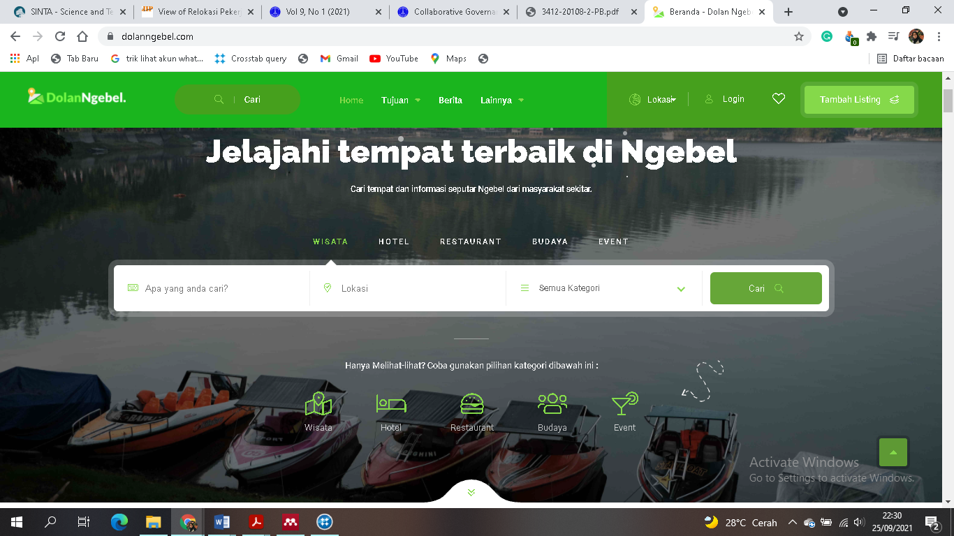
Figure 1. The main page of the dolanngebel.com website
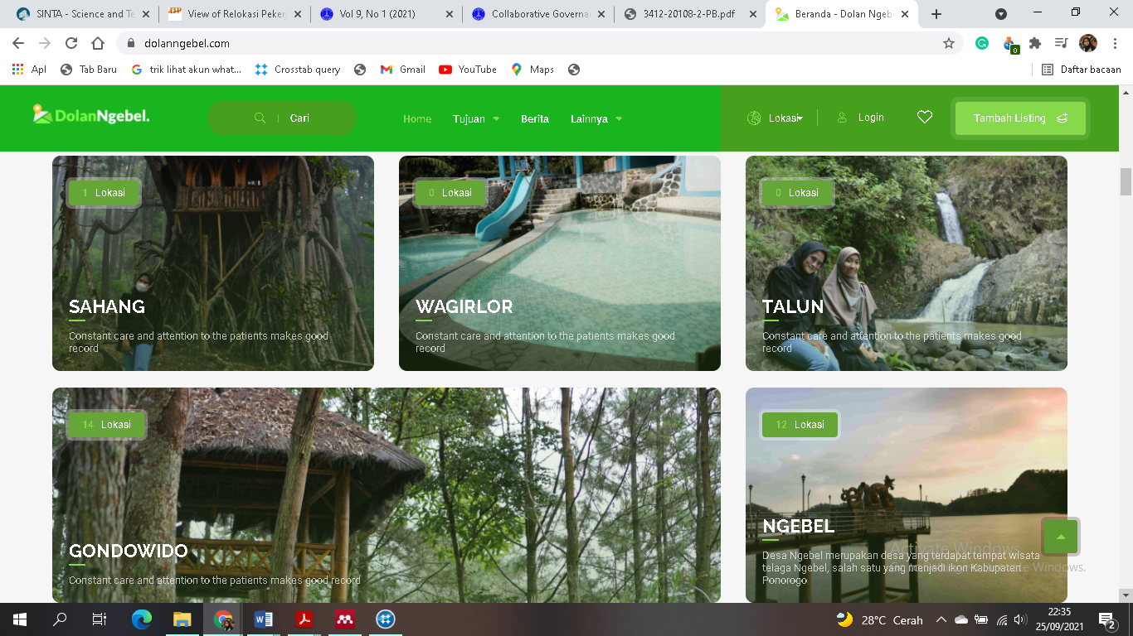

Figure 2. Features of tourist locations based on village data

The development of Ngebel tourism using this website is an implementation of the e-government principle, namely government to citizens (G2C). The dolanngebel.com website is a tool for communication and interaction between the government and the community. The public can access information provided by the government regarding tourist sites, culture, events, maps, hotel, and restaurant reservations. In addition, in carrying out its role the dolanngebel.com website also builds good interactions between the government and business people (hotels and restaurants).(Sriyati et al. 2017).
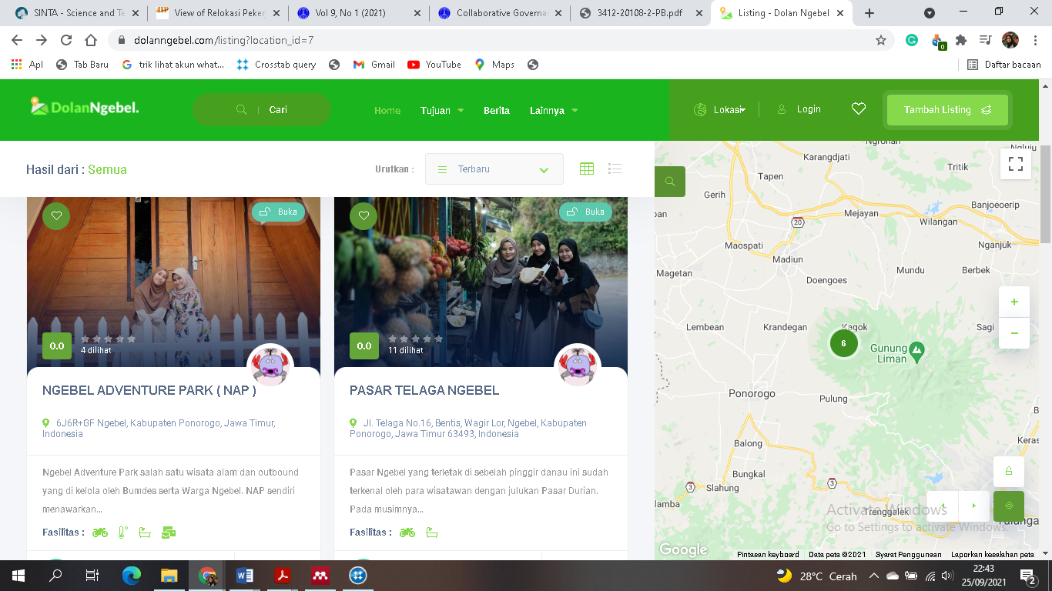

Figure 3. Features of tourist locations equipped with maps

E-Government is a program and government commitment to make some efforts to develop electronic-based governance and carry out transformations to facilitate community and business activities towards a knowledge-based society (Knowledge-based Society). (Sriyati et al. 2017). The Ngebel District Government fully supports the development of tourism potential in Ngebel District, so later Ngebel can become a major tourist destination in Ponorogo Regency. In this era of digitization, all information can spread widely and quickly, so it is necessary to use digital technology to achieve goals in tourism development, tourism promotion in various platforms and websites is very necessary, because the main source of information for today's society is the internet.
In line with the objectives of implementing e-government, there are actors in e-government that can improve the functioning of government. In simple terms, these actors can be divided into two types. The first is the public sector as the administrator of government which consists of the executive (departments of finance, education, health, etc.), the judiciary and the legislature at the national, regional and local levels. The second actor is called the end-user, according to the concept of government, the end-user consists of the non-government sector and the private sector that interacts with the government. Among these two types of actors, ICTs (Information, Communication, and Technologies) can be used for internal and external functions. Internal functions, namely ICTs are used for administrative processes by integrating all internal sectors in the public both horizontally (integration between departments) and vertically (integration between levels). By increasing internal integration both vertically and horizontally, it is hoped that the government will be able to improve its external function, namely providing better public services to end-users. The following is a description of the internal and external functions (Nurhadryani, 2009: 115).
The following are 6 government strategies in the preparation of e-government: 1. Developing a reliable service system, trustworthy, and affordable for the wider community. One of the ways to achieve it can be done by equitable distribution of communication networks, both in terms of area and quality, as well as the establishment of government information portals. 2. Organizing the system and work processes of the government and the autonomous government in a holistic manner. The point is the preparation of human resources in government to adapt to systems that already utilize information and communication technology. 3. Optimally utilizing information and communication technology. Apart from presenting complete information, the security of public service transactions is also the main thing in the use of information and communication technology. 4. Increasing the participation of the business world and developing the telecommunications and information technology industry. The role of the business world tends to participate in the use of e-government so public services are not fully served by the government. 5. Developing the capacity of human resources in both the government and the autonomous regional government accompanied by an increase in community e-literacy. 6. Carrying out systematic development through realistic and measurable stages, namely through the stages of preparation, maturation, consolidation, and utilization(Hamrun et al. 2020)
In terms of the development of information and communication technology, e-government has become one of the policies at the global level. The use of e-government not only provides good service but also increases transparency and accountability in the process of planning and using the budget(Hediyanto 2018). E-government can also cut down the long and complicated traditional bureaucratic system(Basu 2004).
Bureaucratic problems faced by the government office of Ngebel District, Ponorogo Regency. Geographical location and infrastructure are the main obstacles often faced. Ngebel District is a sub-district located at the foot of Mount Wilis. Ngebel Lake has long been developed by the Ponorogo Regency Tourism Office as a tourist attraction that also provides entertainment and educational needs for visiting tourists.(Fistiana, Adam Hilman, and Triono 2020). The development period of Ngebel Lake began in 1998 until 2000 by fulfilling tourism elements such as; aspects of attractions, aspects of infrastructure, and also aspects of accommodation(WAHYU SAPUTRO and ALRIANINGRUM 2019). This development can be seen from the feeling of comfort and safety when visiting Ngebel Lake, which increases the number of tourist visits. Ngebel District also has several other very famous tourist destinations such as Kampung Durian Ngrogung, Mloko Sewu, and Ngebel Adventure Park which is managed by Pokdarwis(Fistiana et al. 2020). Various obstacles were encountered in the development of tourist attractions in the District of Ngebel such as tourism development in Kampung Durian Ngrogung. Kampung durian in Ngrogung becomes the center of culinary tourism during the durian season, from January to April only. Unfortunately, after the durian season is over, this village will be empty of visitors. Therefore, it is necessary to do the right strategy to increase the existence of Kampoeng Durian(Kurniawan and Abidin 2019).
Community response on the dolanngebel.com website
Viewed from the psychological approach, the response is part of the perception, attitude and participation(Santoso 2016). The response itself has two forms, namely a positive response and a negative response. Positive response if you have a response or enthusiasm for the thing at hand. Negative response if the community is less enthusiastic or even rejects the accepted program(Glag 2019). Silviana (2013) argues that the response is a reaction made by a person to the stimulus or behavior presented by the stimulus. Responses are divided into two categories, namely; Over response (response that can be seen by others) and Covert response (response that cannot be seen by others and is private). The following in Figures 2 and 3 are the results of the community response analysis:
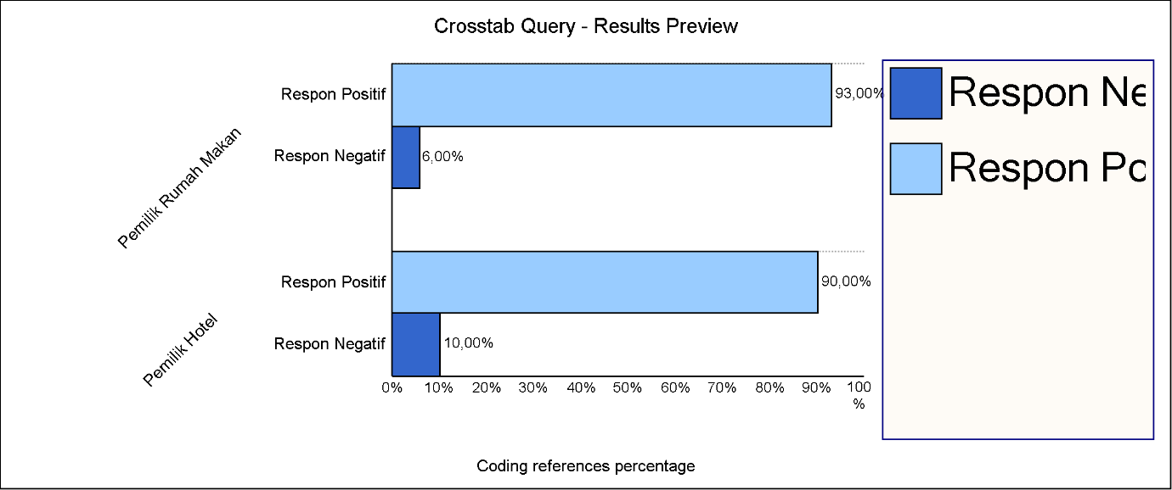

Figure 3. Crosstabulation of Nvivo 12 plus data on the response of business owners in Ngebel
From the results of observations and FGDs conducted, various responses were given by hotel and restaurant owners. Among 32 hotels, 93% gave a positive response and 7% gave a negative response. Then,14 restaurants in Ngebel gave a positive response of 90% and 10% gave a negative response. Business people in Ngebel gave a positive response and showed great hope for the development of the dolanngebel.com website technology.
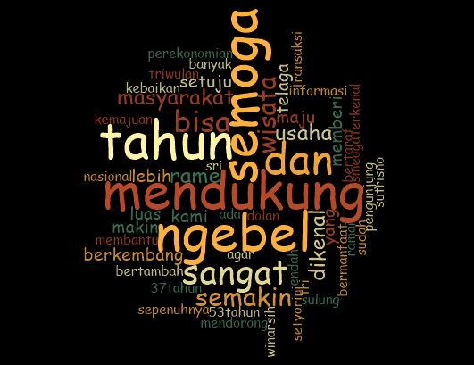

Figure 2. Word similarity by Nvivo 12

The responses from the informants can also be shown in the results of data processing using Nvivo 12 plus with the word similarity feature (figure 2). This figure shows the owners of restaurants and hotels in Ngebel tourism support the development program electronic-based tourism. The over-response given in the form of positive sentences such as support, Ngebel tourism is more advanced, more crowded, more transactions, more useful, agreeing for the good of the community, getting known, and so on.
The constraint faced in implementing the principles of e-government is human resources(Liang 2012; Ogunbodede, Adelanwa, and Adewumi 2020). This is due to the lack of experts who can operate information technology or use the internet. The second obstacle is the security(Dahiya and Mathew 2016; Ogunbodede et al. 2020). In Indonesia, people still think that data will be safe if it is stored in hardware or physical form on an internet system, not storing data in physical form or stored in the cloud system.
CONCLUSION
Development of Ngebel tourism by using the website as an alternative media provided by the government for the community. The emergence of the dolanngebel.com website is quite effective encourages new enthusiasm for tourism business people in the Ngebel area. The features provided by the dolanngebel.com website are also easy to understand with an attractive appearance. The majority of people gave a positive response to the dolanngebel website. The obstacle faced is the lack of experts who can operate the website properly and quickly.
REFERENCES
Agas, Kareldus. 2019. “Community Response to Tourism Development in Labuan Bajo Village, West Manggarai Regency, East Nusa Tenggara Province.” 53(9):1–140.
Basu, Subhajit. 2004. “E-government and Developing Countries: An Overview.” International Review of Law, Computers & Technology 18(1):109–32.
Brandão, Catarina. 2015. “Qualitative Research in Psychology P. Bazeley and K. Jackson, Qualitative Data Analysis with NVivo (2nd Ed.).” 0887(December):7–10.
Dahiya, Deepak, and Saji K. Mathew. 2016. “IT Assets, IT Infrastructure Performance and IT Capability: A Framework for e-Government.” Transforming Government: People, Process and Policy 10(3):411–33.
Fistiana, Inka, Adam Adam Hilman, and Bambang Triono. 2020. “Inventory of Tourism Potential in Ngebel District as a Tourism Center for Ponorogo Regency.” Journal of Tata One Million STIA Mataram 6(1).
Hamrun, Hamrun, Ahmad Harakan, Andi Luhur Prianto, and Nur Khaerah. 2020. “Local Government Strategy in Developing E-Government-Based Services in Muna Regency.” Master: Journal of Government Science 18(2):64.
Handayani, Niken. 2018. “The enchantment of TELAGA NGEBEL AS TOURISM ATTRACTION IN PONOROGO.”
Hariyoko, Yusuf, Ega Purnamasari Biadi, and Adi Susiantoro. 2021. “Development of Mojokerto Regency Tourism Objects With a Collaborative Governance Approach (Case Study of Pacet Hot Springs).” Africa's Potential for the Ecological Intensification of Agriculture 11(1).
Hediyanto, Umar Yunan Kurnia Septo. 2018. “E-Government Research in West Java Province: A Systematic Literature Study.” Metris Journal 19(2018):95–104.
Kurniawan, Dhika Amalia, and Mohammad Zaenal Abidin. 2019. “The Kampoeng Durian Tourism Development Strategy, Ngrogung Village, Ngebel Ponorogo District Through IFAS and EFAS Matrix Analysis.” Al Tijarah 5(2).
Kusuma Dewi, Dian Suluh, Dwiana Binti Yulianti, and Ekapti Wahjuni Djuwitaningsih. 2021. “Implementation of E-Government in the Regional Government of Ponorogo Regency.” 7:357–69.
Layne, Karen, and Jungwoo Lee. 2001. “Developing Fully Functional E-Government: A Four Stage Model.” Government Information Quarterly 18(2):122–36.
Liang, Jiang. 2012. “Government Cloud: Enhancing Efficiency of E-Government and Providing Better Public Services.” Proceedings - 2012 International Joint Conference on Service Sciences, Service Innovation in Emerging Economy: Cross-Disciplinary and Cross-Cultural Perspective, IJCSS 2012 261–65.
Ogbu, SE, S. Idris, and AB Ijagbemi. 2011. “Information and Communication Technology (ICT): A Veritable Tool for Tourism Development in Nigeria.” A Paper Presented at Nigeria Computer Society (NCS): 10TH International Conference–July (ITePED):25–29.
Ogunbodede, Oluwatosin OP, Yinka S. .. Adelanwa, and Oyinkansola Adewumi. 2020. “Impact of Cloud Computing on Network Management.” Journal of Computer Science and Its Application 26(1):71–77.
Purnomo, Singgih, Endang Siti Rahayu, Asri Laksmi Riani, Suminah Suminah, and Udin Udin. 2020. “Empowerment Model for Sustainable Tourism Village in an Emerging Country.” Journal of Asian Finance, Economics and Business 7(2):261–70.
Santoso, Pudjio. 2016. “Response of the Community and Village Government in Seizing Tourism Development Opportunities in Bawean.” 5(2):262–71.
Sripambudi, Galuh Istu, Yusuf Adam Hilman, and Bambang Triono. 2020. “The Tourism Office's Strategy in Infrastructure Development of the Ngebel Lake Tourism Object in Ponorogo Regency.” Ganaya : Journal of Social Sciences and Humanities 3(1):38–50.
Sriyati, Faqih Satria, and et al. 2017. “UTILIZATION OF E-GOVERNMENT AS A PROMOTION MEDIA IN THE FIELD OF CREATIVE ECONOMIC TOURISM (Case Study: Creative Economy Tourism Office, Pesawaran Regency).” Technology Acceptance Models 80–87.
Wahid, Fathul. 2008. “Evaluating Focus and Quality of Indonesian E-Government Websites.” National Seminar on Information Technology Applications 2008(Snati):39–43.
WAHYU SAPUTRO, AGIL, and SEPTINA ALRIANINGRUM. 2019. “Ngebel Lake Tourism, Ponorogo Regency 1993-2000.” Avatar 7(1).
Yamani, Achmad Zaki, Arif Wirawan Muhammad, and Muhammad Nur Faiz. 2019. “Strengthening the Local Economy in Digital-Based MSME Actors in Winduaji Village, Brebes Regency.” Madani : Indonesian Journal of Civil Society 1(1):24–28.

